# **Portal Box Technical Report**

Project Manager: Axel Andrews

Systems & Performance Engineer: James Powick

Design Engineers: Peter Beaudette, Kevin Duong, Aidan Flynn, Colton Jiorle

# **0: Executive Summary**

Our team has successfully developed the fourth iteration of the Portal Box system, an access control solution for makerspaces and fabrication labs that uniquely balances security with accessibility. Building upon three previous generations, this iteration delivers significant improvements in security, user experience, cost-effectiveness, and deployability while maintaining the core functionality that has made Portal Boxes valuable assets at Bucknell University. The Portal Box transforms the traditionally contradictory relationship between security and accessibility into a reinforcing loop where both can be enhanced simultaneously, and our latest iteration continues foraging into the depths of that relationship in search of the optimal solution.

While previous iterations relied on Raspberry Pi microcontrollers, Version 4 transitions to the more cost-effective [ESP32-C6-DevKit](https://www.digikey.com/en/products/detail/espressif-systems/ESP32-C6-DEVKITC-1-N8/17728861) platform while simultaneously expanding functionality through the addition of two-factor authentication (PIN entry via [matrix keypad](https://www.digikey.com/en/products/detail/sparkfun-electronics/14662/8702491)), improved user interface ([LCD screen](https://www.digikey.com/en/products/detail/adafruit-industries-llc/398/5774231)), and streamlined training processes [CITE]. This implementation achieves a remarkable, nearly 50% cost reduction while enhancing security, usability, and deployability.

Comprehensive testing has validated the system's performance, demonstrating 99% authentication reliability, 74% reduced power consumption, and robust operation during extended testing periods exceeding 600 hours of authorized access. The Portal Box V4 controls machine access in the same manner as its predecessors, using two mechanisms: an AC power relay for equipment that can be safely power-cycled and a redesigned USB interlock (upgraded to USB-C) for devices requiring continuous power. Both systems prevent unauthorized access while maintaining seamless operation for trained users.

The project delivers significant innovations beyond hardware improvements. A new [AWS CloudFormation](https://aws.amazon.com/cloudformation/) deployment template enables the entire web infrastructure to be deployed in under 20 minutes with no coding required, dramatically lowering the technical barrier to adoption. Two new admin modes at the point of usage reduce the need for extra equipment and simplify training procedures for new users.

User feedback has been overwhelmingly positive thus far, with polls administered at STEAM Innovation Labs in Sunbury, PA, and Bucknell’s MakerE. The successful deployment at STEAM Innovation Labs represents the first implementation outside Bucknell University, validating the system's broader applicability. New and existing users were quickly onboarded with the Quick Reference and User Manual, two parts of the documentation set. The comprehensive documentation package ensures replicability, with detailed guides for usage, PCB ordering, enclosure printing, ESP32 setup, final assembly, and web infrastructure configuration. All components, firmware, and application code are publicly available on GitHub, ensuring transparency and accessibility for future adopters.

Through its combination of enhanced security, improved user experience, reduced costs, and simplified deployment, the Portal Box V4 achieves its objective of creating a highly replicable, accessible solution for makerspace access control that prioritizes both safety and usability. The team passed its Acceptance Test on April 24th, 2025, a significant step on the V4’s path to widespread adoption.

## **Status Update**

The Portal Box V4 project has successfully completed all major development milestones and entered deployment testing. Key accomplishments include:

* **Hardware Development**: The ESP32-based hardware platform has been fully developed and tested, including PCB design, component selection, and enclosure design. The system has been assembled and validated through extensive bench testing.
* **Firmware Implementation**: The [MicroPython](https://micropython.org/) firmware has been developed, replicating all core functionality from prior iterations [CITE]. The system successfully communicates with the database server and handles all authentication flows. The one missing piece in the new implementation is the emailing functionality, which we sought to move to a server-side implementation due to limitations of MicroPython, however this has not been successfully integrated at this point.
* **Cloud Infrastructure**: The [AWS CloudFormation](https://aws.amazon.com/cloudformation/) template has been created and tested, enabling one-click deployment of the web infrastructure for new adopters [CITE]. This represents a significant advancement in reducing deployment complexity.
* **Documentation**: Comprehensive documentation has been created, including PCB fabrication guides, enclosure printing instructions, assembly procedures, and system configuration guidance.
* **Initial Deployments**: The system has been deployed at [STEAM Innovation Labs](https://www.steaminnovationlabs.org/) in Sunbury, PA, and in testing environments at Bucknell's MakerE, accumulating over 600 hours of power supply to equipment.
* **User Testing**: Initial user feedback has been collected from both administrators and end users, with overwhelmingly positive results and valuable suggestions for future improvements.

# **1: Project Context & Stakeholders**

Many people, from casual users to dedicated professionals, rely on machines to hone their craft efficiently. However, these machines are not always accessible or realistic for individuals to own, which is where makerspaces offer a more affordable solution [1]. While beneficial, these spaces have flaws, such as limited hours of operation, accessibility issues, and potential security concerns if open 24/7 without constant supervision. The issue of balancing security and accessibility effectively often results in a one-sided approach, which leads to outsiders being excluded while insiders roam free [2]. Trust plays a huge factor in how these spaces are set up and how much freedom is granted.

Many spaces with specialized equipment are built around the trust of different users to respect and uphold the guidelines of a communal space [3]. However, given the level of risk involved, it often becomes necessary to ensure users are trained and skilled at operating these machines for their own safety, that of the machine, and others in the space [4]. As more machines become feasible to deploy to wider audiences, this has created a dynamic of accessibility and security for authentication of user credentials in spaces shared by many users of different skill levels. The goal of these spaces is to create a balance between these two factors where users can be both protected and knowledgeable of best practices while still feeling invited in to learn, create, and share.

Bucknell University has deployed the past versions of the Portal Box in its makerspaces, an access-control device that utilizes RFID cards to authenticate and provide access to trained users. Currently, in spaces such as the Maker-E at Bucknell, there are 3D printers, laser cutters, and all sorts of machines available to users at Bucknell with 24/7 access [5]. Users of the space authenticate with a Portal Box by inserting their RFID card before using makerspace machinery. The Portal Boxes communicate with an online database to verify that the user attached to the RFID card is trained for a particular machine before granting access via power or data switching. Portal Boxes are historically well-liked by their users and administrators, and they directly address the identified problem of balancing security and accessibility in makerspaces by making it easy for new users to realize they need training, get that training, and then operate machinery confidently and safely. The current boxes (V2) served as a proof of concept and heavy inspiration for our project, and we are confident that our newest iteration has built upon their incredible foundation in a way that will allow them to proliferate to more spaces inside and outside of Bucknell.

## 

## **Portal Box Evolutionary Timeline**

### **Portal Box V1**

The V1 was developed in 2016. According to Joseph Kale, member of the original Portal Box team, the primary goal of the Portal Box was still to be able to authenticate users. Their thought process is to focus on a way to shut off power to the machines since they all share the need for power. The remainder of the project was to focus on power and making sure that it won’t overheat [9][10].

### **Portal Box V2**

The V2, which is currently used in the Portal Boxes as of spring 2025, was developed in 2018. One of the primary goals of the V4 project was to replace these V2s in Bucknell’s makerspaces. The V2 featured revised and cleaned up code, as well as an improved enclosure. Professor Joe Hass had a lot of influence on the embedded code as he developed the code using 15 different states which improved the functionality of the authentication with a lesser focus on cooling [11]. James Howe, a Computer Engineering student at the time, worked over the summer on improvements to the codebase. He wrote the Python FSM implementation that is currently in use with the Portal Boxes [12].

### **Portal Box V3**

The V3, developed in 2021, was an extension of the V2 which was never deployed at Bucknell. The enclosure once again had substantial changes which went back to a focus on controlling heat with an optional position for a small fan in addition to more ventilation in the enclosure to support the component swaps, such as swapping the Neopixel LEDs for DotStars to increase the functionality of the LED colors, made to the Portal Box which increases the strain on the PCB and microcontroller, but overall increases the accessibility if it finished development and were deployed [11][12].

### **Portal Box V4**

Built throughout the 2024-2025 academic year, the V4 was designed to replace the V2s currently deployed in Bucknell’s makerspaces. They will hopefully be integrated over the summer, launching for the 2025-2026 academic year. The key updates are covered throughout this report, and the project received acceptance from the client, Matt Lamparter, on April 24th, 2025. The V4 is also the first Portal Box to be deployed outside of Bucknell, with one currently in operation at STEAM Innovation Labs in Sunbury.

## **Stakeholders**

Because of their current deployment and development for and in the Maker-E, its administrators and supervisors were some of the biggest supporters and stakeholders in our project. Matt Lamparter, our client, is the most knowledgeable individual about the existing systems due to his role as Director of Bucknell’s Computer and Electrical Engineering labs, the main home of Portal Boxes. Matt’s knowledge about how the past Portal Boxes were developed and what it takes currently to maintain them has guided our development, and his technical support was a massive resource in debugging various issues throughout the development process. Matt, or students under his guidance, will be responsible for integrating the Portal Box V4 into the MakerE, and we have provided a comprehensive documentation package to support this transition.

We were also cognizant of the need for external feedback from those who are not as close to the original product, and thus we sought out feedback from MakerE users, as well as administrators and users at STEAM in Sunbury. Some features of our new Portal Box V4, like the Proxy Card Holder, were direct additions that originated from feedback we received at STEAM. Summarized in *Table 1.1* on the following page are individuals and entities that have been or may be impacted by our project in the future.

*Table 1.1: Stakeholders*

| Who it Impacts Directly | Who it Might impact |
| --- | --- |
| Matt Lamptarter | External Makerspaces |
| Lab Directors | Other Spaces that Provide Equipment (Labs, Workshops, etc) |
| STEAM Innovation Labs |  |
| Makerspace/Maker-E users |  |

We strongly feel that the existing Portal Box system already improved the operational efficiency of the makerspaces they were deployed in by freeing up technicians and other admins to assist users instead of constantly monitoring machines. This allows for a more supportive and educational space by allowing the instructors to interact with students and other users in a stress-free environment. The Portal Boxes also provide enhanced security and safety measures, and many who have used the system note that it is more advanced than other makerspace systems they’ve encountered [6][7]. The strain on administrators and technicians is lowered by removing the necessity to actively monitor who is using what machines, and users are quickly able to start building without waiting for human permission. Furthermore, there are many spaces that operate in a similar fashion to what we see in makerspaces – such as workshops, labs, and hospitals, all which have sensitive equipment that often requires training or authentication to use. We believe that the Portal Box is capable of revolutionizing the way these spaces operate, greatly simplifying authentication and increasing confidence for users and administrators alike. Our project centered around the goal of bringing the benefits seen mostly in the Maker-E to more places where the same benefits can be reaped.

By simplifying the deployment process, we have decreased the difficulty and strain required to set up the entirety of the system, which should contribute to broader adoption. Jeremy Dreese is Bucknell’s Computing Systems Integrator, and he currently manages the database and web server which host the Makerportal on Bucknell L&IT VMs, which is a great operation setup for Bucknell such that L&IT can control security and reliability. However, not all makerspaces have someone who is proficient in server and database administration, so our provided cloud template greatly increases the accessibility of the system by providing a default configuration that can be set up with no coding experience.

Overall, our stakeholders and target audience have not greatly changed throughout the second semester. We tightened our partnership with STEAM through a multi-week and ongoing deployment of our Portal Box V4, and their positive feedback is an indicator that more spaces will be receptive to the project and its benefits. With future marketing we hope the project can catch on in more spaces, and the flexibility we’ve provided through configuration options and comprehensive documentation now allow the Portal Box to be built specifically for the needs of a given space. We believe that our iteration provides more value for the identified audience, and the increased security with PINs opens the door for higher-risk deployments.

# **2: Project Value**

## 

*Figure 2.1: Accessibility & Security*

### **Compromise of Security & Accessibility**

As we identified in the fall, the primary challenge addressed by the Portal Box project is the tradeoff between accessibility and security in makerspaces [13]. Our initial research helped us build a system map of how makerspaces operate, showing the relationships between the directors, technicians, users, machines, and more (See Appendix A). We analyzed our map and realized that security and accessibility form a key loop that ties all of the agents of the system together. These two concepts are at the top of the mind of makerspace managers and directors, as they impact the flow, usability, and community of a space, all of which are critical for operability [14]. The choices that makerspaces make about their machine access structure often result in a linear spectrum, illustrated by the reinforcing loop above in *Figure 2.1*. Focusing heavily on security, like is done at Penn State’s OriginLab where technicians operate the machines for students, limits the accessibility and availability of machines [8]. On the other hand, decreasing security and increased freedom can introduce vulnerabilities, potentially leading to improper or unsafe usage of machinery. Neither of these are good outcomes, and focusing too many resources on either security or accessibility can stall the productivity of a makerspace. The Portal Box system changes this relationship, transforming the linear relationship into a circular spectrum that enables for both enhanced security and accessibility without sacrificing aspects of either. This is illustrated as a balancing loop, where both elements can improve with each other, fostering a safe, supportive, and inclusive community of makers. This approach improves the usability of makerspaces while maintaining safe usage and lowering the barrier to entry for new or inexperienced users. From our group’s own experience as users of the Maker-E, the Portal Box system allowed us to quickly train on new machines and create powerful deliverables for class and independent projects. With our and others’ positive experiences in mind, we did not want to make significant changes to the overall flow and operation of the boxes, because they already did a good job of intervening in this loop. We feel that the existing Portal Boxes began the transformation of this loop from reinforcing to balancing, and the changes we implemented increased both the security and accessibility of the boxes, simultaneously, thus strengthening the relationship without inhibiting the positive benefits brought by the past versions.

### **Cut Costs**

A secondary challenge decreasing the cost of Portal Boxes. The past designs cost $202 for V3 and $140 for V2. The high cost of fabrication restricted the system's wide adoption. In order to make the Portal Box more accessible to a broader audience of makerspaces, we aimed to reduce fabrication costs by roughly 20%. We surpassed the goal of a 20% reduction, with massive cost cuts coming largely from the microcontroller switch ($35 → $9) and the 3D-printed enclosure. While balancing cost reductions and increased functionality, we added peripherals (keypad and LCD) which increased the functionality beyond what existed. However, to remain cost-conscious, we made these components entirely optional, leading to 3 standard Portal Box V4 configurations.

Summary of Portal Box V4 Configurations:

* V4 Pro (~$104): Matrix Keypad + RGB LCD Screen (enables PINs for 2FA, enhanced admin modes and visual user feedback)
* V4 Plus (~$100): Push Button + RGB LCD Screen (enables enhanced visual user feedback)
* V4 (~$75): Push Button (replicates V2 functionality)

The 3 options for peripheral configuration lead to 3 different price points for the V4s, depending on deployer budget and need. For instance, it may not be worthwhile to have PINs on a low-risk or inexpensive machine, but for machines with dangers or costs associated with them, having the extra layer of security ensures safety. Other logical fits for the V4 Pro are machines with charges for usage, like the coffee machine in the MakerE, to prevent users from charging someone else for their usage. The configuration occurs on the microcontroller, and one MakerPortal setup will work with boxes of all 3 varieties at the same time. All 3 iterations represent a significant cost reduction from both the V2 and V3, as illustrated in Figure 2.2 below.

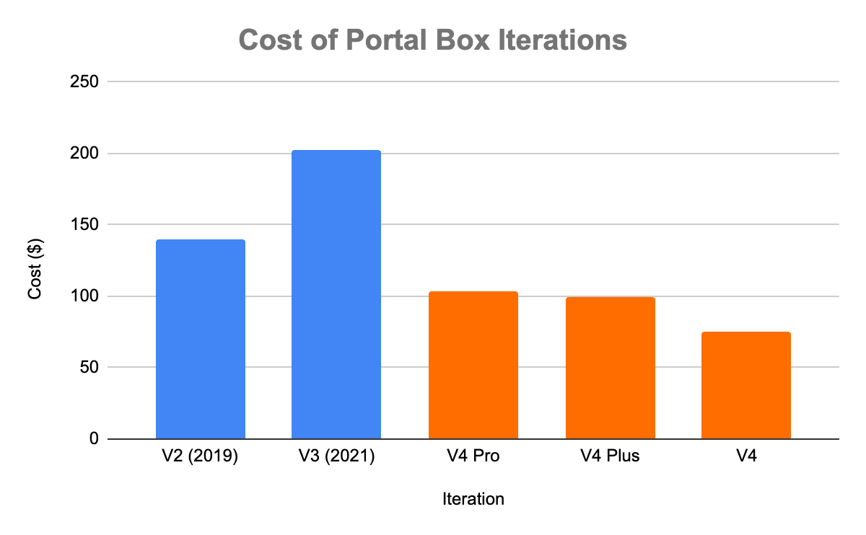

*Figure 2.2: Cost Evolution*

### **Broaden Expansion**

Another area we sought to improve on the existing Portal Box projects was to get it out of Bucknell’s doors. We hope to see Portal Boxes deployed widely in other makerspaces, and in order to do so we added value that simplifies setup and operation of the system. We found from our first semester research that 3D-printers are one of the most common pieces of makerspace equipment, and it was noted that the current enclosure was difficult to assemble [5]. This led us to develop a 3D-printed enclosure, switching over from acrylic (needed to be laser-cut), that will be easier for other spaces to assemble. Right now, the only equipment needed to build our V4 enclosure is a 3D-printer and a soldering iron, eliminating the need for laser-cutters and machining for the old aluminum baseplate. In terms of the MakerPortal, we explored multi-tenancy, but in the end decided that giving each makerspace full control over their instance is probably ideal. However, we did create a makerportal-template.yaml file which allows for zero-code deployment of the MakerPortal and its associated database on AWS resources. This entire process takes roughly 20 minutes, and the guide enables a completely inexperienced programmer to set up this critical aspect of the system (See Appendix B). More information about the CloudFormation template is available in Section 4.5 of the report. Both of these changes represent technical improvements which streamline the process of implementing the Portal Box system. We also built a relationship with STEAM Innovation Labs in Sunbury and their new director, Kevin Brosious, which may serve as a launching pad for broader adoption. The makerspace has been using our latest iteration for around a month as of May 2025, and has expressed interest in getting more Portal Boxes.

### **Technical Competence**

One of our primary goals was to improve the overall technological readiness level of the Portal Box system. We thought that the Portal Box V2 represented a fairly high-TRL project already, and by replicating its behaviour with some minor improvements we could push it to the next level. We achieved these improvements in a few areas. First, the enclosure is simpler and meets the open-source, replicability requirements we set for our project. We wanted it to be as easy to recreate as possible, and utilizing 3D-printing, a widely available resource in makerspaces, achieves that goal. The old enclosure required laser-cutting and some machining, and the new enclosure both simplifies that process and brings additional benefits in flexibility, ease of assembly, cost reduction, and overall feel.

One of the largest sources of increased TRL in the full version of the V4 Portal Box comes from the addition of the keypad. This enables PIN-based two-factor authentication and two new admin modes accessed via the “*” and “#” buttons. PINs enhance security without significantly impacting usability, and some users find entering a PIN adds to the interactive experience.

The two new admin modes streamline technician workflows and reduce reliance on equipment outside of the main Portal Box system:

* **Card Scanner Mode** (* key):
  + Admin authenticates using RFID card and PIN.
  + The box displays the ID of any card inserted.
  + This replaces the need for a separate RFID scanner when adding new cards.
  + Admins can copy the ID and add it to the system via MakerPortal.
* **Authentication Mode** (# key):
  + Admin authenticates using RFID card and PIN.
  + A user card without access can be inserted.
  + The box sends a request to the server and grants access if authorized.
  + This removes the need to manually assign permissions through MakerPortal.

Another area that blends between ease of adoption and technical competence is using sourceable, reliable components. Every item now on our BOM is available from DigiKey, and we sought these improvements for both technical competence and ease of replication. The [RFID reader](https://www.digikey.com/en/products/detail/sunfounder/CN0090/18668629) historically is finicky, with readers known to break over extended periods of time. While the actual chip we are using now is the same MFRC522, we are now sourcing the reader directly from DigiKey rather than relying on 3rd party vendors on Amazon [CITE].

The new microcontroller uses significantly less power, decreasing the long-term costs of deployment. The new USB Interlock utilizes USB-C rather than the outdated USB-A, although some machines may still need USB-A. We made this decision after discussions with our client, and determined that for most makerspaces that may adopt Portal Boxes, it would be simpler for the default to be the current standard cable, rather than the older USB-A. Adapters are available for both cables, but we believe that USB-C will lead to a lower reliance on adapters.

### **Ease of Operation (Admins/Technicians)**

Makerspace administrators and technicians benefit from significantly reduced workload. The system automates credential verification, tracks usage automatically, and eliminates the need for constant supervision. As covered above, the new authentication and card reader modes enable direct-from-box user certification, removing administrative bottlenecks in granting permissions. As reported by MakerE technicians, the system "eliminates extra hardware" and avoids "awkward asking for someone's name over and over again.”

### **User Friendliness**

Ensuring that new users feel welcomed into makerspaces and existing users enjoy using the Portal Box is an important aspect of accessibility we focused on. The new system provides more detailed feedback to users through the use of an LCD screen. Past iterations relied solely on the buzzer and LED lights to provide status updates, but with the LCD screen users are prompted to insert their card to use the machine, welcomed into authorized access with a personal message, informed about the mode of operation (proxy vs training mode), and informed of a lack of authorization when their access is denied. These messages and the screen’s color work cohesively with the buzzer and LEDs to create a consistently informative experience throughout usage. Providing informative prompts and updates to the user eliminates feelings of alienation in makerspaces [3]. The ease of use has also been updated for admins and makerspace technicians through a faster reboot time (3 minutes → 20 seconds), the new admin modes, and simplified deployment process of the Portal Box system. Furthermore, the boxes are more interactive with the integration of the keypad, which does indeed slightly slow down usage, but also makes the Portal Box feel more alive rather than being a simple barrier to equipment access.

## **Deploying the Portal Box V4**

For new implementations of the Portal Box system, we have created comprehensive manuals covering every aspect of the deployment. The guides in brief are as follows:

Portal Box Documentation Packet:

* **PCB Guide (Appendix C):** Covers PCB design, ordering, and assembly.
* **Enclosure Guide (Appendix D):** Covers 3D-printing of enclosure and needed preparation for full Portal Box assembly.
* **Microcontroller Guide (Appendix E):** Covers flashing with firmware, software installation, and configuration.
* **MakerPortal Guide (Appendix B):** Covers AWS CloudFormation deployment process. Defers to README.md from the Bucknell-ECE Github for manual deployment.
  + It is important to note that cloud charges may be incurred, scaling with usage of the space. For small spaces, free-tier AWS services may be sufficient at least for a short period of time, but large spaces may incur additional charges on the order of ~$10/month from our testing.
  + If cost is a significant factor and locally hosted options are available, hosting the database and server locally is a better option in terms of cost and full control.
* **Final Assembly Guide (Appendix F):** Covers integration of PCB and peripherals with the enclosure.
* **Quick Reference (Appendix G):** Front/back manual for day-to-day usage, onboarding new users.
* **User Manual (Appendix H):** Comprehensive manual for admins explaining full operation of the system.

Our GitHub contains all of these guides, the updated repository to enable PIN functionality, and the MicroPython software. We estimate through our testing that setting up one Portal Box V4 (using the AWS CloudFormation stack and ignoring 3D printing time) takes roughly 2 and a half hours.

Time Required for Deployment:

* MakerPortal CloudFormation Stack: ~20 minutes
* ESP32 Flashing & Software Installation: ~10 minutes
* PCB Assembly: ~100 minutes (~55 for SMT, ~45 for Through-Hole)
* Enclosure Printing & Assembly: ~10 active minutes (18 hour print)
* Final Assembly: ~20 minutes

## **Transitioning from Existing System to V4**

We anticipate our new V4 replacing the existing V2s which are deployed at Bucknell. In order to do so, the MakerPortal system needs to be adjusted to allow for PINs. This is a two step process, involving updating the SQL database and the MakerPortal code. The update to the database is simple, the users table needs an extra column titled “pin”, and for simplicity we recommend setting all user PINs to ‘0000’ by default. This can be achieved with the following SQL commands shown below in Figure 2.3.

| -- Add PIN field to users table with default value of '0000'  ALTER TABLE users ADD COLUMN pin VARCHAR(4) NOT NULL DEFAULT '0000';  -- Update schema version  INSERT INTO schema_versioning(version, comment) VALUES ("2.9.1", "Added PIN field to users table with default '0000'"); |
| --- |

*Figure 2.3: SQL to Update Database for PINs*

For updating the code itself, we have opened a [pull request](https://github.com/Bucknell-ECE/PortalBox-ManagementPortal/pull/56) to the main repository which contains the changes we implemented in order to allow users to see and modify their PIN, as well as admins to see and modify all user PINs (See Appendix L). This can be merged into the main branch when the time comes for deployment of the new system. Tom Egan is extremely knowledgeable about the codebase, as he is the primary developer, and he should be kept in the loop during this change to ensure reliability. Deploying the physical boxes will be the same process detailed above, utilizing the guides for PCB, enclosure, microcontroller, and final assembly.

# **3: Project Functions and Design**

The Portal Box V4 consists of the same three integrated components forming a comprehensive access control ecosystem as the prior versions of Portal Boxes, with the overall architecture laid out in our Block Diagram in Figure 3.1.

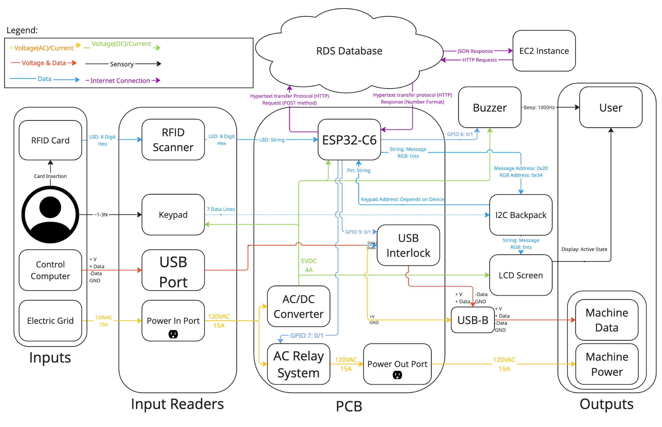

*Figure 3.1: Level 2 Block Diagram*

### **3.1 Physical Portal Box**

The physical Portal Box V4 is built around the [ESP32-C6-DevKit](https://www.digikey.com/en/products/detail/espressif-systems/ESP32-C6-DEVKITC-1-N8/17728861) microcontroller, which serves as the system's brain [CITE]. Major hardware components include an [MFRC522 RFID Reader](https://www.digikey.com/en/products/detail/sunfounder/CN0090/18668629) for card authentication, a [3x4 Matrix Keypad](https://www.digikey.com/en/products/detail/sparkfun-electronics/14662/8702491) for PIN entry, a [16x2 RGB Character LCD](https://www.digikey.com/en/products/detail/adafruit-industries-llc/398/5774231) for status display, and a custom PCB integrating all components with proper power distribution [CITE] [CITE] [CITE].

Two separate systems control machine access: an AC Power Relay rated for 15A at 120VAC controls power to equipment that can be safely power-cycled, while a USB Interlock blocks data transmission between control computers and machines that must remain powered. The V4 implementation fixes a critical flaw in previous versions by interrupting the data and clock lines instead of the power line. For hand-assembled boards, it is still critical to exercise extreme caution and precision when soldering the USB Interlock, as we had issues with it on several of our boards. The pins are extremely small, so careful installation and inspection is critical if the box will be used with the USB interlock as the control method.

The hardware is housed in a custom 3D-printed enclosure designed for ease of manufacturing in typical makerspace environments. The enclosure features cutouts for power connections, the LCD screen, keypad, and a specialized card slot that guides RFID cards into proper reading position. The RFID reader mounts to the back of the card slot, and can be adhered with tape or an adhesive of your choice. Another difference from past iterations, and something that was born directly from STEAM’s feedback, was the Proxy Card Holder on the right-hand side of the box. This allows for proxy cards to be stored directly in the box itself, eliminating the hassle of finding one if it is misplaced in the makerspace.

### **3.2 Database and Web Application**

The system utilizes a MySQL database storing user information, equipment specifications, authorization mappings, and access logs. The MakerPortal web application provides administration capabilities through a PHP-based interface for user management, equipment configuration, and analytics. Google OAuth is used for logging into the web application and handling user authentication. The components interact through a well-defined API, with HTTP requests handling authentication, logging, and system configuration. box.php handles all requests and responses to the physical box. An API table is available in **Appendix I**. This infrastructure can be built from scratch with a provided schema and repository, and we have also provided an AWS CloudFormation template for a zero-code deployment (See Section 4.5).

### **3.3 Firmware Architecture**

The ESP32 firmware implements a Finite State Machine (FSM) with approximately 15 states governing the authentication process, machine operation, and special modes. Key software features include peripheral control, WiFi connectivity for database communication, two-factor authentication processing, and special operational modes:

* **Card ID Reader Mode (New)**: Displays card IDs for registration purposes
* **Certification Mode (New)**: Allows trainers to authorize new users directly from the box
* **Training Mode**: Enables supervised operation under a trainer's authority
* **Proxy Access**: Allows extended operation without keeping a personal card inserted

The firmware replicates essentially all functionality of the original firmware that was written in CircuitPython. HTTP requests are sent from the box over Wifi to log updates to the database, get user permissions, and authorize new users. The one piece of missing functionality is the emailer, which in past iterations sent a user an email if they left their card in the box for an extended period of time. We struggled to integrate this capability with MicroPython, and suggest incorporating it in the same style as other box.php functions. When the box wants to authorize a user, log an update, or any other action, it sends an HTTP request to the server running the MakerPortal which communicates with the MySQL database to achieve whatever needs to be done. The emailing was implemented in a different fashion originally, with the emails being sent straight from the box. We suggest modifying box.php to allow for an HTTP message which will trigger the email being sent from the server-side, but we did not get to this point.

### **3.4 Project Evolution**

While most of our final functions were planned throughout the year, there were a few changes and things that we did not get to.

The display was something we were uncertain about heading into the second semester, and ultimately we settled on a 16x2 RGB LCD display, which allows for brief messages to be shown, and enhanced feedback with colors. It is also a good backup if the DotStars fail, because there is still some color feedback for users. We ruled out using E-Ink displays despite their attractive looks, largely due to costs and low refresh rates. We did find some E-Inks with fast refresh times, but they required a dozen GPIO pins which we did not have available on our microcontroller. We are using an Adafruit [backpack](https://www.digikey.com/en/products/detail/adafruit-industries-llc/781/6419354) for serial communication with the LCD display, cutting down the needed number of GPIOs to just 3 for the screen [CITE].

The enclosure was a matter of debate throughout development. Some people feel a strong attachment to the old acrylic enclosures, and they do look very nice. However, they are cumbersome to build and take apart, making assembly and debugging difficult. Furthermore, they require laser cutters and a machined piece of aluminum for the baseplate, adding to the equipment needed to build the project. Around March we ultimately decided we would create a 3D-printed enclosure, which in the end looks really nice, and also cuts cost and difficulty of assembly significantly. Due to the lower weight of the new enclosure, we recommend putting rubber feet on the bottom as a future improvement to prevent the box from sliding around.

Other functions that we did not implement, but discussed early on, were local storage and a dashboard. Local storage would have enabled the box to run completely free of an internet connection, by storing users and permissions for a given machine right on the box. We ran into difficulties implementing this due to a lack of experience and ultimately a lack of priority. The box runs perfectly fine while connected to WiFi, and we decided eventually that any increase in speed due to local storage would not have been significantly noticeable. This would still be neat to implement down the line for increased reliability. Along with local storage, we did not get around to implementing a dashboard on the MakerPortal. This was an idea that would’ve provided administrators with more information about machine usage. When we failed to implement a current-sense IC on the PCB, we decided that the information displayed on the dashboard would not necessarily be meaningful, as there is no way to determine whether a machine has actually been used for 20 hours, or if someone just left their card in for 20 hours. This would be nice to implement down the line, but would likely require the integration of the current-sense IC on a new version of the PCB in order to get meaningful data.

The only existing functionality that we did not replicate was the emailer. As noted earlier in the report, we tried to switch to a server-side implementation, where a POST request from the box would trigger the server to send an email. This should not be incredibly difficult, but due to limited time-resources and experience coding in PHP it was a struggle, and ultimately we were not able to implement it. This does not introduce a massive barrier to adoption, as many users of the current system are unaware of this feature entirely, but it was a neat feature that should be added down the line. If other students or Tom Egan have time, it would be nice to add this before deploying the new iteration. Database.py controls all API requests from the box, while box.php should receive the request in the MakerPortal code. It would also be beneficial to add an email flow that is triggered if connection is lost with the box.

# **4: Fabrication and Implementation**

The manufacturing process has been simplified to enable broader adoption. The PCB uses sourceable components, the enclosure is now 3D-printed to widen the range of spaces that can replicate it, and software/web-interface setup has been streamlined for inexperienced developers.

### **4.1 Bill of Materials**

Our complete BOM covers everything that goes into the project physically, aside from 3D printing filament. The full BOM is available in **Appendix J**. For filament, we used [transparent 1.75mm PLA from Amazon](https://www.amazon.com/ELEGOO-Filament-Translucent-Dimensional-Cardboard/dp/B0DM1QTZKN/ref=sr_1_3?crid=1OX6IJ3O5S3PB&dib=eyJ2IjoiMSJ9.8JJ2i8nZIDiUOig-n1KdZn7eJxhvU7RPNPC1GAmdZui0-Hi3Kfy9pkKHQKKqYCPzxdQspo2lrGNJbFTtcPNboo2xgYiBLE9Ni_2ljPlC_hKJvvUJ1JUpXGixF6tJimDZYUm28skpXVPsJ4pkYtG04iyKjI1qEkfIemCEmI9j4rcsftkD9RYjVuKfO_hGPZdvkz33aC7YDefq_zslfVZkGpGz8wD86TgwEpD6p0icHALersOC4iDFG8NCDJ0riiFVJucI2OyeNt1T5yllZ75bZu9ZUpsI9FtXZGApfnHKwDLCRzJncraqlNshFUOmHd905LufU3DuWPc06MM9CYOnfnPkn_bTvkDTNsE4iPQQVlA.q-JlOZ4iwviQehuoUR_Ai53n0knKkvLw7QhNhFUQGLk&dib_tag=se&keywords=cloudy%2Bpla&qid=1743192285&s=industrial&sprefix=cloudy%2Bpla%2Cindustrial%2C62&sr=1-3&th=1), but other filaments will also work [CITE]. We recommend using clear or transparent filament to allow the [DotStar LEDs](https://www.digikey.com/en/products/detail/adafruit-industries-llc/2343/5761204) to shine through, but modifications could also be made to a translucent box to allow light to shine from the bottom. We have also created a [BOM on DigiKey](https://www.digikey.com/en/mylists/list/NODQQK4VBZ) with everything that goes directly on the PCB, allowing a new deployer to export the BOM and order prefabricated PCBs that will arrive simply awaiting peripheral integration [CITE]. All components on the PCB are sourced from DigiKey, as well as all peripherals.

### **4.2 PCB Fabrication**

The PCB is designed in [KiCad](https://www.kicad.org/), an open-source PCB design software, making it accessible to potential adopters [CITE]. Fabrication can be ordered from any PCB manufacturer, with detailed instructions provided for [JLCPCB](https://jlcpcb.com/) [CITE]. The PCB design features 2oz copper weight for power-carrying traces, modular component layout for easier repairs, and standardized headers for peripheral connections.

Assembly options include manual assembly with through-hole components and SMD (requiring solid soldering skills), partial assembly service from manufacturers (reducing required soldering), or full assembly service (higher cost but minimal technical requirements). Detailed assembly guidance is provided in the PCB Guide in **Appendix C**. It is important to exercise caution if soldering the board by hand, especially with small components like the level shift, LEDs, and USB interlock.

### **4.3 Enclosure Production**

The enclosure is designed for 3D printing on standard FDM printers, requiring approximately 18 hours of print time and $7 of filament. Post-processing involves removing support material, installing heat-set threaded inserts using a soldering iron, and verifying all mounting points. The design includes internal structures to support the PCB, card slot, and peripherals. More details are included in the Enclosure Assembly Guide in **Appendix D**.

### **4.4 Hardware Integration**

Final assembly involves installing the PCB in the enclosure (5 minutes), mounting peripherals including the LCD screen and keypad to the lid (15 minutes), installing the RFID reader in the card slot, connecting peripheral wiring (10 minutes), and configuring the ESP32 (10 minutes). Total assembly time (excluding 3D printing and PCB fabrication) is approximately 45 minutes. It is important to follow the PCB and Enclosure guides to ensure integration is as seamless as possible. Full instructions can be found in the Final Assembly Guide in **Appendix F**.

### **4.5 Software Deployment**

The database and web application can be deployed through the AWS CloudFormation template, which automates the creation of necessary infrastructure including a Virtual Private Cloud, EC2 instance, RDS MySQL database, and appropriate security configurations [CITE]. The full makerportal-template.yaml file is available in **Appendix M**. This process takes approximately 20 minutes and requires no coding. Alternatively, the GitHub repository can be cloned and the server/database manually configured, with further instructions in the README.md of the repository.

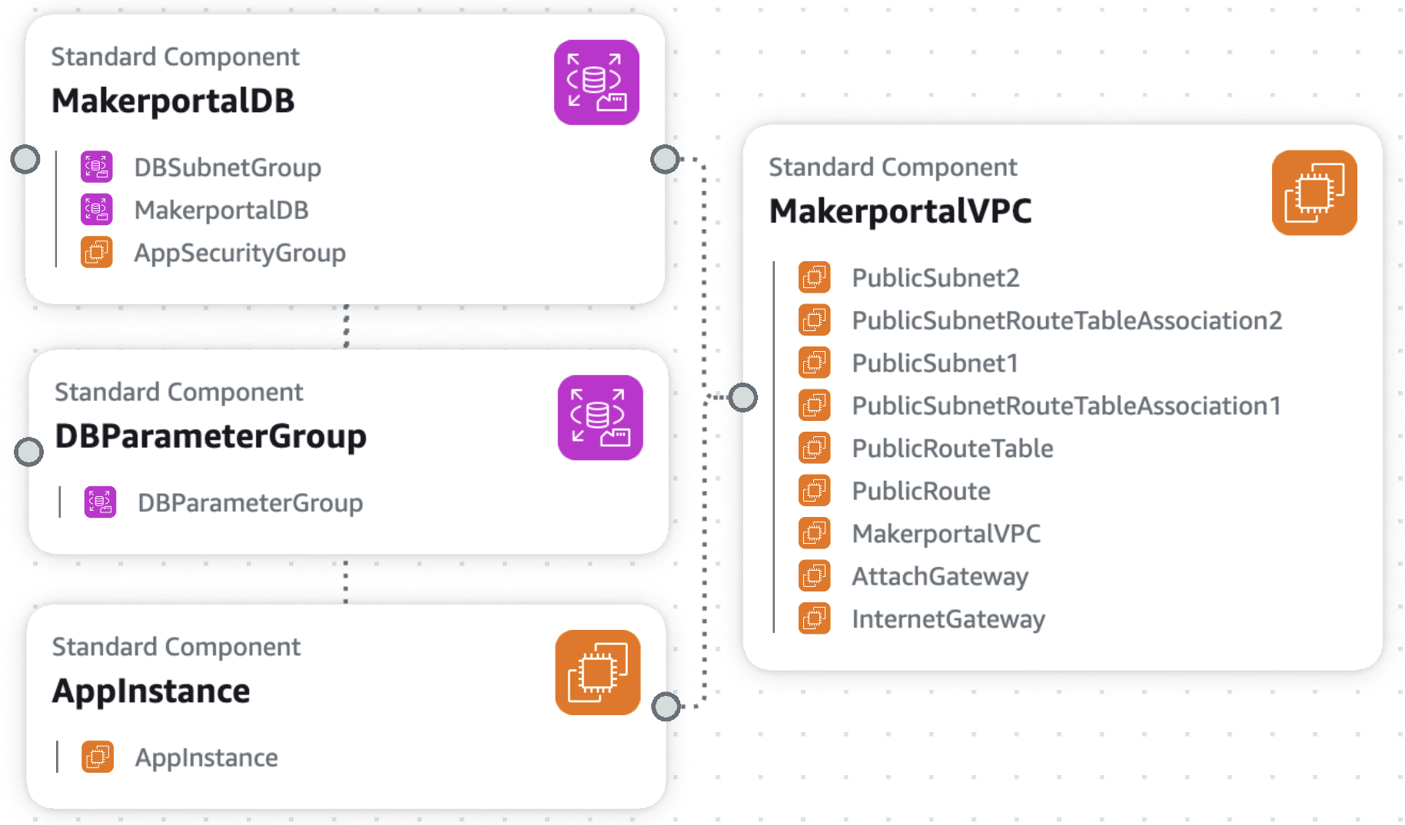

*Figure 4.1: AWS CloudFormation Stack Architecture*

The ESP32 firmware is flashed using standard tools, with a dedicated setup guide providing step-by-step instructions available in **Appendix E**. System configuration is handled through a configuration file (config.json) allowing customization of WiFi settings, database connection parameters, and operational modes dependent on available peripherals.

# **5: Performance**

Comprehensive testing validated the system's performance across multiple metrics gathered during integration, acceptance, and user testing:

### **5.1 Power Delivery Efficiency**

The power relay system demonstrated excellent performance with a measured RMS voltage of 125V, rise time (0V → 125V) of 560 μs, and fall time (125V → 0V) of 65 ms. This ensures near-instantaneous power delivery upon authorization while preventing harmful power surges during shutdown.

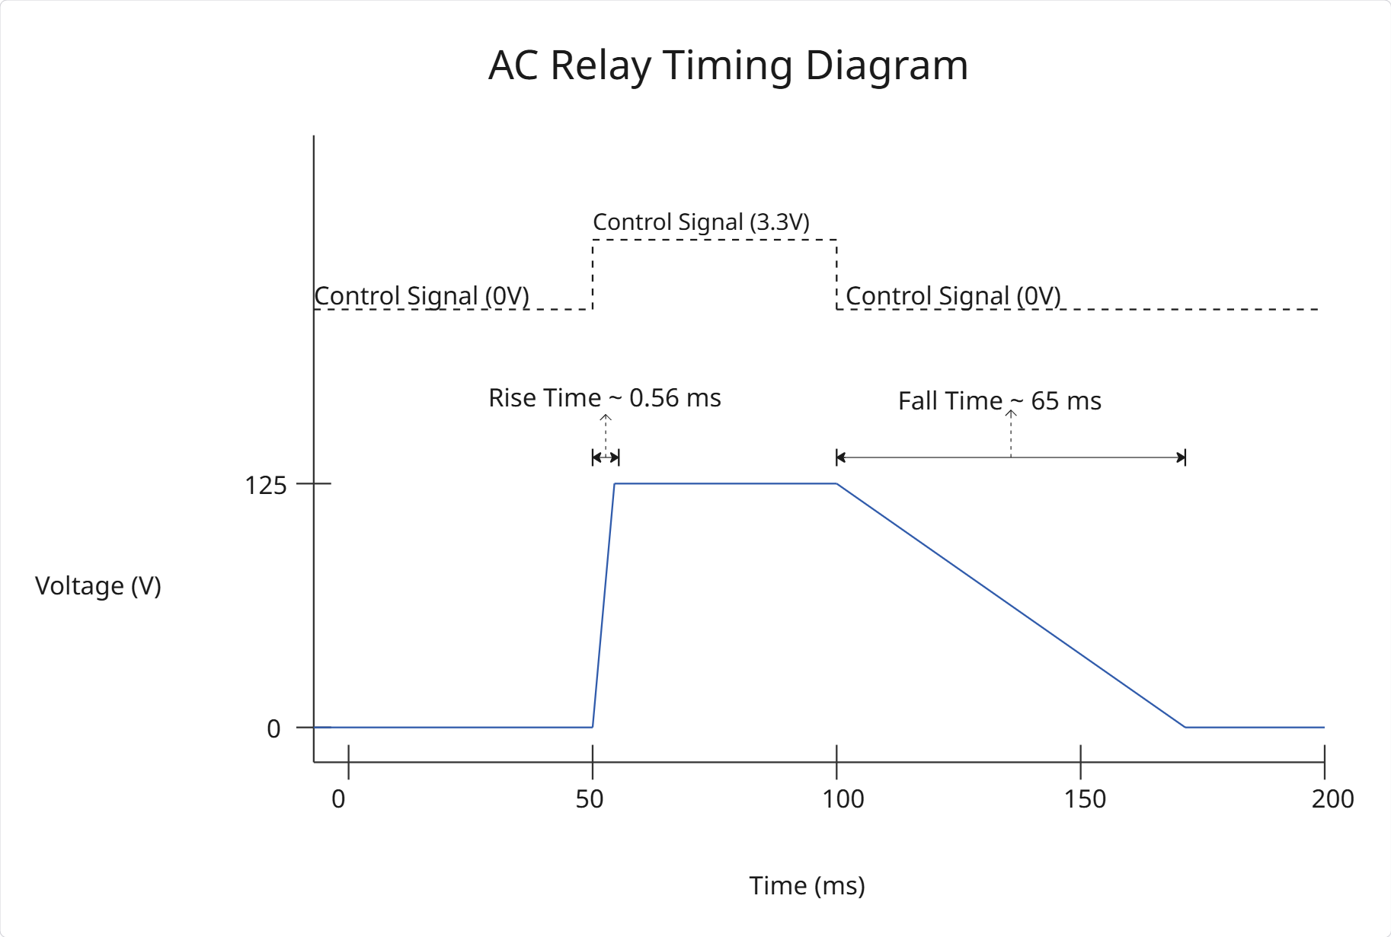

*Figure 5.1: Power Relay Timing Diagram*

### **5.2 Authentication Reliability**

Testing across 300 authorization attempts with authorized RFID cards demonstrated a 99% success rate, with failures only occurring when cards were placed beyond the optimal reading distance (>5cm).

### **5.3 Power Consumption**

The system achieved an average current draw of 315.5 mA and power consumption of 1577.5 mW, representing a 74% reduction from the Raspberry Pi-based system which typically drew over 1.2A.

### **5.4 Fault Recovery**

The system demonstrated robust recovery capabilities, maintaining proper state awareness even after unexpected power loss. Recovery times averaged 13-15 seconds for power loss and reset events, with immediate response to shutdown cards.

### **5.5 Endurance Testing**

Long-term operation was validated at both test sites with STEAM Innovation Labs logging 238 hours of continuous operation controlling a 3D printer and MakerE deployment powering a lamp for 110 hours. No failures or temperature increases were observed during these extended tests.

### **5.6 User Experience**

User feedback from both STEAM Innovation Labs and MakerE was overwhelmingly positive:

* Overall Satisfaction: 100% of STEAM users and 75% of MakerE technicians reported being "Very Satisfied"
* Interface Clarity: 100% of STEAM users reported receiving "Enough Information" from the interface
* Training Flow: 75% of MakerE technicians reported being "Very Satisfied" with the new training flow
* Security: 100% of users appreciated the PIN security feature despite finding it "cumbersome"

# **6: Standards**

Standards are a critical aspect of engineering design as they help establish reliability and safety across different systems. The Portal Box adheres to multiple standards for a quality design that is dependable for many applications. Adhering to these standards ensures our system functions as intended and is compatible with existing technologies. Below is a summary of the standards integrated into our work:

* HTTP (Hypertext Transfer Protocol) [CITE]
  + Standard Reference: HTTP/1.1 (RFC 7230–7235) and HTTP/2 (RFC 7540), maintained by the Internet Engineering Task Force (IETF)
  + Function: HTTP serves as the primary communication protocol for exchanging data between the Portal Box, its backend database, and the Makerportal. It enables API calls for retrieving user information and sending status updates, playing an important role in automating system control and database logging.
* USB-C (Universal Serial Bus Type-C) [CITE]
  + Standard Reference: USB Type-C Specification Revision 2.2 and USB Power Delivery (PD) 3.1, maintained by the USB Implementers Forum (USB-IF)
  + Function: USB-C is used for data transfer within the system. It allows high-speed communication between the Portal Box, control devices (like computers) and machines. USB-C allows for machine control when switching power is not an option.
* Power Connectors [CITE]
  + Standard Reference: IEC 60320 (appliance couplers) and NEMA 5-15 (standard U.S. power plugs), maintained by the IEC and National Electrical Manufacturers Association
  + Function: These standards ensure safe and consistent electrical connections for powering the Portal Box and the machines it controls. They define voltage and current specifications, helping to avoid electrical mismatches and ensure safe operation of machinery.
* 3D Printing [CITE]
  + Standard Reference: ISO/ASTM 52900:2021, maintained by ISO and ASTM International
  + Function: This standard provides the terminology and framework for manufacturing processes like 3D printing, which we use to fabricate the Portal Box’s enclosure. It ensures that printed components are dimensionally consistent and compatible across different printers.
* PCB Design (Printed Circuit Board) [CITE]
  + Standard Reference: IPC-2221 (Generic Standard on Printed Board Design) and IPC-7351 (Surface Mount Design and Land Pattern Standard)
  + Function: These IPC standards define the best practices for PCB layout, thermal performance, and component land patterns. By following them, we ensure that our PCB performs reliably and is manufacturable from vendors using standard industry techniques.
* MicroPython Programming [CITE]
  + Standard Reference: Python 3 Language Reference; PEP 8 (style guide) and PEP 257 (docstring conventions)
  + Function: MicroPython, based on Python 3, is used to program the ESP32 microcontroller in the Portal Box. Adhering to Python Enhancement Proposals (PEPs) helps maintain readable, portable, and consistent code, which is essential for long-term maintainability and collaboration.

Each of these standards plays an important role in the functionality of the Portal Box. When applied together, they form the technical foundation that ensures our system is safe.

# **7: Conclusion**

The Portal Box V4 project has successfully delivered a high technical-readiness-level solution that addresses the fundamental security-accessibility challenge in makerspaces. By transitioning to more cost-effective hardware while enhancing functionality, the team has created a system that is not only more capable than previous versions but also more accessible to a wider range of potential adopters.

The system has demonstrated excellent performance across all metrics. User feedback has been overwhelmingly positive, validating the design decisions and highlighting the value of new features like two-factor authentication and direct certification capabilities.

The successful deployment at STEAM Innovation Labs represents a significant milestone, proving the system's applicability beyond the university setting and establishing a pathway for broader adoption. The comprehensive documentation package and cloud deployment infrastructure further lower barriers to implementation, ensuring that the benefits created can be shared with the wider maker community.

The Portal Box V4 transforms the traditional trade-off between security and accessibility into a positive-sum relationship where both can be enhanced simultaneously. This fundamental breakthrough enables makerspaces to provide safe, welcoming environments that foster creativity and learning while maintaining appropriate access controls.

Through continued refinement and adoption, the Portal Box system has the potential to become a standard element in makerspaces worldwide, improving safety, accessibility, and operational efficiency for institutions of all sizes.

# 

# 

# 

# **8: Bibliography**

[1] “How MIT’s fab labs scaled around the world,” MIT News | Massachusetts Institute of Technology, Jun. 05, 2023. https://news.mit.edu/2023/how-mits-fab-labs-scaled-around-world-0605

[2] C. Cahoon and K. Furlong, “Interview: L&IT and Makerspaces,” Sep. 16, 2024.

[3] E. L. T. Davies, R. D. Morris, and A. S. Jariwala, “Trust as the Foundation for a Successful Balance of Power in a Student Run Academic Makerspace”.

[4] G. Rokavek, “Interview: Risk Management,” Sep. 27, 2024.

[5] M. Lamparter, “Interview: Maker-E,” Sep. 11, 2024.

[6] T. Derk, “STEAM Site Visit,” Nov. 15, 2024.

[7] J. Wayland, “Interview: QMUL Makerspace,” Sep. 12, 2024.

[8] R. Wetzel, “Penn State Makerspace Visit,” Sep. 19, 2024.

[9] J. Hale, “Interview: 2016 Portal Box,” Nov. 19, 2024.

[10] A. Sellers, “Interview: 2016 Portal Box,” Sep. 26, 2024.

[11] J. Hass, “Interview: Firmware Owner,” Oct. 22, 2024.

[12] B. Buentello, “Interview: V3 Portal Box,” Sep. 4, 2024.

[13] [J. Logas, R. Zhong, S. Almeida, and S. Das, “Tensions between Access and Control in Makerspaces,” Proc. ACM Hum.-Comput. Interact., vol. 4, no. CSCW3, pp. 1–33, Jan. 2021, doi: 10.1145/3432914.](https://www.zotero.org/google-docs/?9s8JSU)

[14] Z. Li, H. Qi, Z. Sun, C. Shi, and D. Zhu, “Research on an Open and Shared Maker Space and Curriculum System,” in *2024 47th MIPRO ICT and Electronics Convention (MIPRO)*, Opatija, Croatia: IEEE, May 2024, pp. 1234–1237. doi: [10.1109/MIPRO60963.2024.10569945](https://doi.org/10.1109/MIPRO60963.2024.10569945).

# 

# 

# 

# 

# 

# 

# **9: Appendices**

# **Appendix A: System Map**

The system map represents the relationships between interconnected components within makerspaces and spaces with access control elements. It highlights how elements relate to access and security for users, identifying reinforcing (R) and balancing (B) loops that are affected by Portal Box implementation.

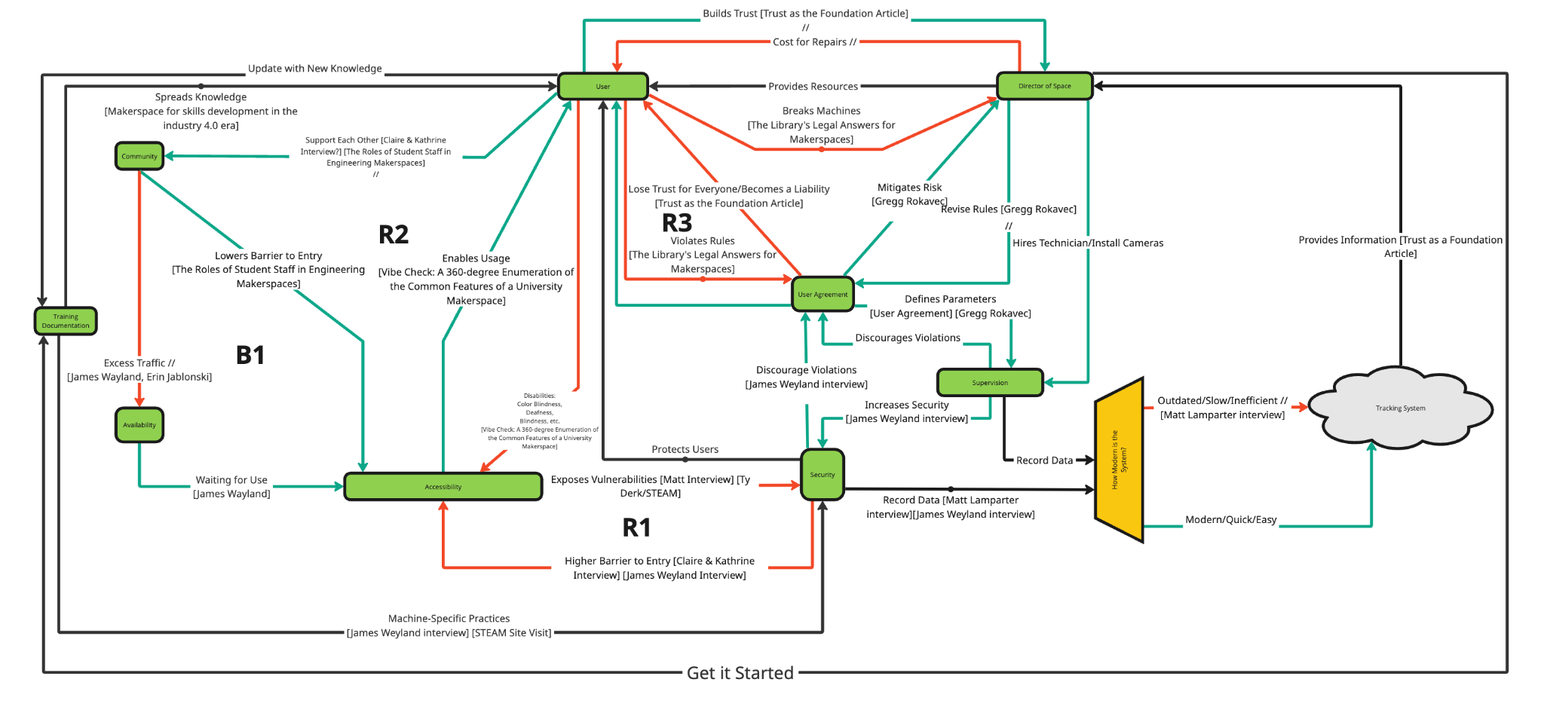

# **Appendix B: MakerPortal Setup Guide**

This guide explains how to set up the MakerPortal using the AWS CloudFormation template. This will build all the needed resources, and launch an instance of the web application. Alternatively, as explained in the guide, manual set up can also be done using the instructions on GitHub.

URL for Living Document: <https://docs.google.com/document/d/1Efe3J8czig7-NeUkT0MoV11OhivSSvs8YGzT39vNRik/edit?usp=sharing>

MakerPortal & Database Setup Guide

This guide explains how to quickly setup the MakerPortal and its associated infrastructure with no coding required. Estimated Time to Complete: 25m

Important Note: If you wish to create your own server configuration, simply clone this GitHub repository and proceed as you wish. The README file contains additional information about building the application and has recommendations for server configurations. For those with little experience configuring servers we recommend using our AWS CloudFormation to deploy with no coding required.

# Prerequisites

* [AWS Account](https://aws.amazon.com/free/?trk=7541ebd3-552d-4f98-9357-b542436aa66c&sc_channel=ps&ef_id=Cj0KCQjw2ZfABhDBARIsAHFTxGxivSgDphUWF8vx5aGTd5fjy6obd-xFdH9L3jV3CzatDrxzD8B4DykaAqUoEALw_wcB:G:s&s_kwcid=AL!4422!3!651751058790!e!!g!!aws%20account!19852662149!145019243897&gbraid=0AAAAADjHtp9GJl1OUwl6kWoOQA2WeCbht&gclid=Cj0KCQjw2ZfABhDBARIsAHFTxGxivSgDphUWF8vx5aGTd5fjy6obd-xFdH9L3jV3CzatDrxzD8B4DykaAqUoEALw_wcB&all-free-tier.sort-by=item.additionalFields.SortRank&all-free-tier.sort-order=asc&awsf.Free%20Tier%20Types=*all&awsf.Free%20Tier%20Categories=*all): Used to login to AWS Console and use CloudFormation.
* [Google OAuth Client ID](https://developers.google.com/identity/protocols/oauth2): Used for authentication with the MakerPortal.

# AWS CloudFormation MakerPortal

## CloudFormation Architecture

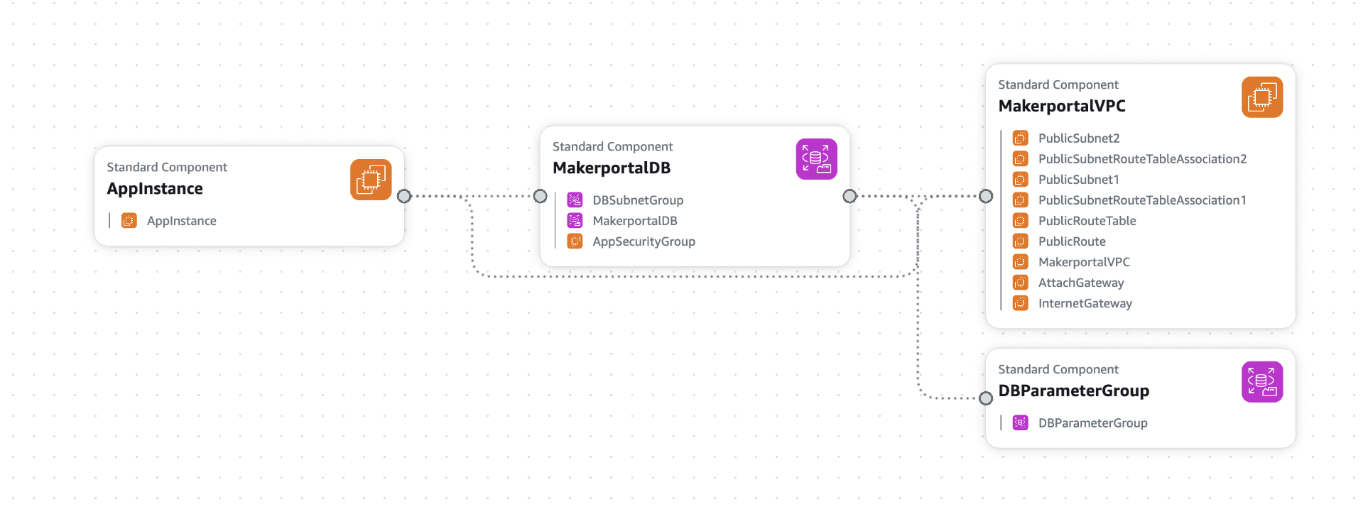

Figure 1: CloudFormation Stack Diagram

The MakerPortal system consists of a MySQL database which feeds data to the Portal Box and MakerPortal through an API. The MakerPortal and API are hosted in an AWS EC2 instance, while the database is hosted on AWS RDS. We’ve created a CloudFormation template which allows you to set up your own MakerPortal with no coding needed. The database lives in a subnet group which talks to the virtual private cloud hosting the web application. The following section will walk you through the process of building the system.

## Prerequisites for CloudFormation

* [AWS Account](https://aws.amazon.com/free/?trk=7541ebd3-552d-4f98-9357-b542436aa66c&sc_channel=ps&ef_id=Cj0KCQjw2ZfABhDBARIsAHFTxGxivSgDphUWF8vx5aGTd5fjy6obd-xFdH9L3jV3CzatDrxzD8B4DykaAqUoEALw_wcB:G:s&s_kwcid=AL!4422!3!651751058790!e!!g!!aws%20account!19852662149!145019243897&gbraid=0AAAAADjHtp9GJl1OUwl6kWoOQA2WeCbht&gclid=Cj0KCQjw2ZfABhDBARIsAHFTxGxivSgDphUWF8vx5aGTd5fjy6obd-xFdH9L3jV3CzatDrxzD8B4DykaAqUoEALw_wcB&all-free-tier.sort-by=item.additionalFields.SortRank&all-free-tier.sort-order=asc&awsf.Free%20Tier%20Types=*all&awsf.Free%20Tier%20Categories=*all): Used to login to AWS Console and use CloudFormation.
  + Task Duration: ~5 minutes
  + Notes: Requires credit card even for free tier usage. MakerPortal instances are unlikely to incur charges over $3-5 per month, and depending on usage will remain in the free tier.
* [Google OAuth Client ID](https://developers.google.com/identity/protocols/oauth2): Obtain an OAuth Client ID to enable the authentication for the web application.
  + Task Duration: ~3 minutes
  + Follow these steps to create the Client ID needed for the application:

1. Create or login to your Google account.
2. Visit the [Google Console](https://console.developers.google.com).
3. APIs & Services → Credentials → Create Credentials
4. Choose “Web Application” for the type.
5. Click “Create” and copy down your Client ID.
6. Enter a name for your credential set. This is all for now, but we will revisit this at the end to finish setting up the configuration.

## CloudFormation Deployment

1. Login to the AWS Console.
2. Make sure your region is set to us-east-2.
3. Search for “CloudFormation” and visit the service.
4. Click “Create Stack”
5. Download the makerportal-template.yaml file (full code in Appendix if unavailable - copy into a file and save).
6. “Choose an existing template” → “Upload a template file” → choose the file you just downloaded.
7. Fill in the parameters:
   1. **Stack name:** choose something descriptive for your deployment, will not impact anything externally.
   2. **AMIId:** automatically set to a public Amazon Machine Image for the server and app configuration.
   3. **AdminEmail:** your email address.
   4. **AdminName:** your name or nickname.
   5. **DBName:** what you want your database to be labeled as. Defaults to “makerportal”.
   6. **DBPassword:** password for the database, write it down somewhere in case you want to make manual modifications down the line.
   7. **DBUser:** name of administrator for the database. Defaults to “admin”.
   8. **KeyName:** name of keypair used to SSH into the server. You may need to create a keypair by visiting EC2 → Network & Security → Key Pairs → Create key pair
      1. Enter whatever name you like, choose RSA and .pem
   9. **OAuthClientID:** the Client ID from the credentials you made in the Google Console.
8. Click through to build. Once build is complete, check for the needed database parameters and update your config.json file before uploading to the ESP32.

## Adding URIs to Google Console (< 2 minutes)

1. Return to Google Console → APIs & Services → Credentials → Your Client ID
2. Add your public EC2 endpoint as an Authorized JavaScript Origin. It should look like the following example:
   1. <http://ec2-instance-ip.region.compute.amazonaws.com>
3. Add three variants of your public EC2 endpoint as Authorized Redirect URIs. They should look like the following examples:
   1. <http://ec2-instance-ip.region.compute.amazonaws.com>
   2. <http://ec2-instance-ip.region.compute.amazonaws.com/>
   3. <http://ec2-instance-ip.region.compute.amazonaws.com/api/login.php>

# **Appendix C: Portal Box PCB Guide**

This guide explains the changes in the new PCB, and how to order it using the Gerber files and JLCPCB (other manufacturers should also work). It also covers soldering the components and places to be particularly careful.

URL to Living Document: <https://docs.google.com/document/d/1vIeOuQA8OipZnVniSEMwQbaalhNu06y5QjatpJUF6Iw/edit?usp=sharing>

Portal Box Printed Circuit Board

## Device Specifications

The Printed Circuit Board (PCB) of the Portal Box is where all of the hardware and connections, excluding peripherals, are housed and organized. All of the machine power and/or data is routed through the PCB where relays are used to manipulate the functionality of machines based on access conditions. Device logic is controlled centrally by the software housed on the box microcontroller (ESP32). Additionally, many of the peripherals such as the LEDs and Buzzer are soldered directly to the PCB. Finally, various headers are also placed throughout the board where peripheral components interface with the board itself. Version 4 of the Portal Box builds on the previous work of older Portal Box iterations, modifying the design to accommodate the microcontroller and user interface changes characteristic of the newest design. This [DigiKey BOM](https://www.digikey.com/en/mylists/list/NODQQK4VBZ) contains all components that go on the board.

## Changes to the Version 4 Portal Box

### 3.11 Board

A majority of the structure and form of the version 4 Portal Boxes is based on the 3.11 revision of the Portal Box. Developed in 2021, the rev 3.11 already includes many changes and progressions from the rev 2.0 Portal Boxes which are presently deployed in Bucknell’s Maker-E and Mooney Makerspaces, as such, much of our user feedback and research was based on the rev 2.0. Rev 3.11 is built in the Altium software, however, this will be changed in the rev 4.0. While the general layout and design of the 3.11 PCB is preserved for the 4.0, various systems are excluded and certain components have become obsolete, warranting additional changes for the next revision of the Portal Box.

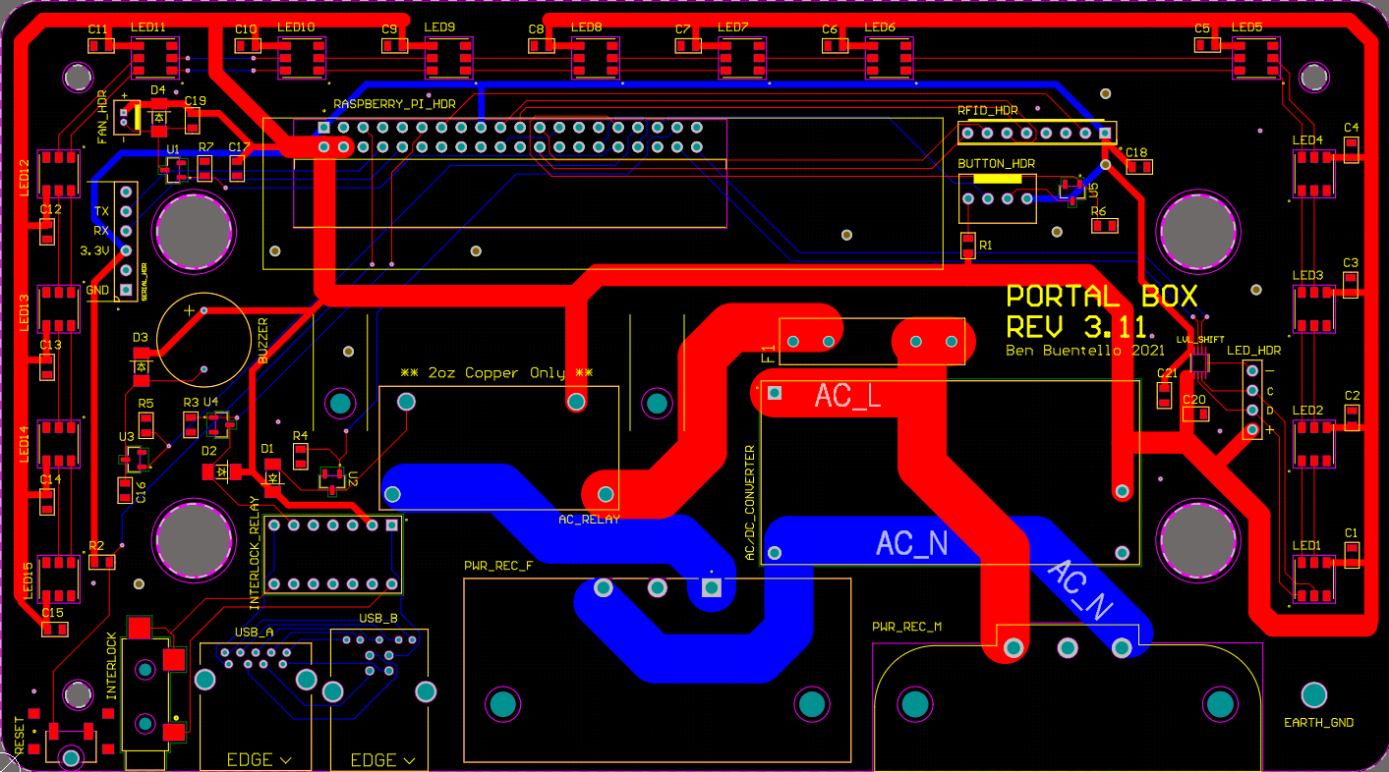

Fig 1: Rev 3.11 PCB Rendering

### 4.0 Revisions

The 4.0 version constitutes the most major changes to the system’s hardware and CAD software thus far. The most notable switch is the moving of the Portal Box schematic and PCB to KiCad, an open sourced software. Much of the structure and layout of the board from the 3.11 version has been maintained. The Raspberry Pi has instead been replaced with an ESP32. Additionally, certain systems and/or headers have been determined to be extraneous and were removed from the board including the button header, serial header, fan header, and interlock jack. The power relay and fuse from the 3.11 version are now categorized as obsolete components and have been replaced with parts equivalent in function. The USB relay has been updated to cut the Data + and Data - lines between the USB ports instead of power, however, that system is erroneously wired in the 4.0 version. All unassigned GPIO pins have been routed to 2 6-pin headers to be accessed for testing and development.

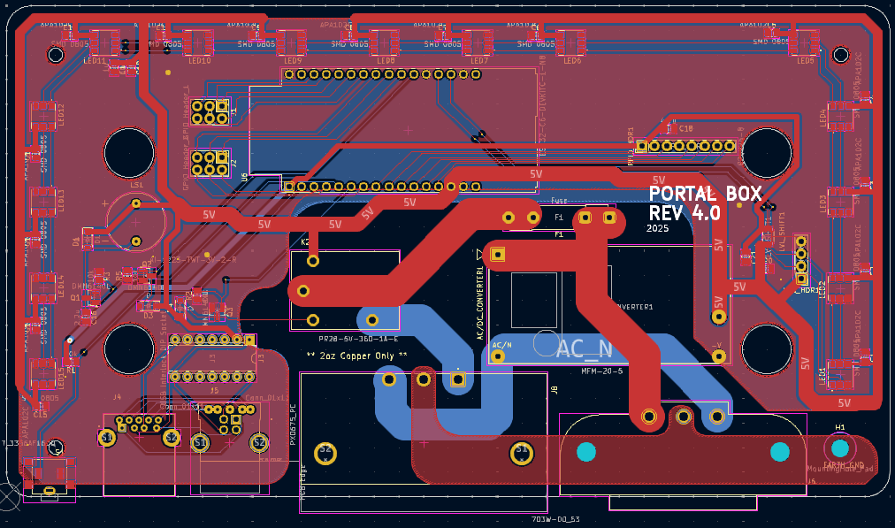

Fig 2: Rev 4.0 PCB Rendering

### 4.1 Revisions

The 4.1 version represents some design and configuration changes that improve upon the 4.0 revision. Most notably, the Neopixels that make up the lighting display within the box have instead been replaced with Dotstars. The USB B port for the USB interlock system has been replaced with a USB C port for future compatibility with a more widespread standard. However, this relay system is still wired erroneously on this version. Finally, two new headers have been introduced, the matrix keypad header and the SPI header for communication with the LCD screen. The GPIO pin header persists but is instead a single 4 pin header.

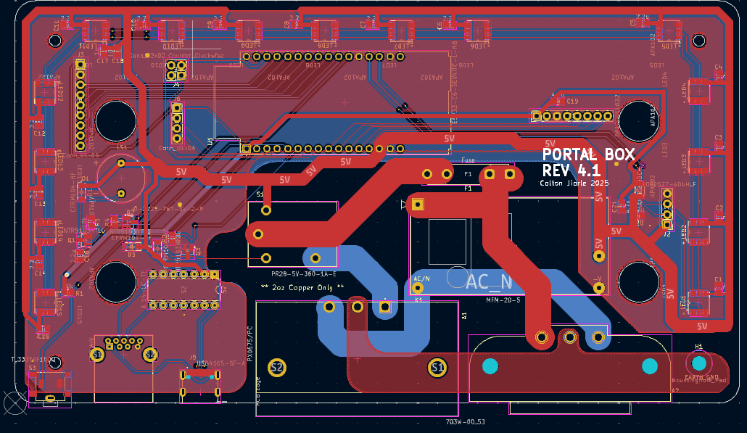

Fig 3: Rev 4.1 PCB Rendering

### 4.2 Revisions

The 4.2 revision to the Portal Box PCB includes minor improvements and fixes. The pins which control the data and clock lines for the LEDs have been switched to prevent issues with accidentally calling the boot file. An additional LED has been added to the board to fill in the gap where previously the cardholder and button would have blocked. Minor configurations have been made of the matrix keypad and SPI headers. Additionally, a new header for the optional button variant has been added. The GPIO pin header now includes a 3.3 V and GND connection. Revisions have been made to the USB relay for the proper wiring configuration. Additionally, the USB C pin wirings have been adjusted to add redundancy to the signal leaving the port.

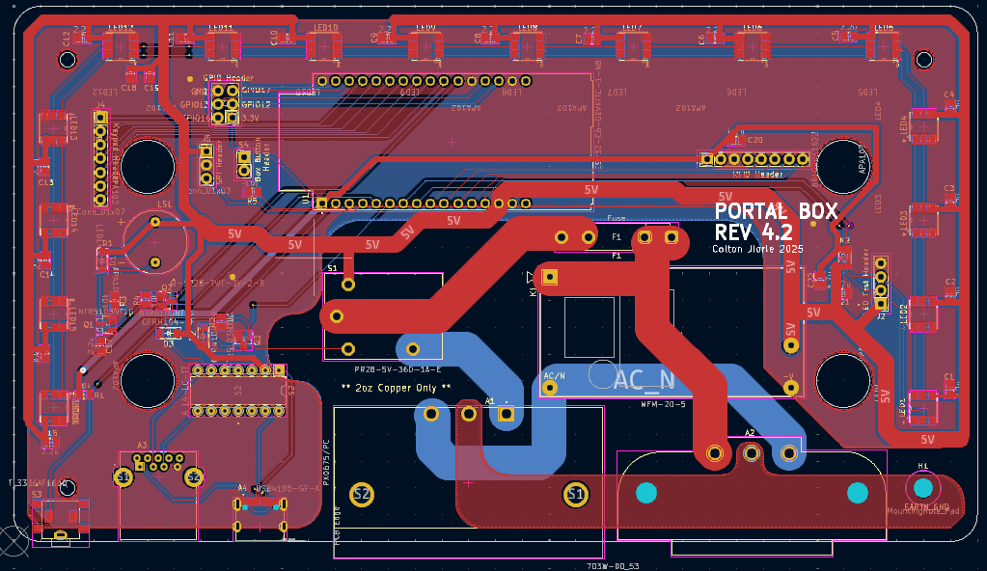

Fig 4: Rev 4.2 PCB Rendering

## PCB Ordering Guide

This guide is for ordering a PCB from JLCPCB. If you wish to make modifications from the original design, begin at step 1 for ordering. If you plan to order the Portal Box as designed, skip to step 5.

Step 1: Open KiCad Files

* First, open the Portal Box 4.2 files in KiCad (.kicad_pro, .kicad_sch, .kicad_pcb)
* If you wish to make any changes to the files, they can be adjusted in this window
  + Reference the KiCad Documentation Manual for help learning the software: https://docs.kicad.org/

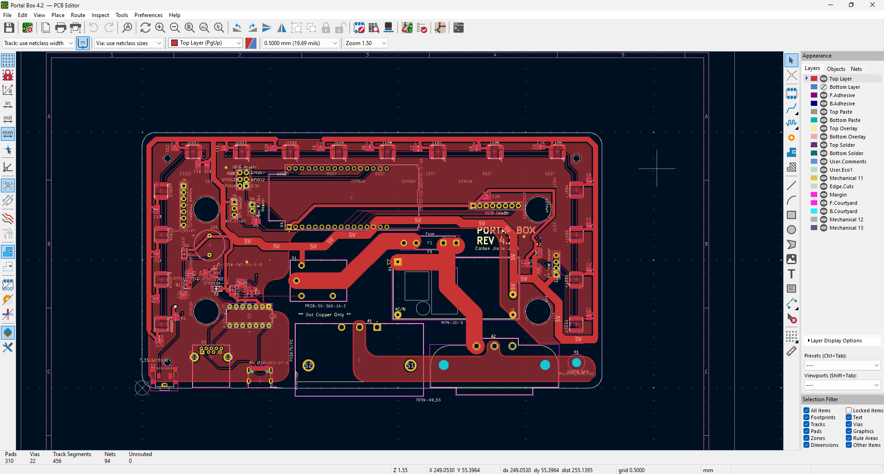

Step 2: Navigate to the gerbers output page

* Use File > Fabrication Outputs > Gerbers (.gbr)

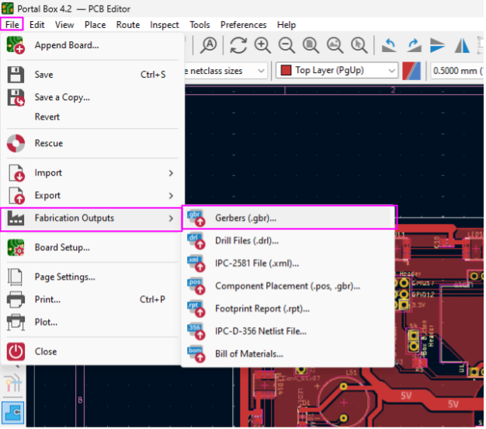

Step 2: Plot Gerber Files

* First, you should have a file set up in your computer’s file system where you will be exporting the gerber files to
* Second, you will navigate to the output directory and select that file as the output for the gerber files
* Third, on the included layers column, select the following materials:
  + Top Layer, Bottom Layer, Top Paste, Top Overlay, Bottom Overlay, Top Solder, Bottom Solder, Edge.Cuts
* Finally, select “Plot”

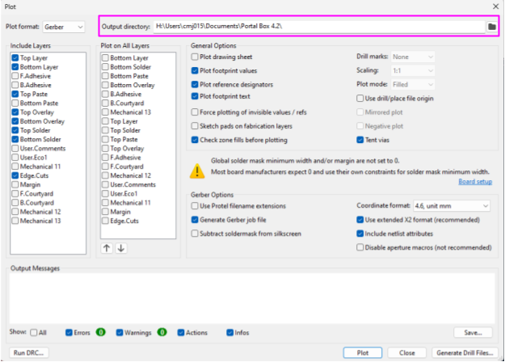

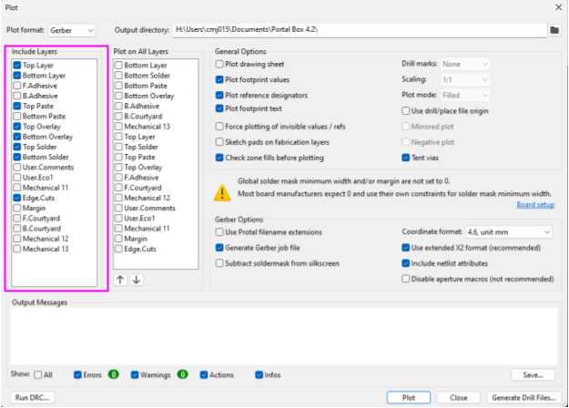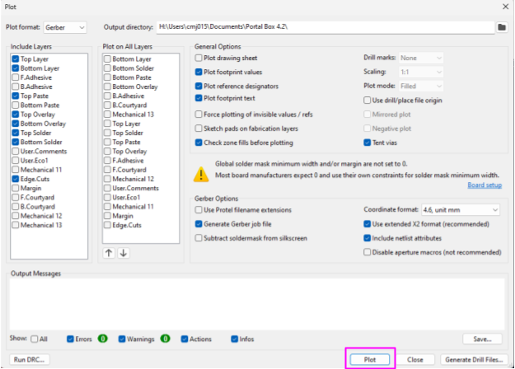

Step 3: Plot Drill Files

* On the same menu as the gerber outputs, select “Generate Drill Files..” in the bottom right corner
* Next, ensure the output folder is the same as where you copied your gerber files to
* Finally, select “Generate Drill File”

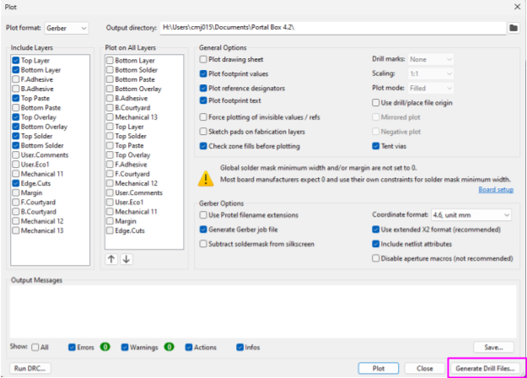

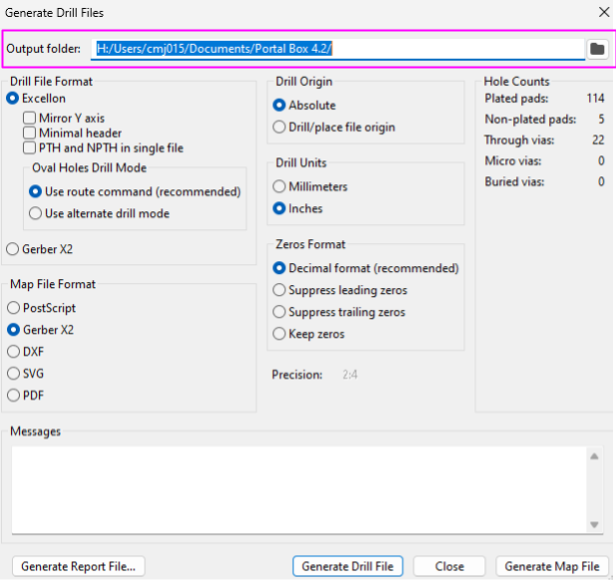

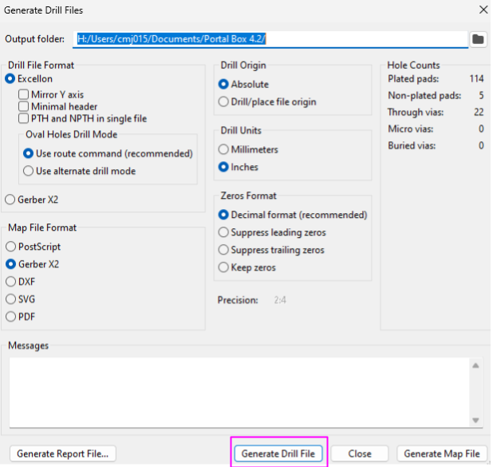

Step 4: Create Zip File

* Navigate to the folder you chose to export your files to and ensure all of the contents are there (8 .grb, 1 .gbrjob, 2 .drl)
* Select the options to compress this folder into a .zip file

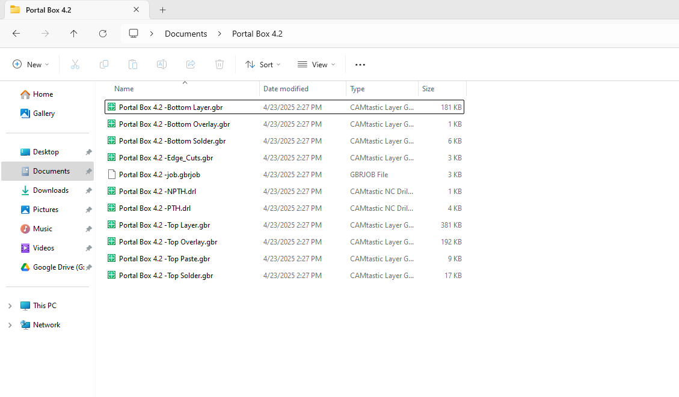

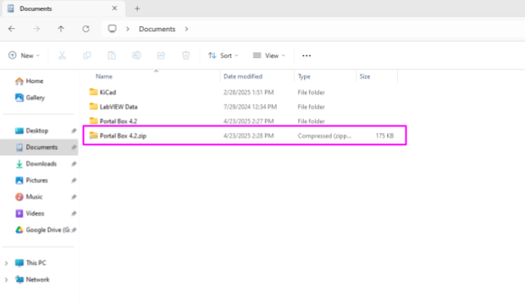

Step 5: Order From JLCPCB

* Navigate to jlcpcb.com/ and select the option to get an instant quote
* Upload the zip file you created to “Add gerber file”
* Select 2 for the “Layers” category
* ***Ensure that you select “2 oz” for Outer Copper Weight***
  + 2 oz copper is necessary for handling the Portal Box’s intended capacity of 15 A
* Finally, select the option to also order a stencil for pasting on your pcb

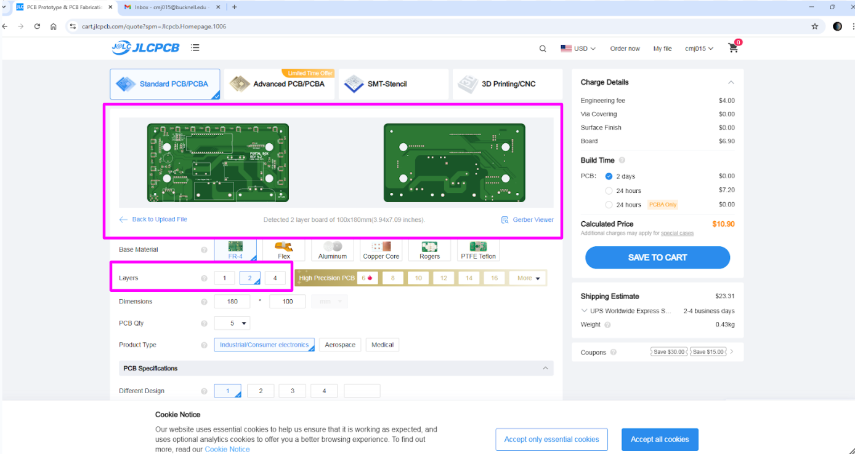

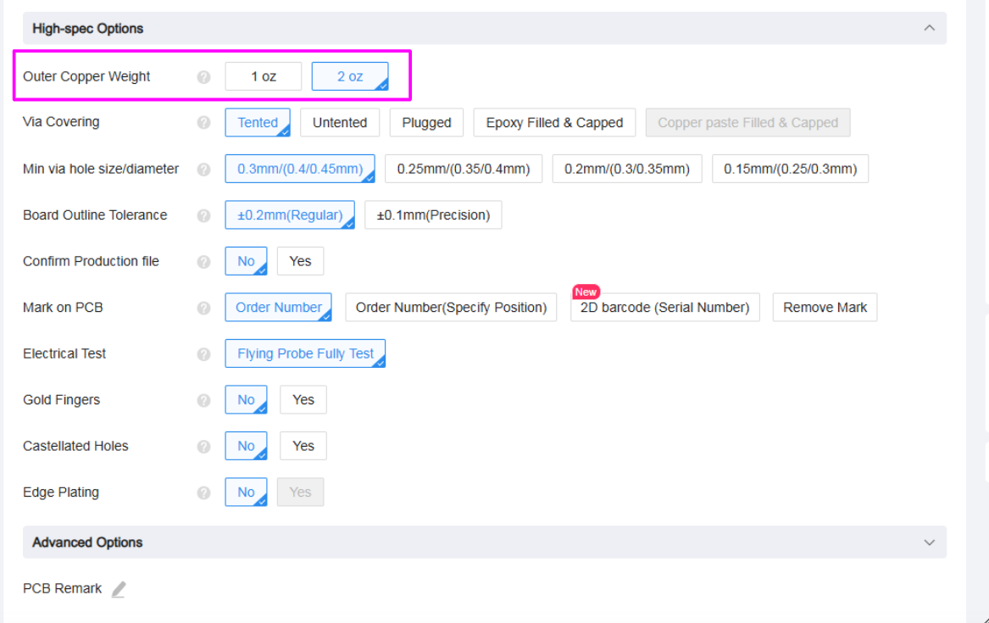

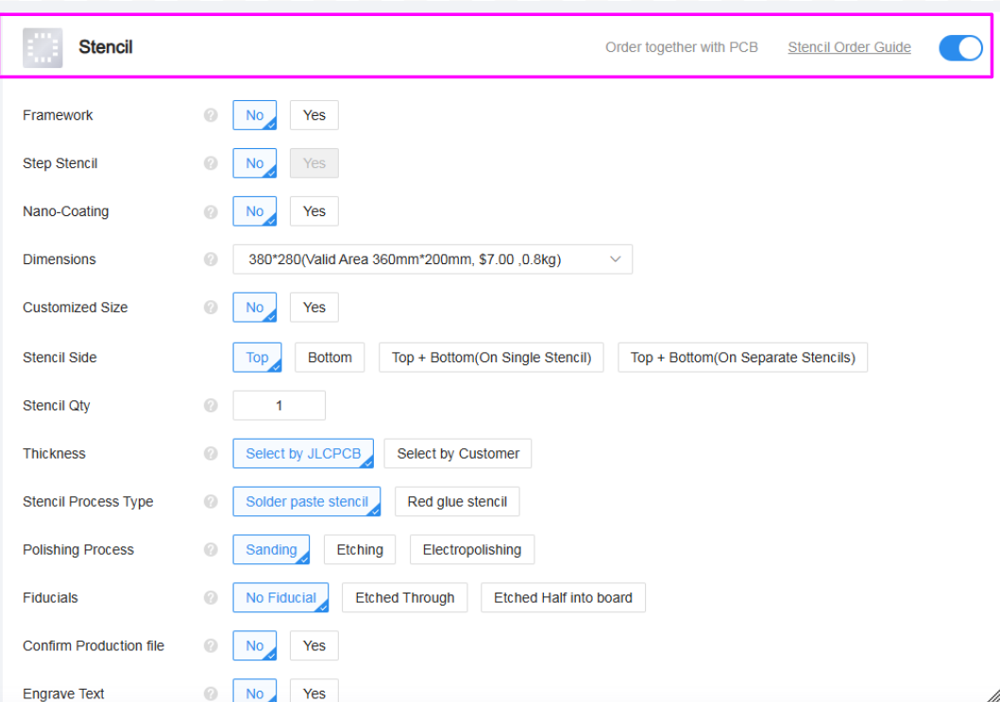

Step 6: Place PCB Order

* Review your order to ensure all options were selected correctly
* Select “Save to Cart” and follow JLCPCB’s instructions for completing your order

## PCB Soldering Guide

Step 1: Collect all components together

* Before beginning the soldering process, ensure that you have all the [necessary components](https://www.digikey.com/en/mylists/list/NODQQK4VBZ)
* A complete list of device components can be found in the Portal Box Bill of Materials
* It is helpful at this stage to separate the through-hole components from the surface mount components

Step 2: Surface Mount Components

* Use the stencil to distribute solder paste to the pad mounts
* Components can be placed onto the PCB by matching the component reference number in the Bill of Materials with the corresponding number on the PCB itself
  + Take special caution when placing the USB C port and Level Shift, these components have the smallest pins on the board and are the most likely to be misaligned, causing connectivity issues
  + The side of the diode footprint that have a closed line indicates the location of the cathode, the anode of the diode should be oriented towards the opening in the box
* Use a reflow oven to melt the solder and fuse the components to the board

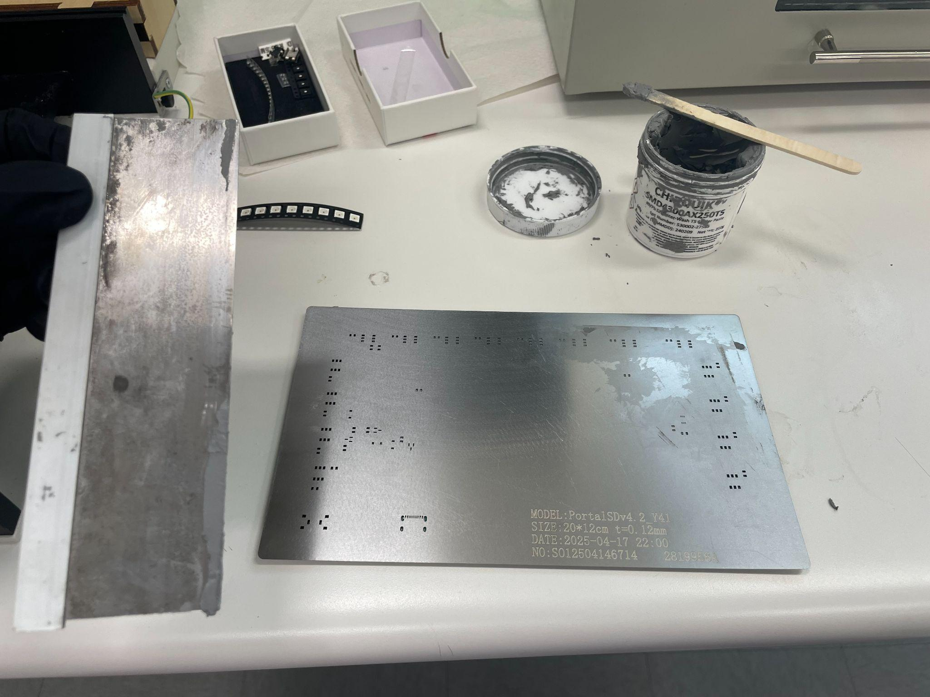

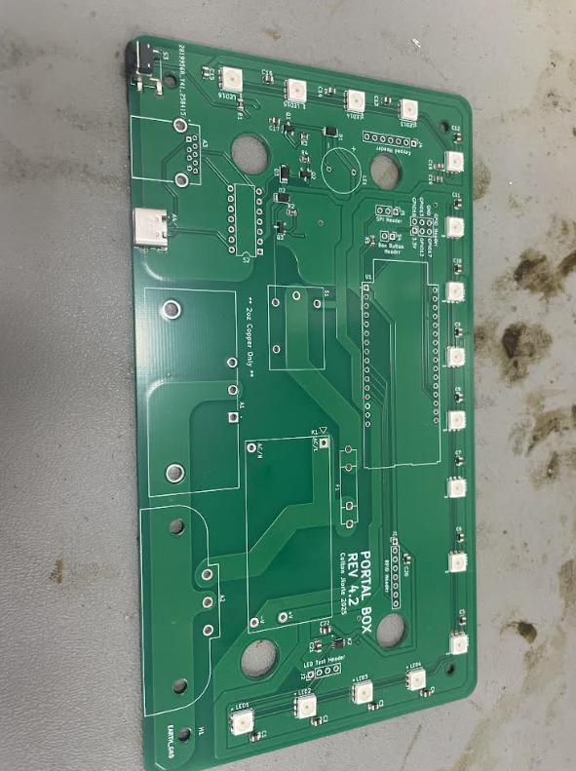

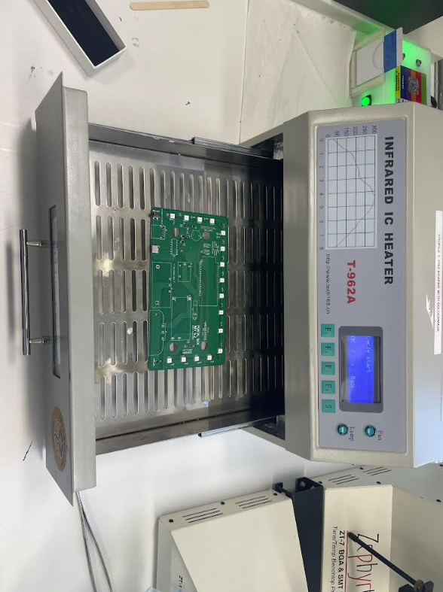

Step 3: Through Hole Components

* Use a soldering iron and wire to solder the remaining components to the board
* Note that the ground pins and AC power connections may take longer to solder due to the large planes providing heat dissipation

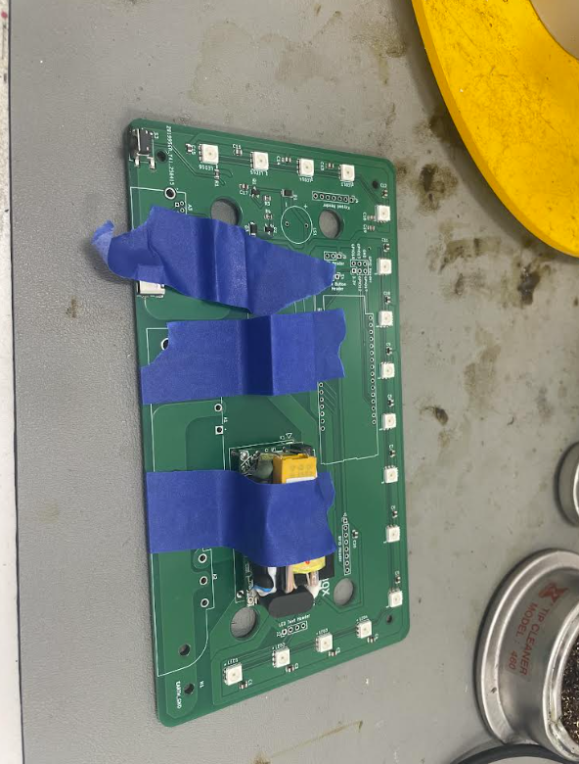

Step 4: Visual Inspection

* Perform a visual inspection of all solder joints to ensure connectivity

# **Appendix D: Portal Box Enclosure Guide**

This guide covers how to print the enclosure for the Portal Box, and explains the different options for the top panel (dependent on peripherals).

URL to Living Document: <https://docs.google.com/document/d/1yZIqGpXh8KTeaR3B30hVFT3VOugDRlXyn8OK4IrToo0/edit?usp=sharing>

Portal Box Enclosure Guide

# Materials/Prerequisites

* At least 3400in 1.75mm diameter PLA 3D printer filament
* 3D Printer:
  + We used PrusaSlicer 2.8.0 software
  + This example was created on an Original PrusaXL printer with a 0.4mm nozzle
* Soldering iron (370º C)
* 8x 4-40 0.135in Brass Heat Set Inserts
* PrusaSlicer software, available for free [here](https://prusaslicer.net/)

# Design Options

The bottom of the box is standard for all configurations.

## [Bottom Of Enclosure:](https://drive.google.com/file/d/1V_AeusbCwUD0dHSmgCmc1y88UvvvcG6f/view?usp=drive_link)

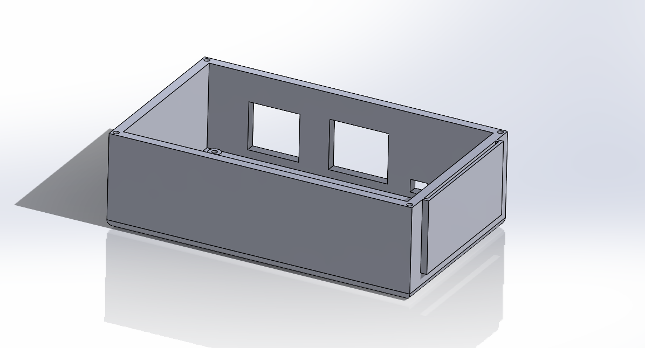

Figure 1: Enclosure

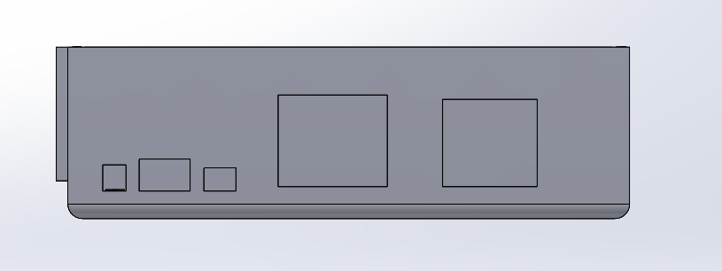

Figure 2: Enclosure rear view

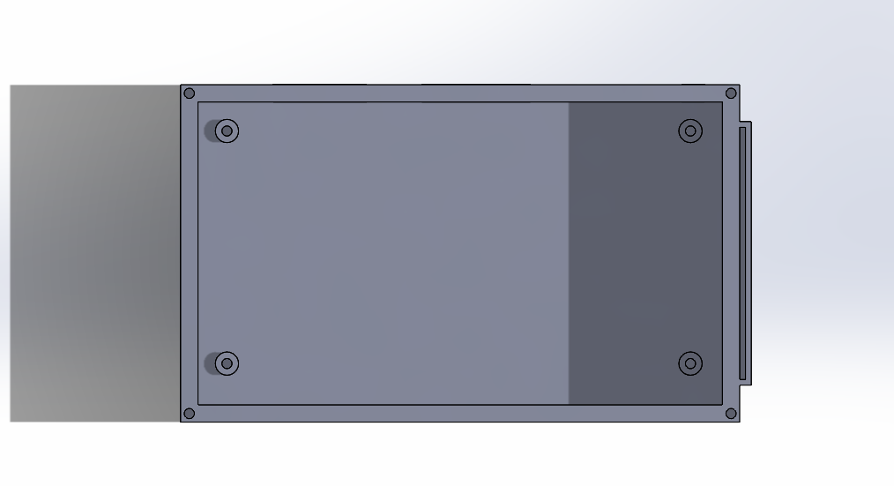

Figure 3: Enclosure top view

## [Lid Option 1: Keypad + LCD:](https://drive.google.com/file/d/1e46EqoP3oJepmiwFb82J7MjQj0g0bSy0/view?usp=drive_link)

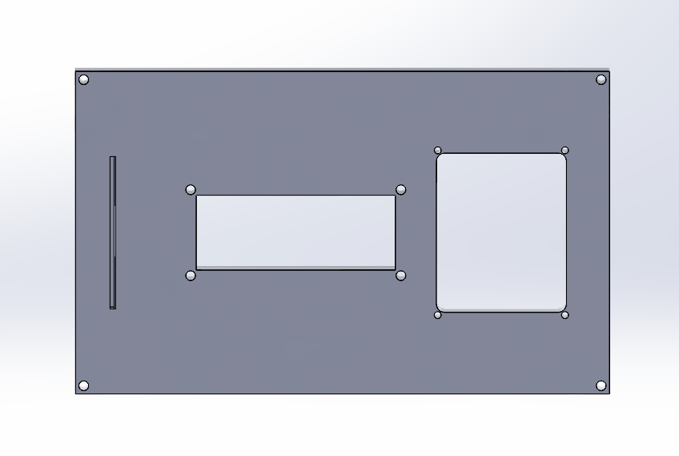

Figure 4: Lid keypad + LCD top view

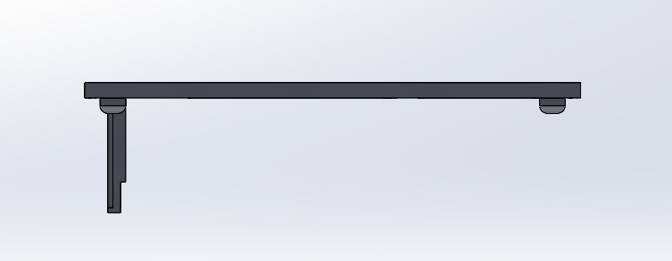

Figure 5 Lid side view

## 

## 

## 

## 

## [Lid Option 2: Button + LCD](https://drive.google.com/file/d/1RKXyrJLL7KUnwls2bY4AAVVnLYSylA5c/view?usp=drive_link)

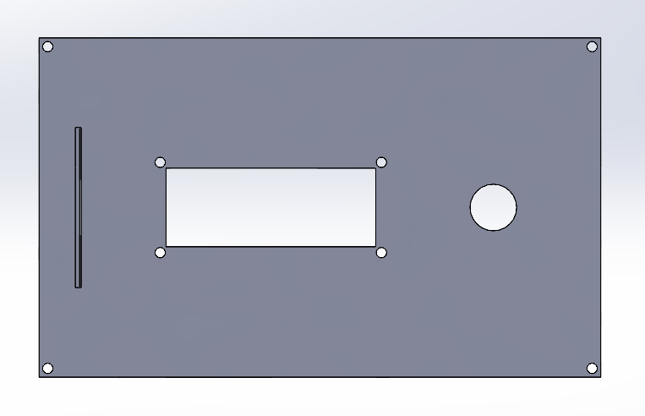

Figure 6: Lid LCD + button top view

## [Lid Option 3: Button](https://drive.google.com/file/d/1Td1Yyop_XnEjtsBR-ceI-rRVC6HV9OCx/view?usp=drive_link)

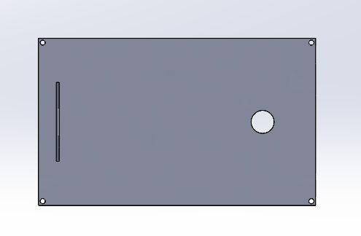

Figure 7: Lid button top view

# Printing Instructions

* Notable printer settings: this example was printed on recommended defaults set up by PrusaSlicer software for the Original PrusaXL (prints have also been accomplished with same settings on a MakerGear M2 printer, should print fine on default settings)
  + Infill: 15%
  + Supports required, recommended “Snug” supports in PrusaSlicer software
    - Overhang threshold: 65
  + Speed
    - Perimeters: 50mm/s
    - Small perimeters: 25 mm/s
    - External perimeters
  + Temperature: 290 degrees C

Enclosure Assembly

1. Remove support material from the printed enclosure. The use of a small hobby knife/tool may be required to remove the smaller supports for the rear ports as well as the supports for the card holder.
2. Place the non-threaded (circled) end of the brass inserts into the four standoff holes as well as the four holes on top of the box, as shown.

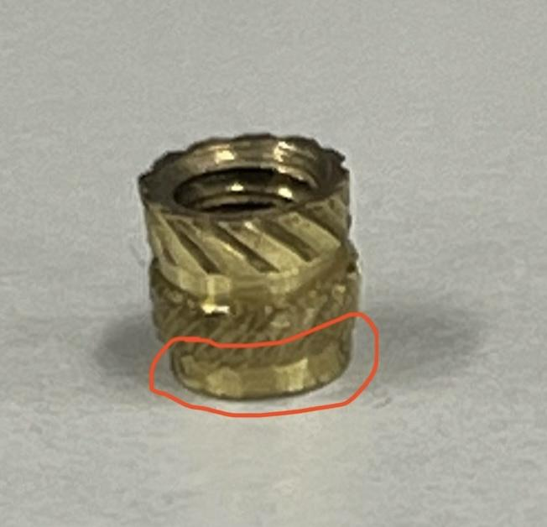

1. Place the tip of the soldering iron onto the brass insert as shown. Slowly and carefully push the insert down with the iron until it has melted into the hole. Be careful not to push too far to prevent molten plastic from getting inside the thread.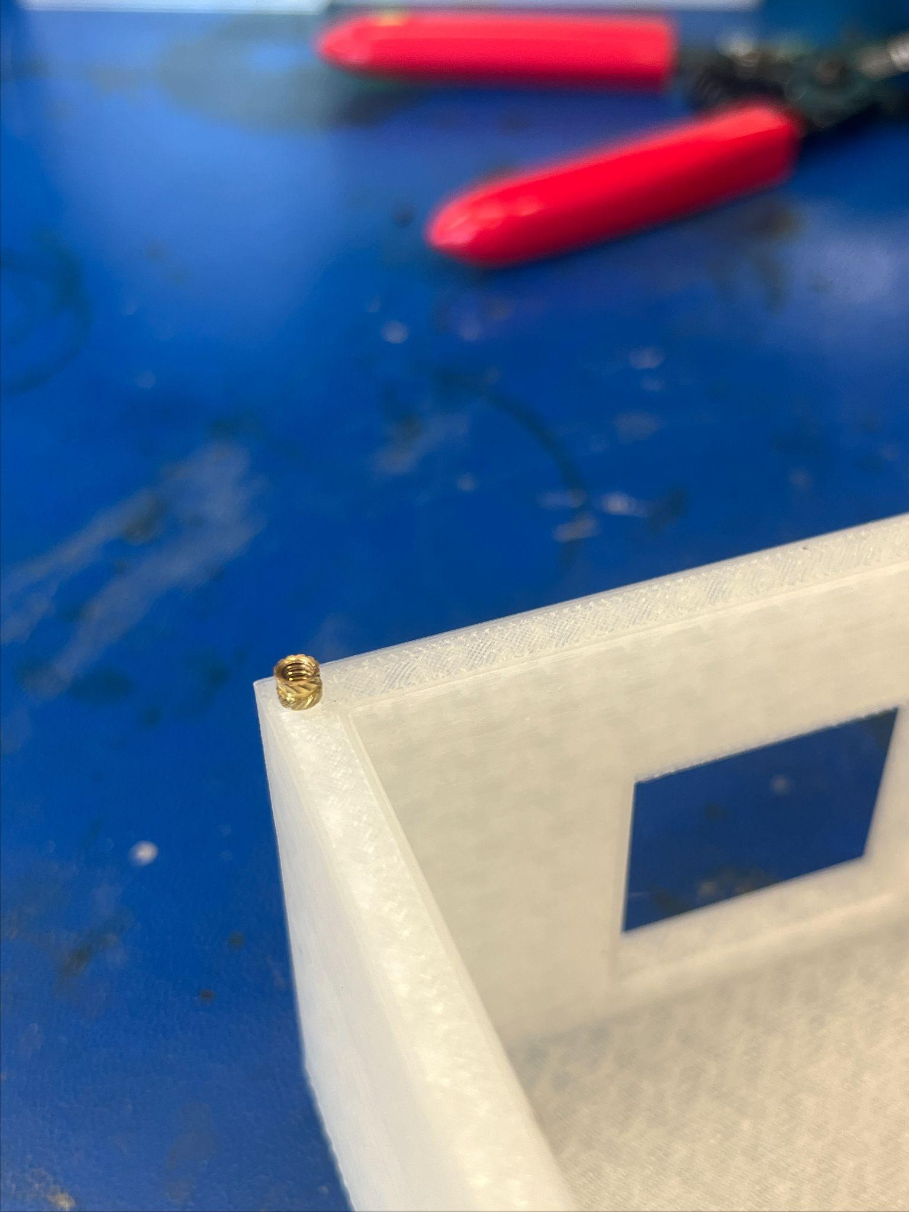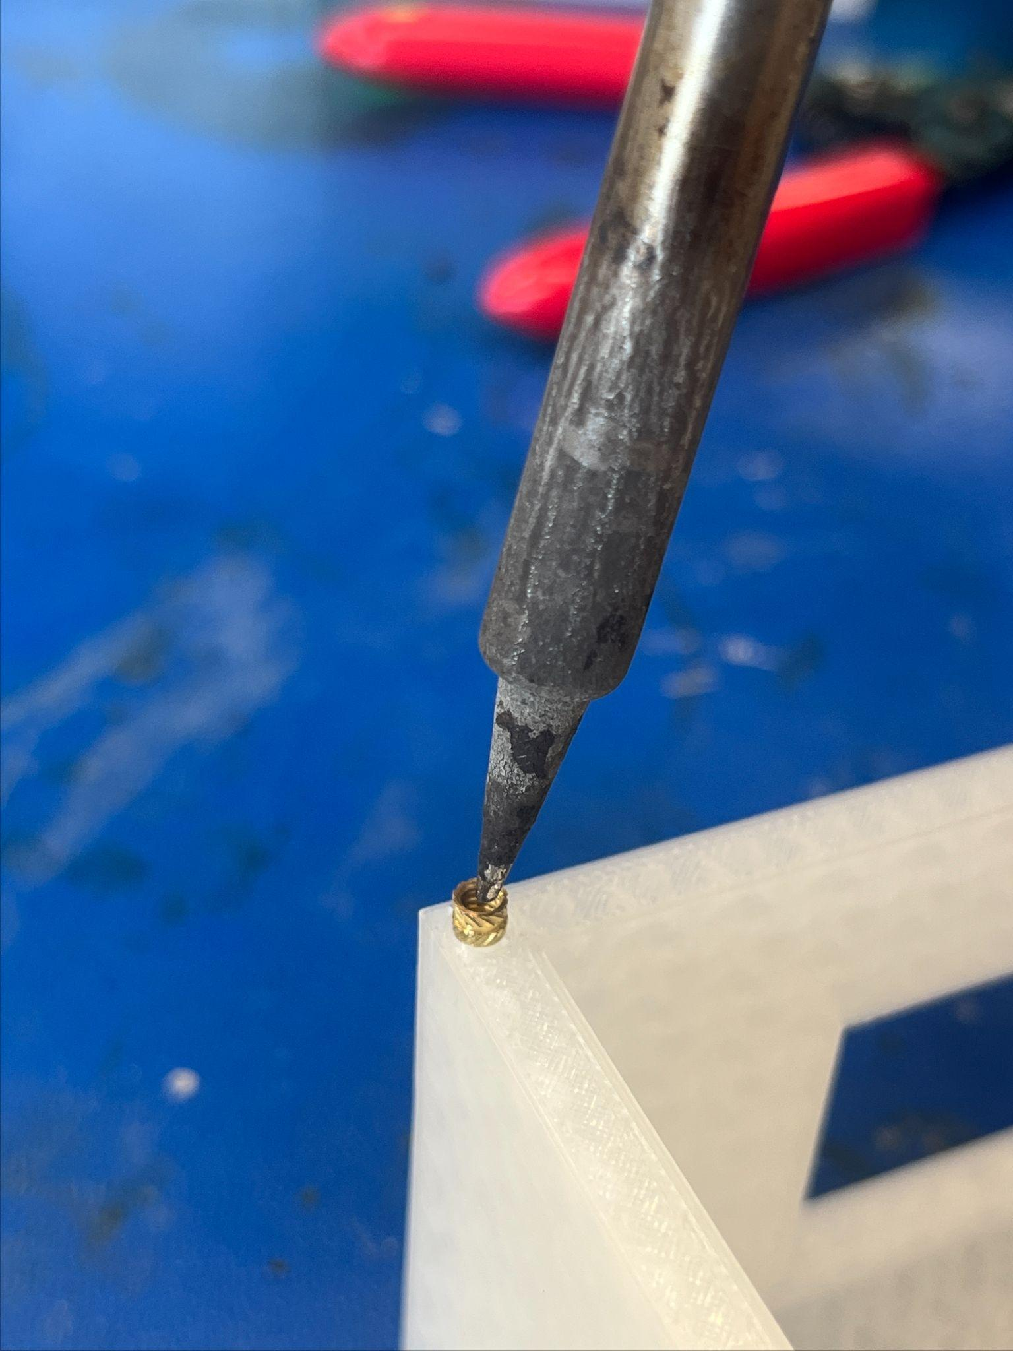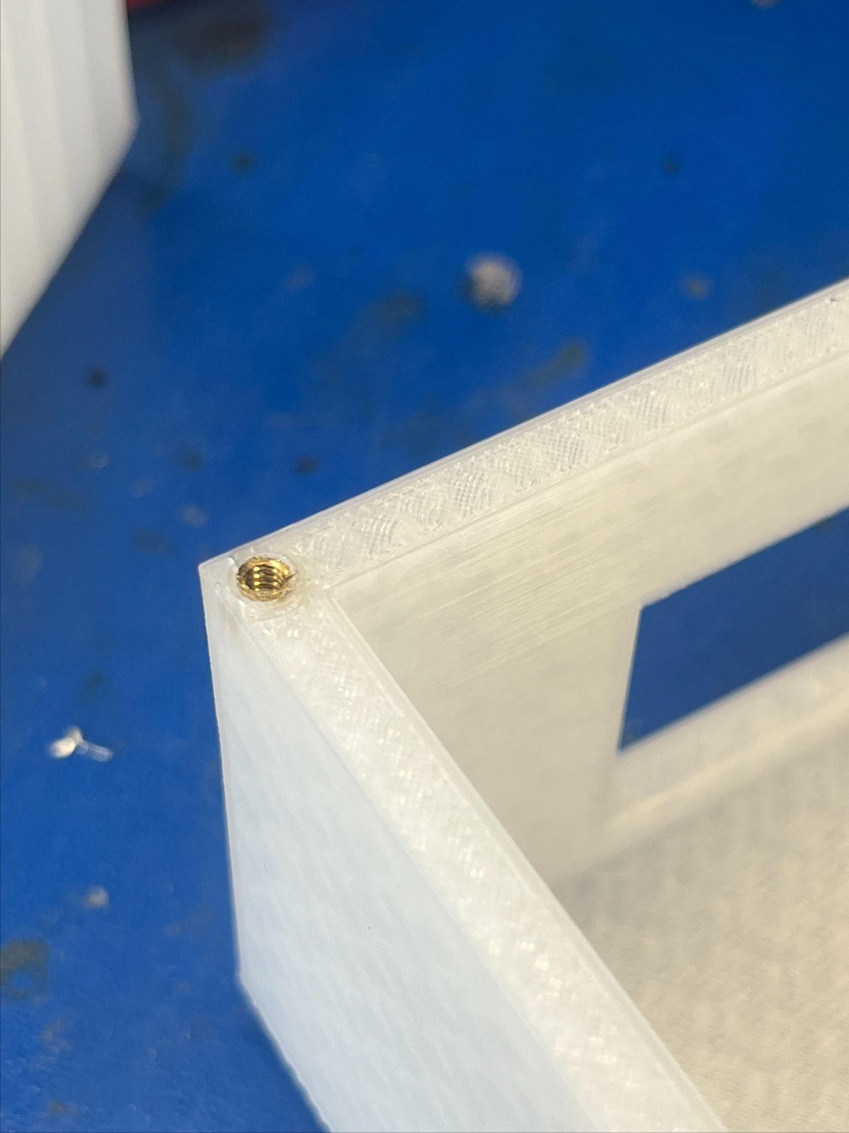
2. Wait ~3 minutes for the brass inserts and the standoffs to cool. Place PCB on standoffs to confirm correct placement of brass inserts. Use the soldering iron to adjust brass insert as necessary. Repeat steps 3-4 until all four standoffs and all four corners are set up.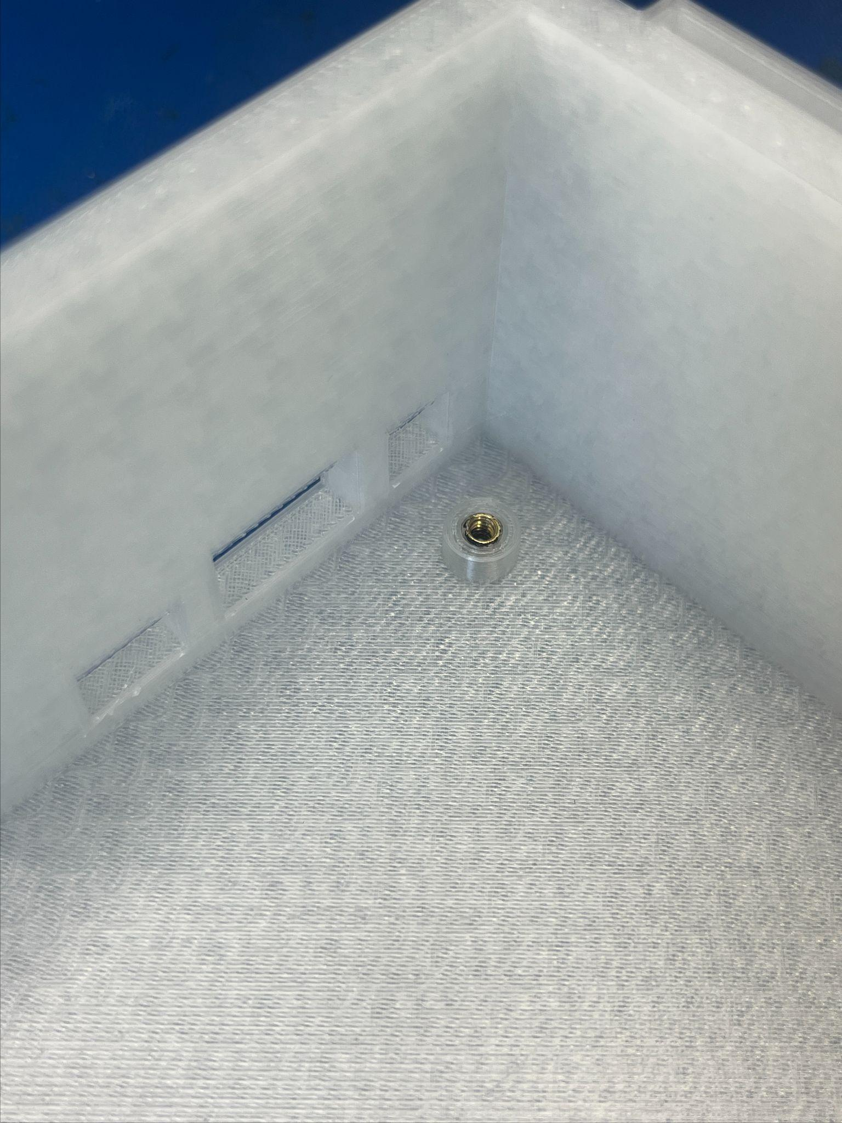

# **Appendix E: Portal Box Microcontroller Guide**

This guide explains how to start using the ESP32, download our software, and put it on the microcontroller. It also covers how to use the “config.json” file to get the box set up for a specific internet/database connection and configure the peripherals.

URL to Living Document: <https://docs.google.com/document/d/1g384_tL9M6RhhY-4YpHSNVq1-W_CzYQTKuRvIzMxAE0/edit?usp=sharing>

**Portal Box ESP32 Guide**

# Device Specifications

# 

Figure 1: [ESP32-C6-DevKitC-1 v1.1](https://docs.espressif.com/projects/esp-dev-kits/en/latest/esp32c6/esp32-c6-devkitc-1/user_guide_v1.1.html)

In the previous version of the Portal Box, a Raspberry Pi Zero was used, however, the Raspberry Pi was expensive and had much more processing power than what was required to operate the function of the Portal Box. We have decided that an ESP32-C6 would be the better option because it was 1/10 of the cost of the Raspberry Pi while also being more than capable enough to run the software. Currently, we have transitioned from CircuitPython to MicroPython due to the lack of tools which enable CircuitPython to be coded onto the C6. The C6 has a built-in Wifi Module as well as two ports for UART and USB connections. Comparing the C6 to other ESP32 models such as the S3 or the C3, the C6 provided the best specifications of everything we wanted while also maintaining functionality and cost. For more information, a link has been provided to the ESP32-C6 above in Figure 1.

# Software and Firmware Installation

Step 1: Installing the Integrated Development Environment (IDE)

* First, we chose [Virtual Studio Code (VSCode)](https://code.visualstudio.com/download) as our IDE of choice.
* Second, we need to install [GitBash](https://www.geeksforgeeks.org/install-git-on-windows/) using the tutorial provided.
* Third, we need to install 2 important modules using the terminal (ctrl + `) while in VSCode. While in the terminal, type:
  + **esptool**: (pip install esptool)
  + **mpremote**: (pip install mpremote)

Step 2: Installing the Firmware and Flashing the ESP32

* First, we must first install the Firmware for Micropython to put onto the ESP32 from the link below:
* <https://micropython.org/download/ESP32_GENERIC_C6/>
* Scroll down to the bottom of the page and click on the first link in the **Firmware** section as shown in bold below:
  + [**v1.25.0 (2025-04-15) .bin**](https://micropython.org/resources/firmware/ESP32_GENERIC_C6-20250415-v1.25.0.bin) (or a future version of the Firmware).
* 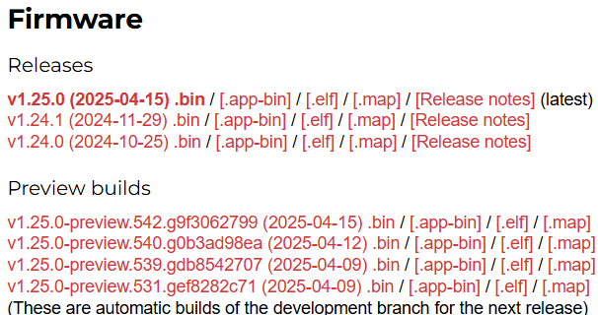
* Second, connect to the ***USB*** port on the ESP32 using a cord that is **able to** transfer data and not just power.
* Third, we need to find the proper Port that the device is located at. This can be done a number of ways when the device is connected.
  + Method 1 (**Windows**):
    - Click on the Windows button on your keyboard OR click on the Windows icon in the bottom left corner of your screen and look up “Device Manager”.
    - Scroll down to **Ports (COM & LPT)** and make note of which COM port is assigned to your ESP32. They may require you to reconnect. ***THE COM PORT IS DIFFERENT PER MICROCONTROLLER.***
    - 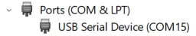
  + Method 2 (**Mac):**
    - Open Terminal (you can find it in Applications > Utilities, or by searching for "Terminal" in Spotlight)
    - Type ls /dev/tty.* and press Enter
    - Look for something like /dev/tty.SLAB_USBtoUART or /dev/tty.usbserial-* in the results - this is likely your ESP32 port
    - If you don't see a matching device, try disconnecting and reconnecting your ESP32, then run the command again
    - **Remember that the exact port name might vary depending on the USB-to-serial chip used in your ESP32 development board**
* Fourth, open the terminal on VSCode and type and enter the lines:
  + (esptool --port <COMX> erase_flash)
  + (esptool --port <COMX> --baud 460800 write_flash 0 <PATH TO THE DOWNLOADED .bin FILE>)
    - **NOTE:** Getting the path can be done by finding the file, right clicking and clicking on “Copy as path”
    - The COMX is the name of the port like the one shown above where X is the number assigned to the COM port.
* Finally, the ESP32 is flashed with MicroPython and ready to be used
  + The ESP32 can be modified using [mpremote](https://docs.micropython.org/en/latest/reference/mpremote.html).
  + The commonly used mpremote commands are:
    - (mpremote)
      * Check to see if a device is connected to the computer.
    - (mpremote run <fileName.py>)
      * Runs the file from your computer
      * Note: Imported Files must be stored onto the ESP32.
    - (mpremote fs cp <source file> :<destination file>)
      * Note: There is a space between the source file and the colon
      * The destination file, will be the name of the file and overwritten if it already exists.
    - (mpremote fs rm <fileName.py stored on the ESP32>)
      * Removes a file from the ESP32
  + Full list of commands can be found in the link provided above.

Step 3: Cloning the Repository

* Go to our GitHub repository: <https://github.com/AxelAndrews/PortalBoxSD>
* Click on the blue “< > Code” button and click on the HTTPS tab within “Local” and copy the link.
* Open VSCode and open the terminal and change your directory (cd <path to file you want this to be stored at>) to the location you want to store the files at via the terminal. Then to clone the repository, type (git clone https://github.com/AxelAndrews/PortalBoxSD.git). This will copy the files from the repository to the file location that you are currently at.
  + 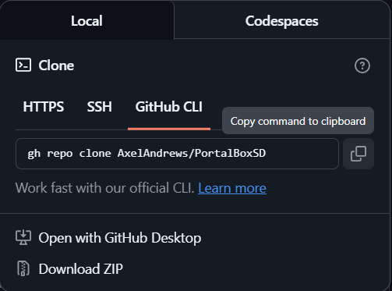
  + 

Step 4: Updating config.json

* ***At this point, the Portal Box SHOULD be assembled. Refer to*** [***Portal Box Assembly Guide***](https://docs.google.com/document/d/1g384_tL9M6RhhY-4YpHSNVq1-W_CzYQTKuRvIzMxAE0/edit?usp=sharing) ***for the construction instructions. Future instructions will be under the assumption that the box has been built without hardware issues.***
* After cloning the files, it is crucial that you update the config.json file with your credentials. In particular, it is **critical** that you update the db and wifi section of the json file with the credentials to your network and to your respective database such that the Portal Box can connect to the internet and to the database where user information is stored.
* Additional options:
  + "enable_buzzer": Enables/Disables the buzzer while in operation
  + "buzzer_pwm": Enables modulation of the buzzer frequency for various tones
  + "enable_keypad": Enables/Disables the keypad while in operation. A pushbutton replaces its position if set to “*False*”
  + "enable_LCDScreen": Disables the LCD Screen if set to “*False*”

Step 5: Uploading files onto the ESP32

* While in the root of the newly cloned repository and while connected to the ESP32. Reset the device and then type: (py copyFiles.py Firmware/) into the terminal and click enter. This will attempt to clone all files from the Firmware folder onto the ESP32 which are all the necessary files required to use the Portal Box.
  + **NOTE 1: For your specific device may not need py to run the file. It may be python or python3 instead.**
  + **NOTE 2: It may crash the first time and may require the code to be ran several times until all files are copied. If the code were to crash then either kill the terminal, click the reset button on the ESP32, or click (ctrl+c) while in the terminal and try again.**

Step 6a: Running the Portal Box while connected via USB-C (For Debugging/Testing)(RECOMMENDED for the first use of the device)

* While in the root of the repository, you can use (mpremote run Firmware/Service.py) to initialize the Portal Box. After a series of changing colors for starting up the box and getting connected to the database and internet, we are able to start using the Portal Box!
* **Note: The box may require you to press the reset button before running any mpremote commands**

Step 6b: Running the Portal Box for full time operation

* In order to have the box running full time. We need to copy boot.py (mpremote fs cp boot.py :boot.py) onto the ESP32 which will run Service.py **while the device has power.** The next time the device is reset, the software should operate with just power.

# Debugging

While boot.py is on the ESP32, users cannot communicate with the ESP32. Under that circumstance, users should refer to the reset_boot.py stored in the BootingHelp folder on the repo. The directions are stored both on the file as well as below.

* Removing Boot.py
* While connected to the ESP32: Reset the Device
* Enter “mpremote” (Recommended that you pre-type this). This will start a 3 second countdown
* Before the countdown expires. Press (ctrl+c) on the keyboard to enter REPL.
* Copy the entire script of reset_boot.py (ctrl+a → ctrl+c)
* Enter the entire script onto the REPL (ctrl + v)
* Press the enter button twice and boot.py should be removed from the device.
* Press (ctrl+x) to exit the REPL.
* Debugging the Software
  + While the Service.py is running, the terminal will have an abundance of outputs displaying anything that happens. Pay attention to anytime the software may crash and what state it was in prior to crashing. Once finished, you can load boot.py onto the ESP32 and continue operation. Refer to Step 6a to operate the Portal Box whilst connected via USB-C.

# 

# **Appendix F: Portal Box Final Assembly Guide**

This guide details the final assembly of the Portal Box. It explains what screws are needed to install the peripherals, the different peripheral options, and how to connect everything.

URL to Living Document: <https://docs.google.com/document/d/1g384_tL9M6RhhY-4YpHSNVq1-W_CzYQTKuRvIzMxAE0/edit?usp=sharing>

Portal Box Assembly Guide

This guide explains how to assemble the Portal Box, assuming that you have a fully assembled Portal Box enclosure and an assembled Portal Box PCB. Estimated Time to Complete: 25m

# Materials & Prerequisites

* Portal Box Enclosure (3D printed - see Portal Box Enclosure Guide)
* Assembled Portal Box PCB (see Portal Box PCB Guide)
* Screws:
  + Top/LCD screen screws: 4/40 X 7/16 (8x)
  + Keypad screws: M2 X 14 (4x)
  + PCB screws: 4/40 X 1/4 (4x)
* Nuts:
  + LCD screen nuts: 4/40 X 7/16 (4x)
  + Keypad nuts: M2 X 14 (4x)
* Peripherals:
  + Portal Box Pro (User PINs & Admin Modes):
    - 4x3 Matrix Keypad (1x)
    - 16x2 RGB Character LCD (1x)
    - RGB LCD Backpack (1x)
    - MFRC522 RFID Reader (1x)
    - 5” 8 pin ribbon cables (2x)
    - STEMMA JST H 3 pin cable (1x)
  + Portal Box:
    - LED Pushbutton (1x)
    - 16x2 RGB Character LCD (1x)
    - RGB LCD Backpack (1x)
    - MFRC522 RFID Reader (1x)
    - 5” 8 pin ribbon cables (1x)
    - STEMMA JST H 3 pin cable (1x)
    - Wire (2x)
  + Portal Box Lite:
    - LED Pushbutton (1x)
    - MFRC522 RFID Reader (1x)
    - 5” 8 pin ribbon cables (1x)
    - Wire (2x)

# Assembly

PCB Installation

1. Take assembled PCB and place it in the bottom half of enclosure, aligning the power in and out ports with respective cutouts on the enclosure

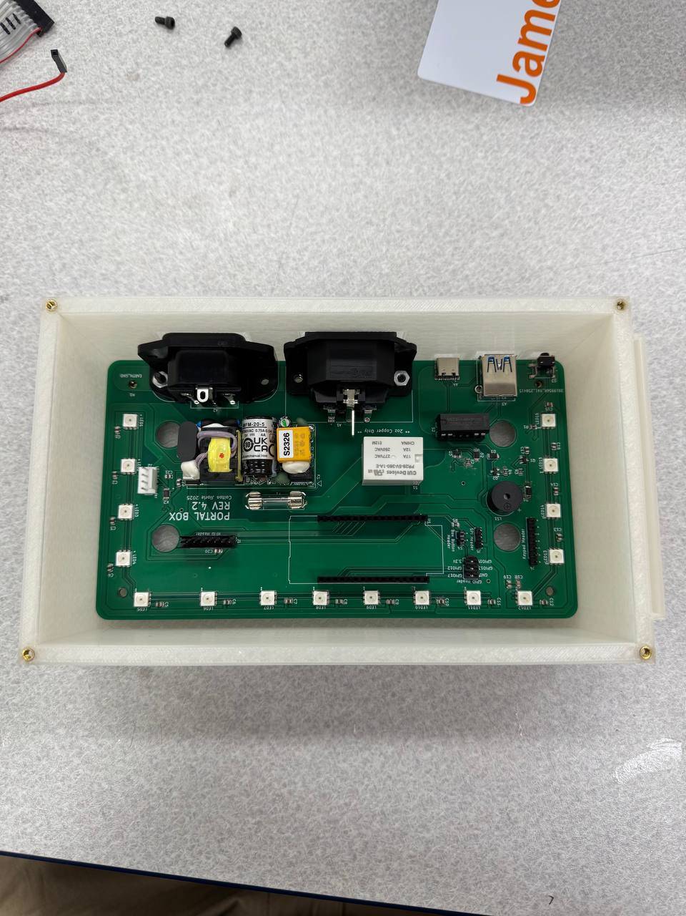

1. Insert PCB screws (4/40 X 1/4 [4x]) through PCB mounting holes and into standoffs and tighten

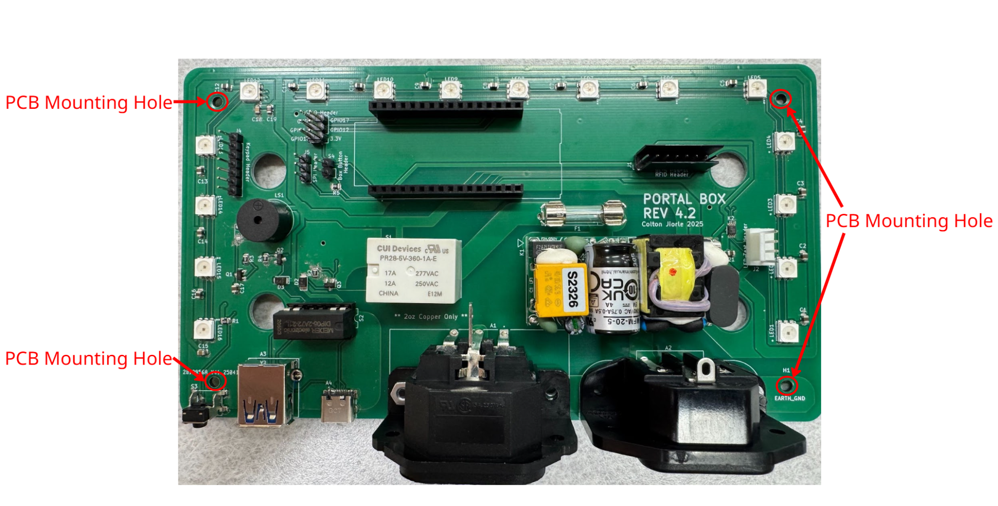

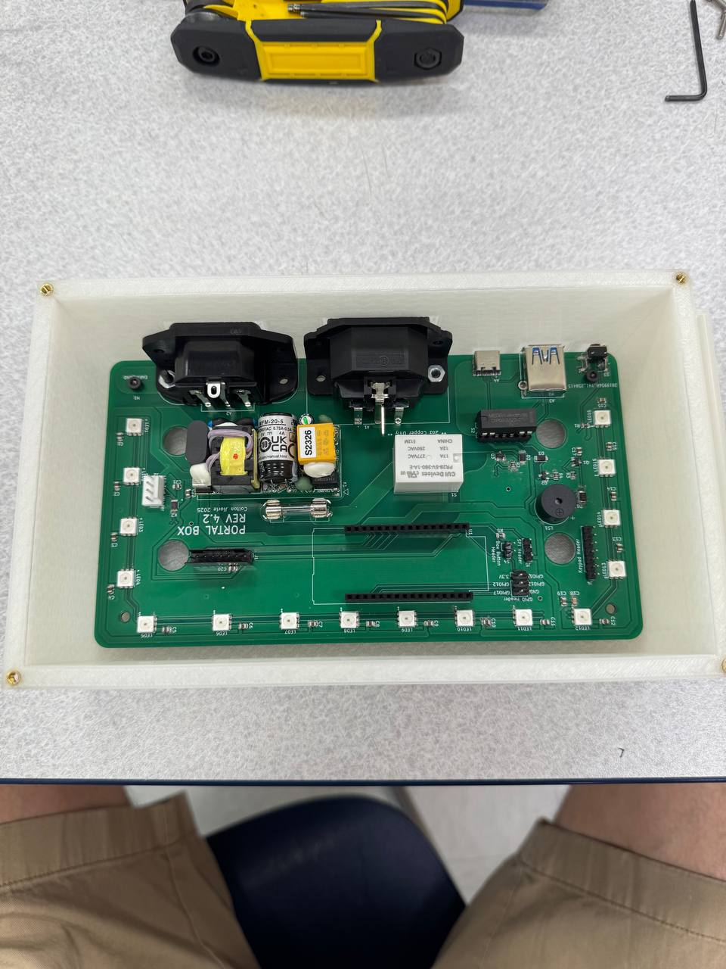

Peripheral Device Installation

1. Take the lid of the Portal Box enclosure along with the 4x3 Matrix Keypad,16x2 RGB Character LCD with RGB LCD Backpack attached and Keypad screws: M2 X 14 (4x) LCD screen screws: 4/40 X 7/16 (4x)
2. Place 4 LCD screen screws into the LCD screen mounting screw holes

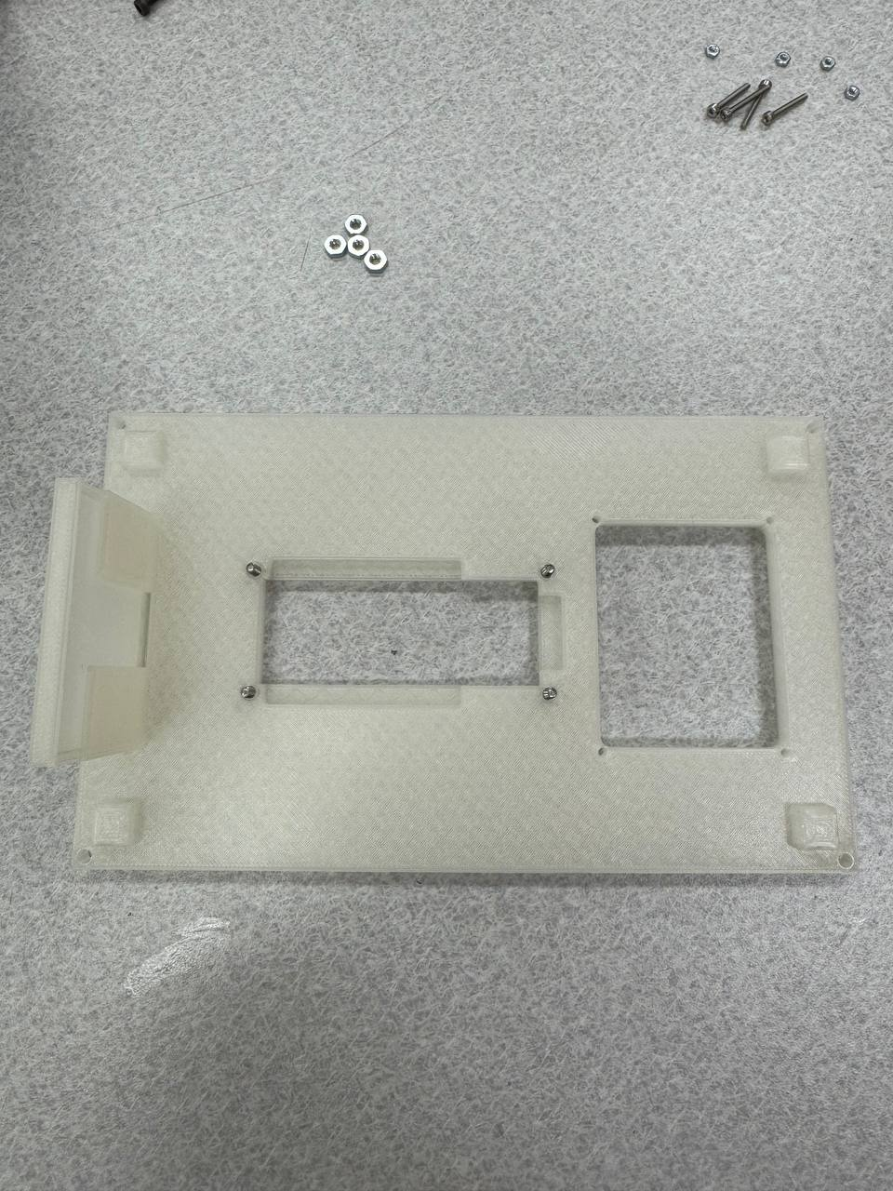

1. Place LCD screen onto screws

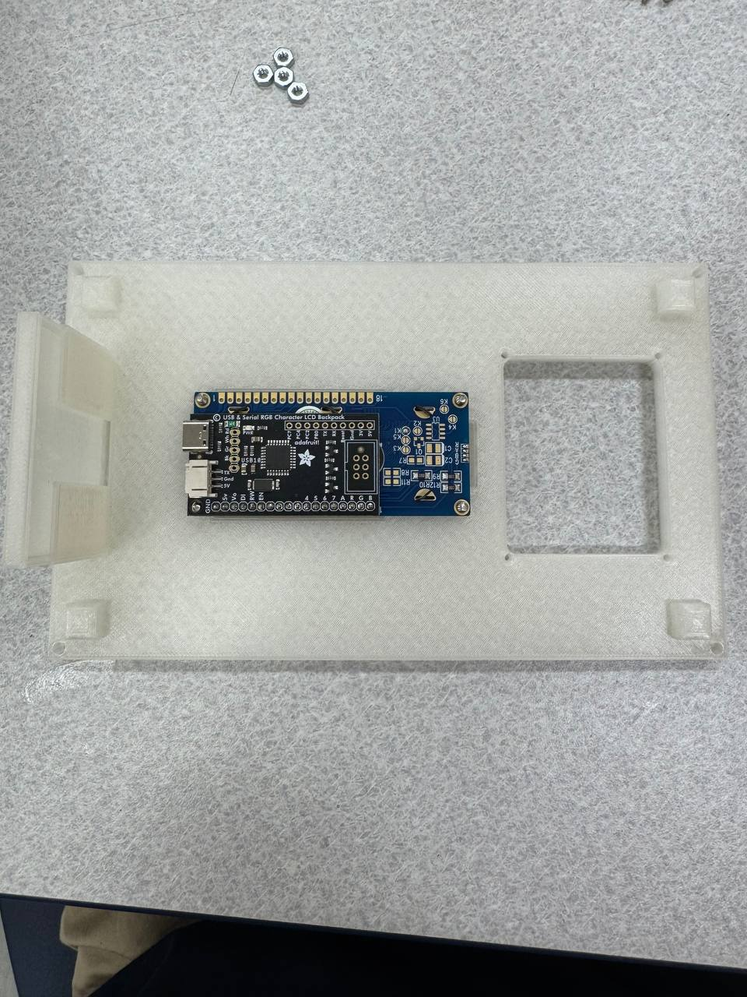

1. Place three LCD screen nuts on three visible screws and tighten

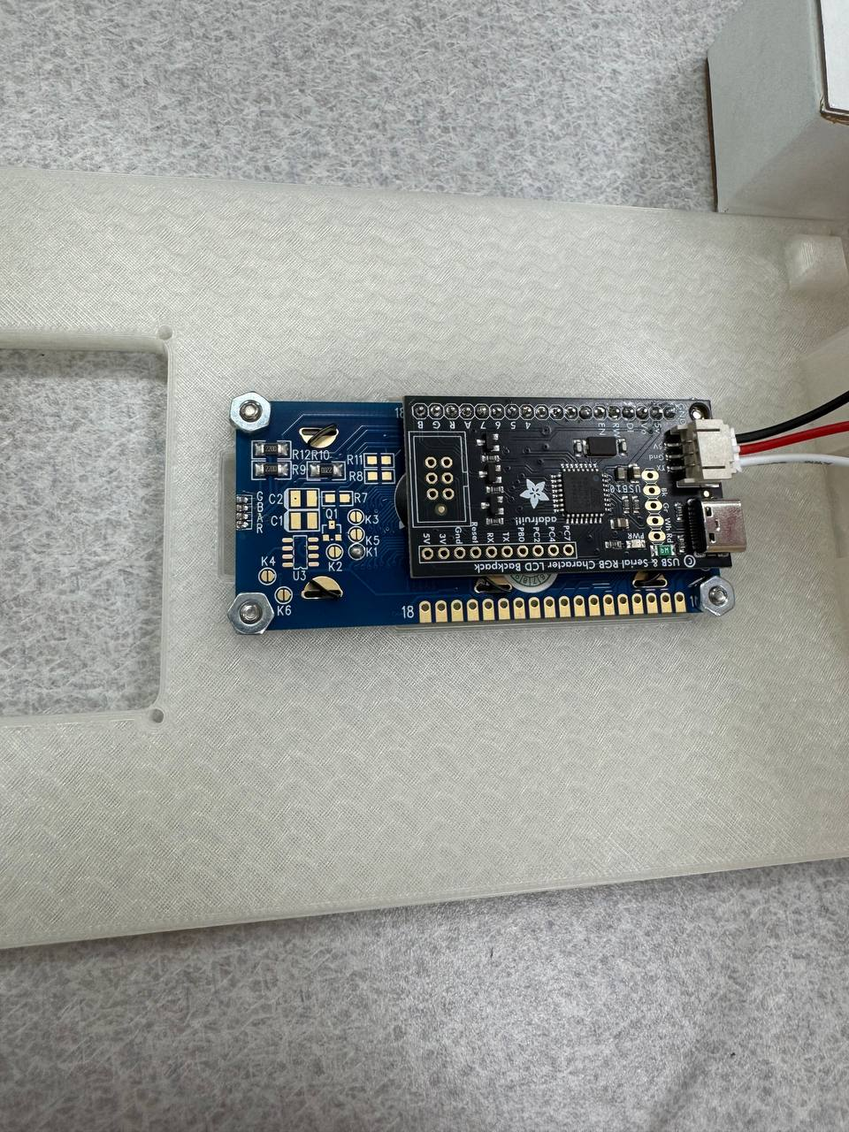

1. Place one LCD screen nut on the screw in between LCD backpack and the LCD screen and tighten

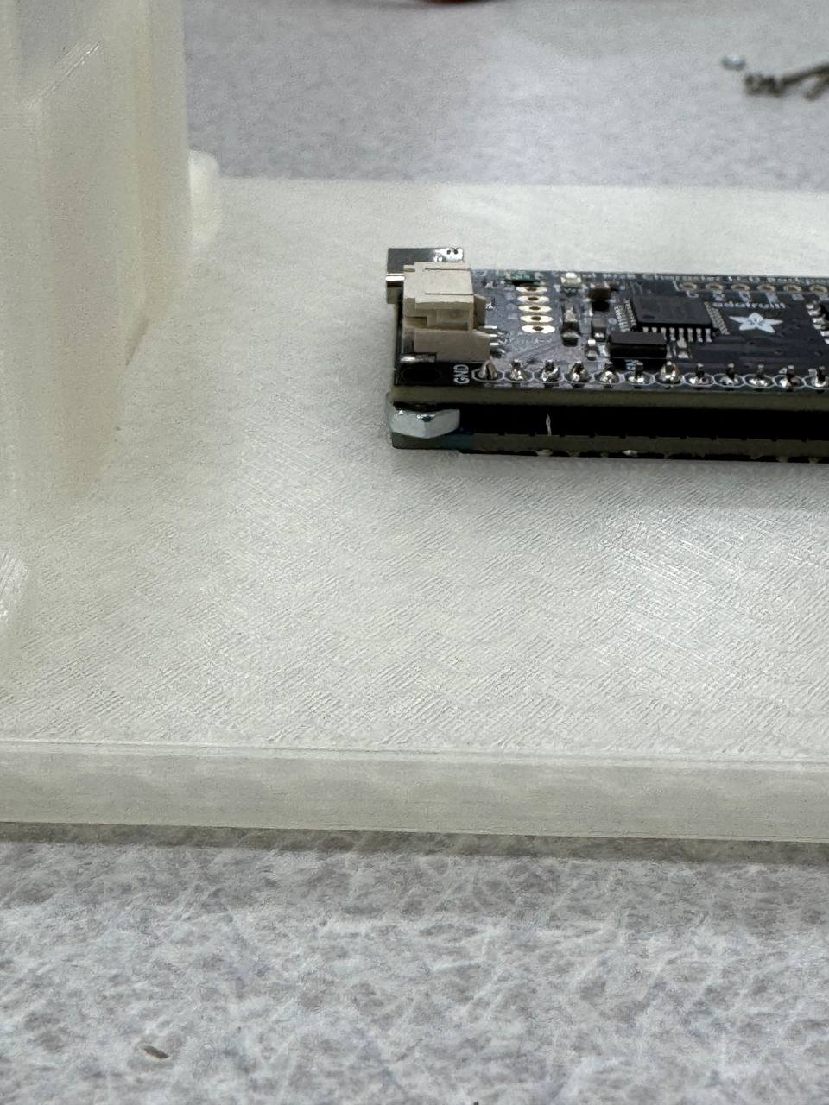

1. Place 4 Keypad screws into the Keypad mounting screw holes

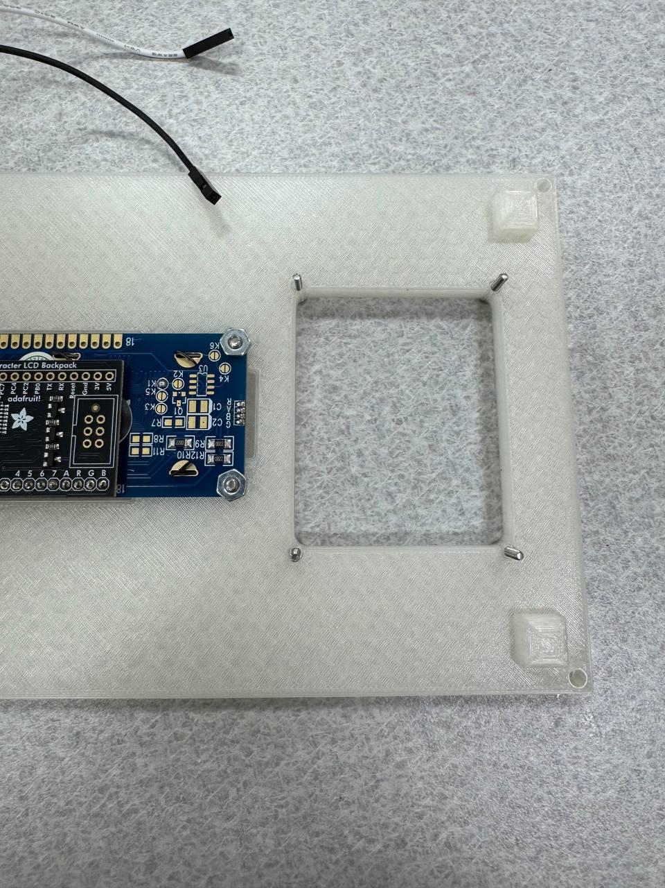

1. Place keypad onto the screws, placing the keypad pins towards the side with two visible LCD screen screws

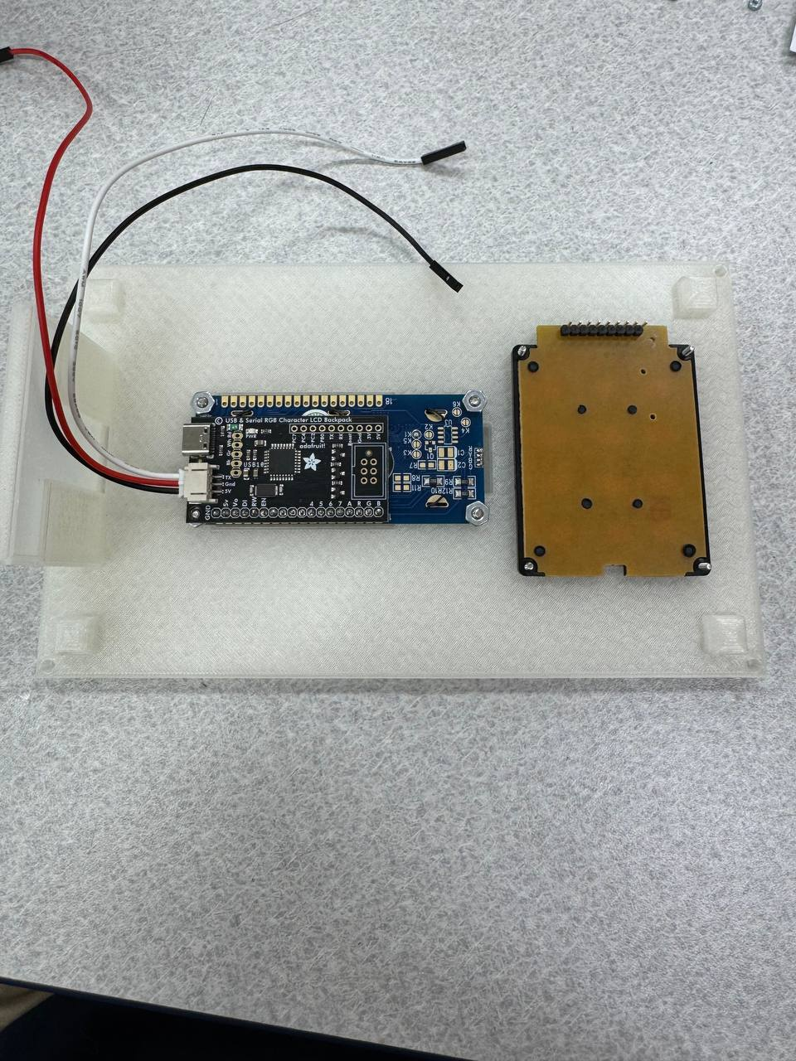

1. Place four keypad nuts on the screws and tighten

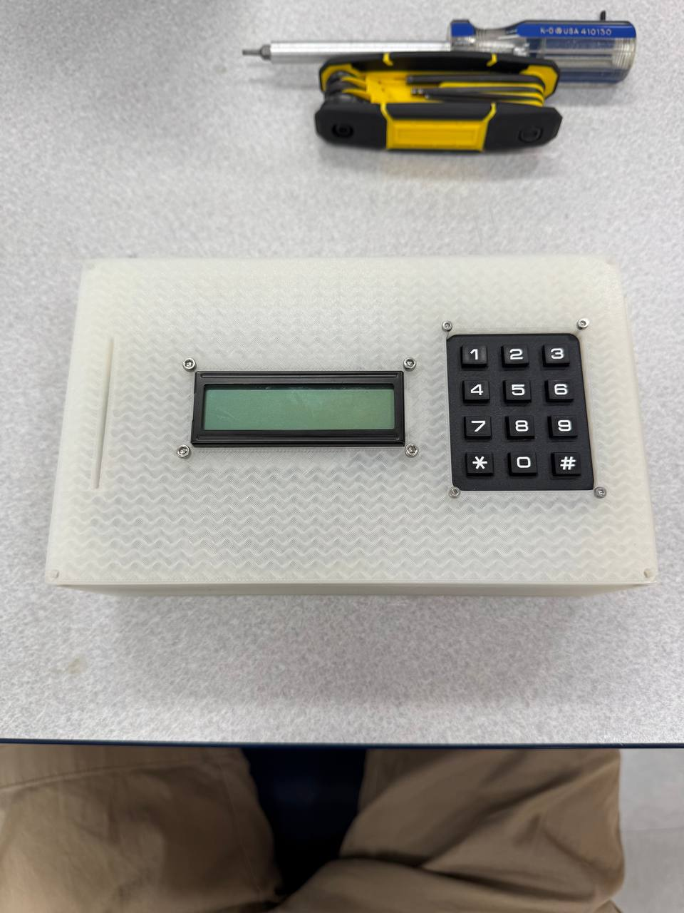

1. Slot the RFID Reader into the side of the card holder slot and use tape to secure. (Do not place tape in a way the can block the scanner, Only place near edges)

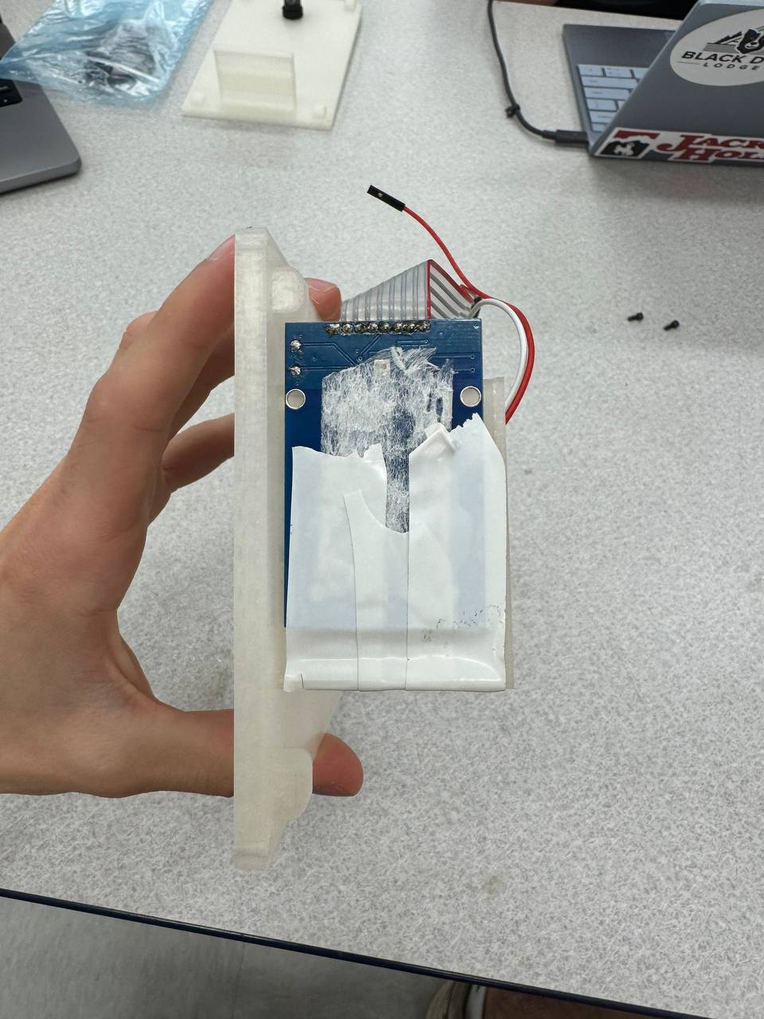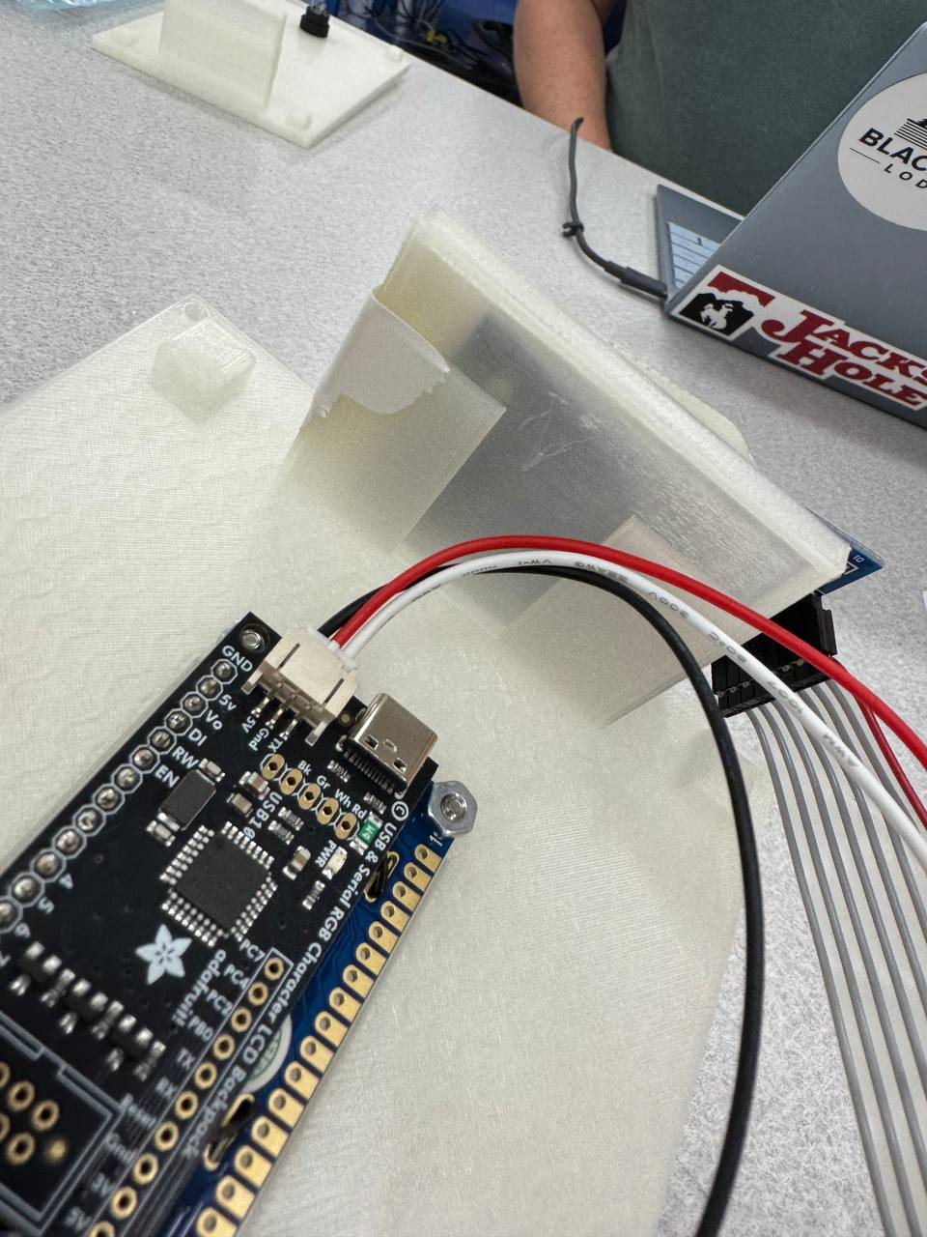

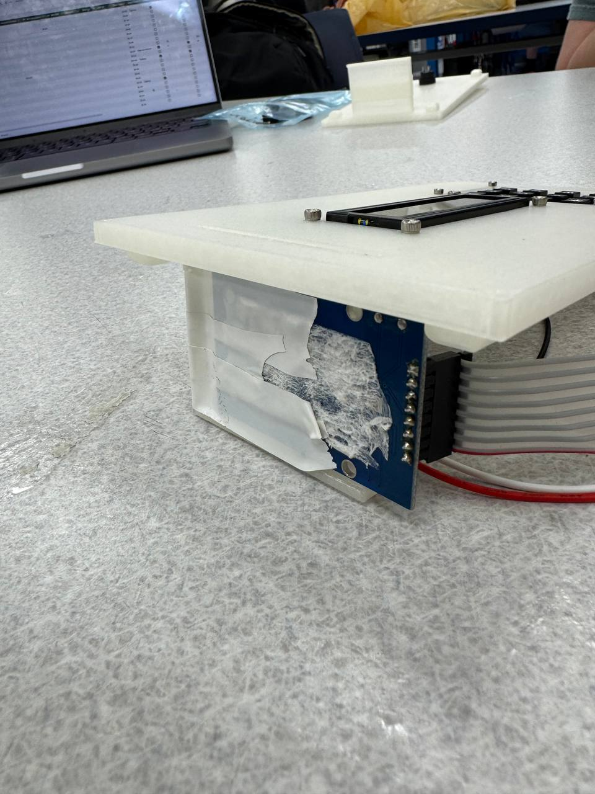

1. *If applicable* Unscrew the plastic fastener from the LED pushbutton and put the LED pushbutton through the enclosure lid. Place the plastic fastener on the back of the LED pushbutton and tighten.

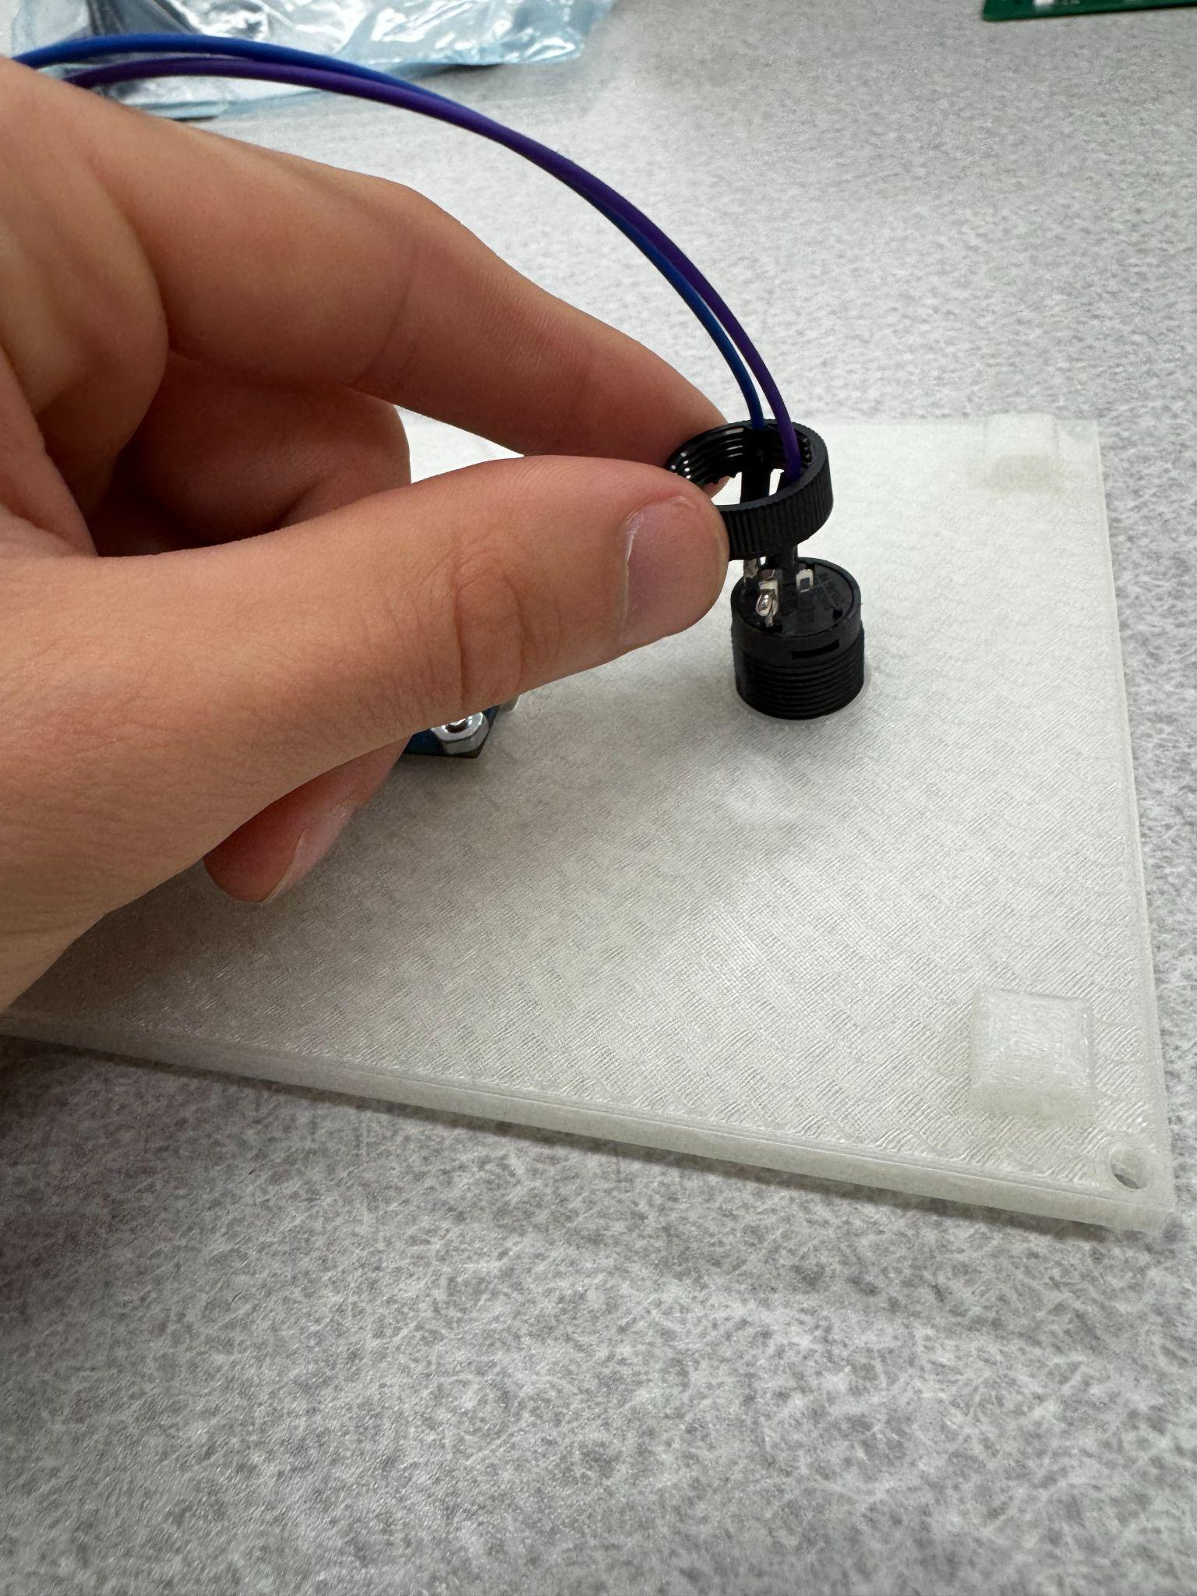

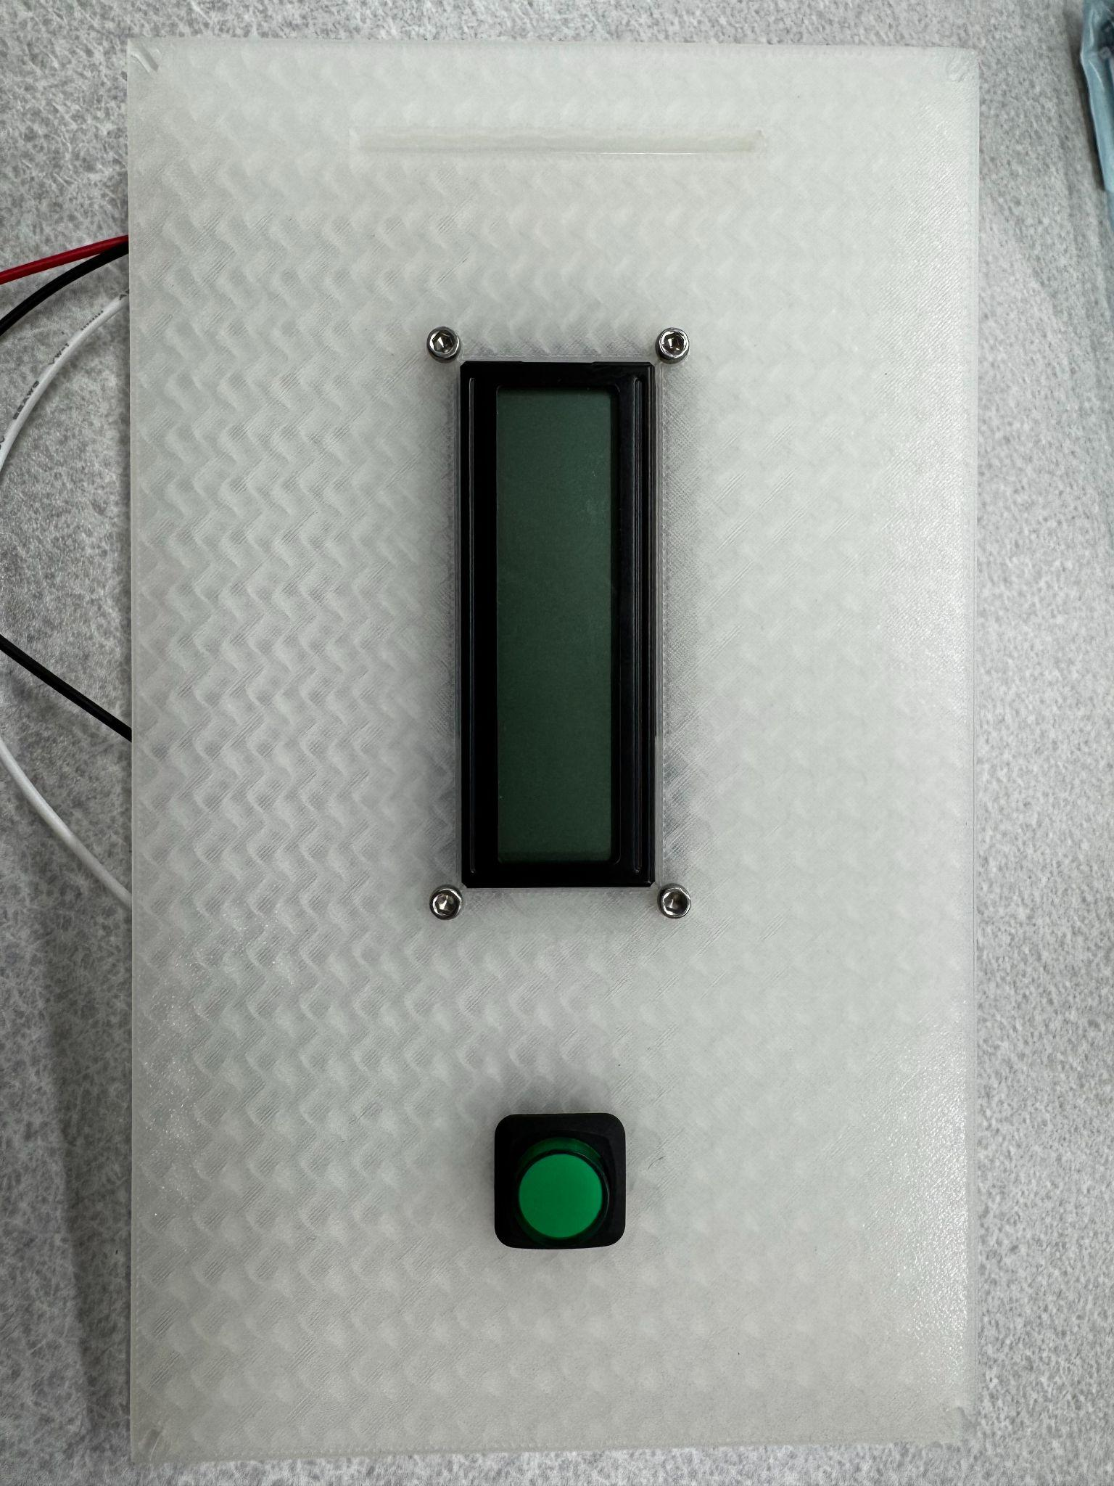

Peripheral Device Wiring

Below is a labeled PCB with no peripheral devices wired to it yet. Refer to this diagram for orientation and clarification in the following steps.

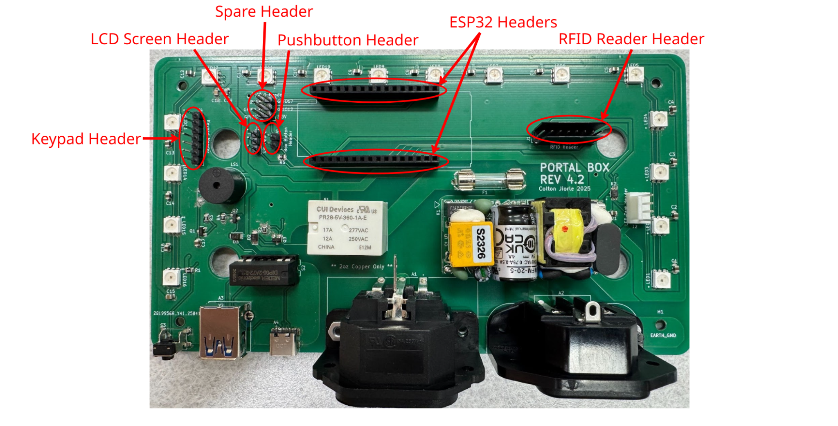

1. Begin by connecting the STEMMA JST H 3 pin cable to the LCD screen backpack



1. Connect the other side of the STEMMA JST H 3 pin cable to the LCD screen header

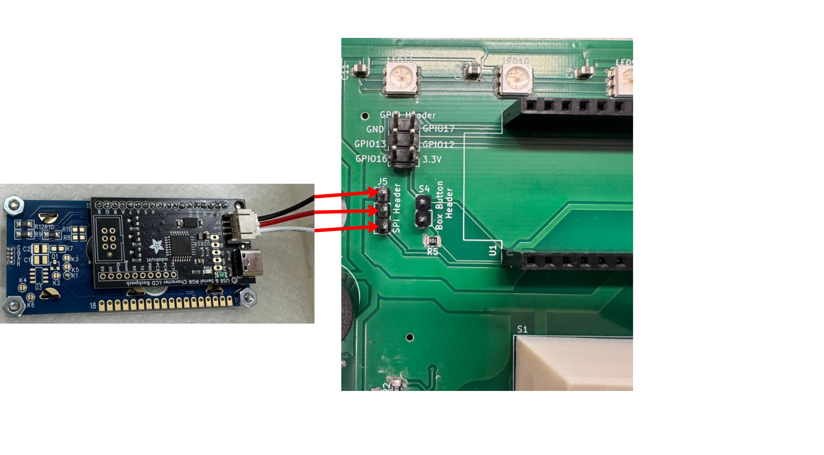

1. Next connect the 5” 8 pin ribbon cable to both the RFID reader and the Keypad
2. Connect the other end of the ribbon cable to the respective header (RFID reader to RFID reader header, Keypad to keypad header)

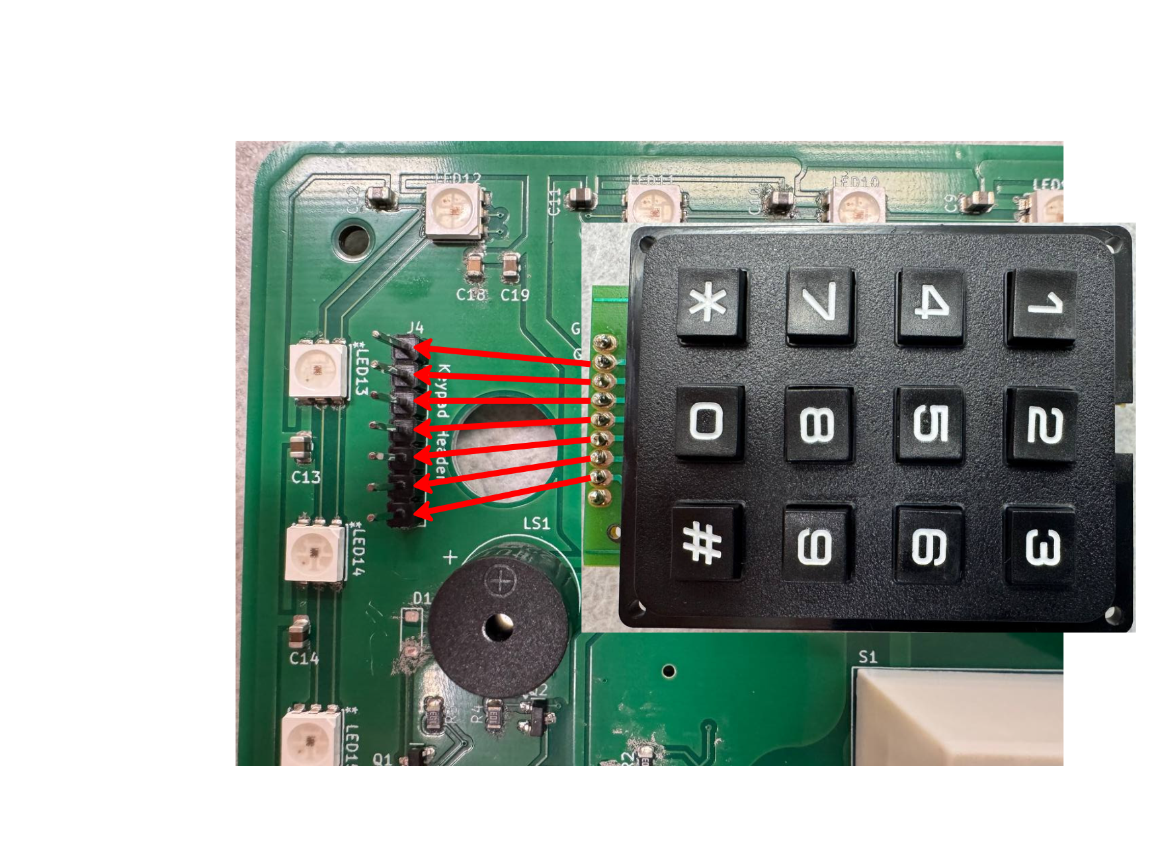

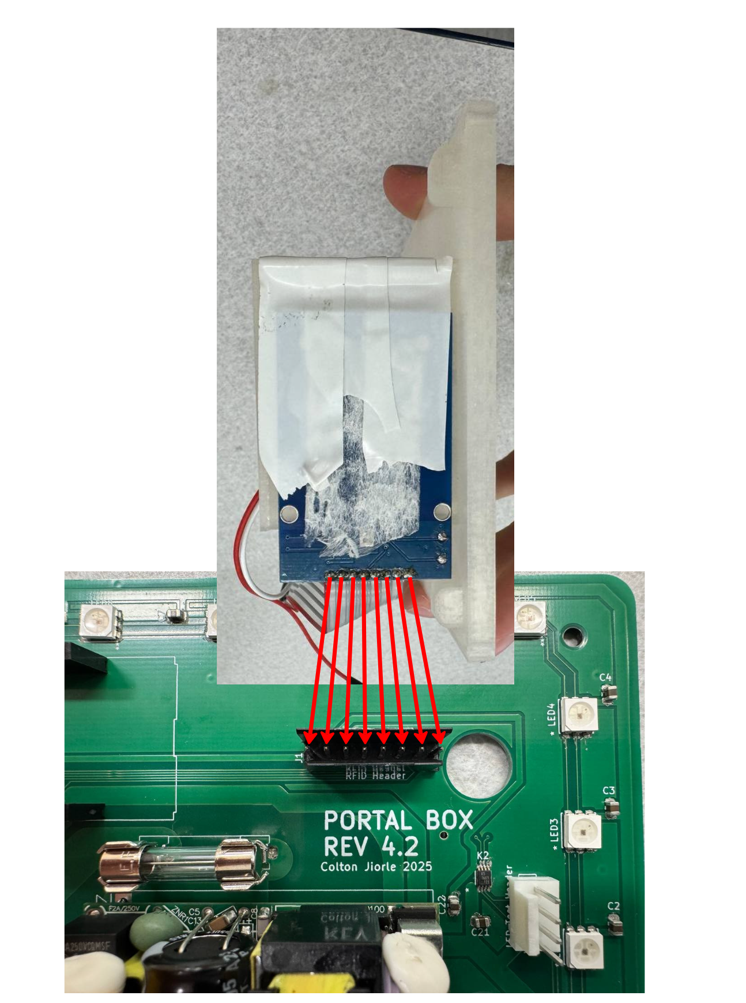

1. *If applicable* Attach the two LED pushbutton wires to the pushbutton header on the PCB.

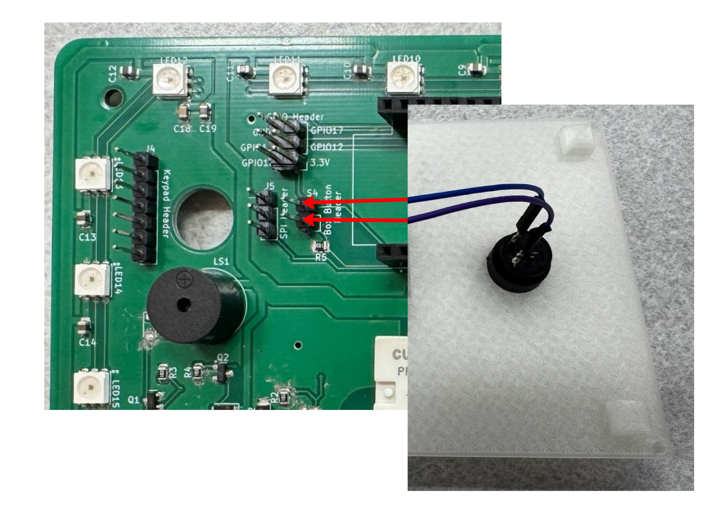

1. Connect the ESP32 microcontroller to the headers on the board following the orientation in the picture below

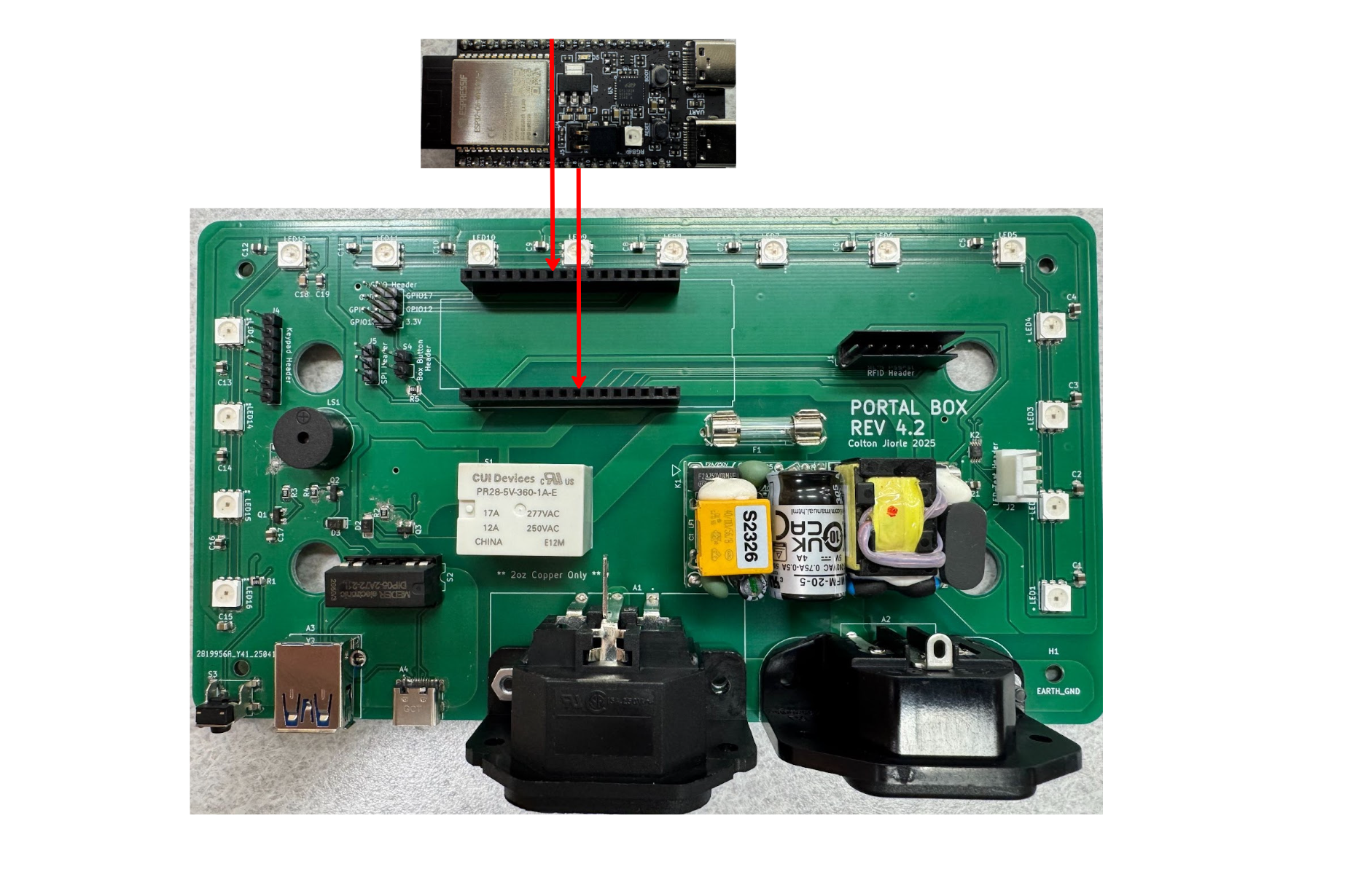

1. Ignore the spare header, nothing should be attached to it
2. Place the lid on the box ensuring all wires and connectors are inside
3. Place Top screws in each corner and tighten

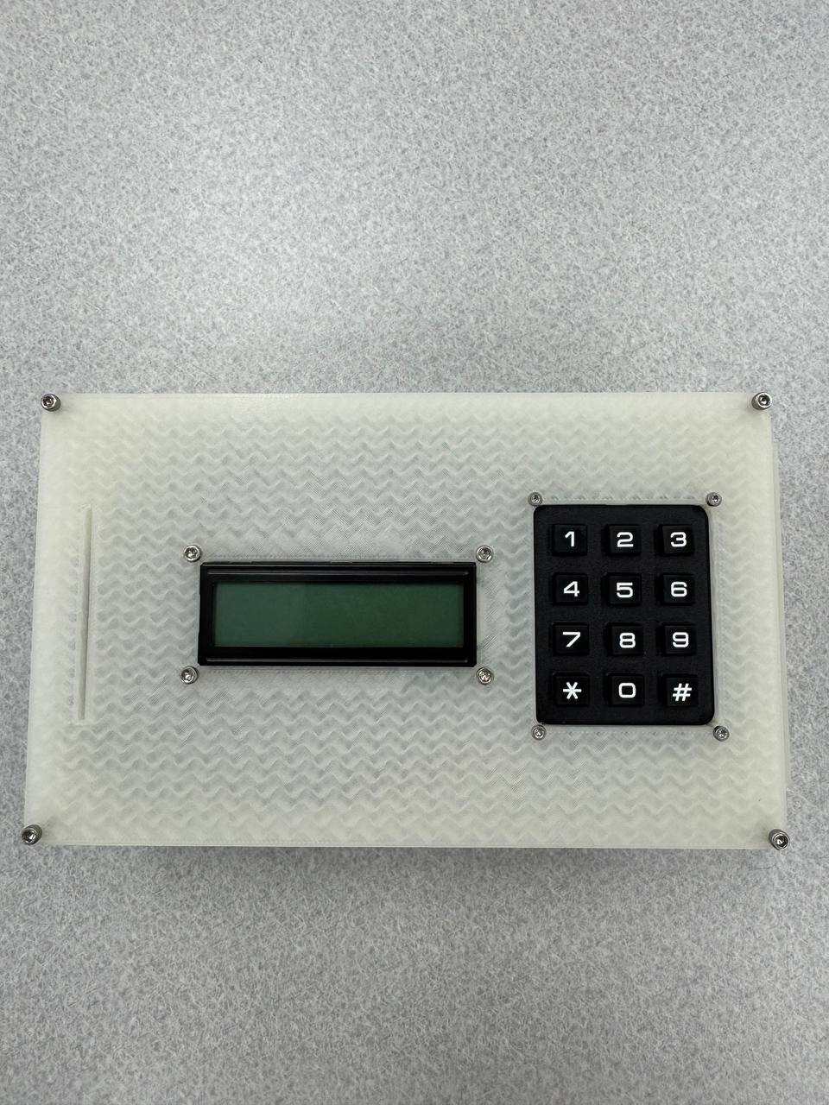

# **Appendix G: Portal Box Quick Reference**

This brief guide explains how users and admins interact with the Portal Box in a simple fashion. Useful for training new users, this guide will not be helpful for troubleshooting if anything goes wrong.

URL to Living Document: <https://docs.google.com/document/d/1wapcqINTDlt0A8bDXPmcC4drh0aq9AU65X-mgdPrq68/edit?usp=sharing>

# **Portal Box System - Quick Reference Guide**

## **Portal Box Hardware**

### **Basic Card Usage**

1. **Access Equipment**: Scan your card → Enter 4-digit PIN → Green "Machine On" display appears
2. **End Session**: Remove your card → Equipment powers off after grace period (10 seconds), or press ‘*’ to end before the grace period expires.
3. **Continue Session**: Remove card → Reinsert before grace period ends

### **Status Indicators**

| **Screen Color** | **Portal Box State** |
| --- | --- |
| Blue | Awaiting Card  (Idle State) |
| Green | Access Granted |
| Red | Access Denied |
| Orange | Proxy Mode |
| Purple | Training Mode |
| Yellow | Grace Period  (Push ‘**\***’ to end) |

### **Special Key Functions (From Idle State)**

* **\* Key**: Enter Card ID Reader mode (for card registration)
* **# Key**: Enter Certification mode (user authorization)
* Press/hold the same key used to enter the special mode to exit it.

### **PIN Entry**

* You have 3 attempts to enter your 4-digit PIN
* Default PIN for new users is 0000
* Contact admin to reset forgotten PINs, or go to MakerPortal → Profile

## **MakerPortal Web Interface**

Access the STEAM MakerPortal at **makerportal-steam.com**

### **User Account**

* **Login**: Click account icon → Sign in with Google
* **View Profile**: Click account icon → Select Profile
* **View Balance**: Check balance at bottom of transaction history
* **View Authorizations**: Listed on your profile page

### **Admin Quick Actions**

1. **Add User**: Users → Add → Complete form with name, email, PIN, role
2. **Add Card**: Cards → Add → Enter Card ID (get from Card Reader mode) → Select type
3. **Add Equipment**: Equipment → Add → Enter name, MAC address, type, location
4. **View Logs**: Access Log → Use filters for specific date ranges/equipment

### **Common Troubleshooting**

* **Card Not Reading**: Try repositioning card or reboot system with small button on back of the Portal Box
* **Unauthorized Message**: Verify your account has proper authorizations (check via MakerPortal → Profile)
* **Portal Box Unresponsive**: Press the reboot button on back of box, if that is unsuccessful power cycle the device (unplug/replug)
* **Session Timeout**: Equipment has automatic timeout (check equipment settings)

## **Card Registration Process**

1. At Portal Box: Press ‘**\***’ → Scan card → Note the Card ID → Press ‘**\***’ to exit
2. In MakerPortal: Cards → Add → Enter Card ID → Select card type → Save
3. Link to user: Select user from dropdown → Save

## **Authorization Process**

1. **Admin Method**: In MakerPortal, edit user profile and check equipment authorizations
2. **Portal Box Method**: Press ‘**#**’ → Scan admin card + enter PIN→ Scan user card → Confirm authorization

**Need help?** Contact system administrator at: aa034@bucknell.edu

# **Appendix H: Portal Box User Manual**

This comprehensive guide covers full operation and debugging of the Portal Box V4. It explains the admin modes, how to add new users, and more.

URL to Living Document: <https://docs.google.com/document/d/1zy0pSIEoggrR6NhjHCJBrImPLDNS1P6n5tHyGhDeywY/edit?usp=sharing>

# **Portal Box System User Guide**

This comprehensive guide covers both the MakerPortal web interface and the Portal Box hardware device. Together, these components form a complete access control system for managing equipment access in maker spaces, workshops, labs, and similar environments.

## **Table of Contents**

1. Portal Box Hardware
   * Basic Operation
   * User Authentication Flows
   * Special Modes
   * Troubleshooting
2. MakerPortal Web Interface
   * Getting Started
   * Dashboard and Navigation
   * Managing Users
   * Managing Equipment
   * Managing Cards
   * Access Logs
   * System Configuration

## **Portal Box Hardware**

### **Basic Operation**

The Portal Box is a physical control device that manages access to equipment. It features an LCD display, RFID card reader, keypad, and indicator lights to provide visual feedback.

#### **Power On and Startup**

1. When the Portal Box powers on, it displays "Setting Up..." on the LCD screen while connecting to WiFi and initializing
2. Once connected, it will display "Getting Role..." on the LCD screen as it identifies itself in the system
3. After successful setup, the LCD screen shows "Ready!" and transitions to the idle state
4. In idle state, the display shows "Welcome! Scan Card to Use" and the display and lights will glow blue

#### 

#### **Starting a Session**

1. Place your RFID card in the slot on the top of the Portal Box
2. The Portal Box will automatically read your card and check your authorization
3. If authorized, you'll need to enter your 4-digit PIN using the keypad on the top of the Portal Box
4. The LCD screen will display your how many attempts you have to enter your PIN
5. Upon successful authentication, the equipment will be powered on and the display will show "Welcome [Name], Machine On" and the display and lights will glow green

#### **Ending a Session**

1. When finished using the equipment, remove your card from the slot in the top of the Portal Box
2. The Portal Box will enter a grace period (typically 10 seconds) showing a countdown and the lights will glow yellow
3. Either reinsert your card to continue using the machine or press the ‘**\***’ button on the keypad to end the session
4. After the session ends, the equipment powers off and the box returns to idle state

### **User Authentication Flows**

#### **Authorized User Flow**

1. Scan your card at the reader
2. Enter your 4-digit PIN when prompted
3. If authorized, the display turns green and shows "Welcome [Name], Machine On"
4. Equipment is now powered on and ready to use
5. Remove your card then press ‘**\***’ button when finished to end your session
6. Your access is logged in the system

#### **Unauthorized User Flow**

1. Scan your card at the reader
2. Enter your PIN when prompted
3. If unauthorized, the display turns red and shows "Unauthorized, Access Denied"
4. The equipment remains powered off
5. Your access attempt is logged in the system

#### **Training Mode**

Training mode allows authorized trainers to grant temporary access to trainees:

1. Scan an Admin/Trainer card(authority level 3+) and enter PIN
2. During the grace period after trainer removes their card, the trainee inserts their card into the slot in the top of the Portal Box
3. The system enters training mode, showing "Training Mode, Machine On" and the display and lights will glow purple
4. The trainee can now use the equipment under supervision
5. When finished, remove the trainee's card and press ‘**\***’ to end the session.

#### **Proxy Access**

If enabled for specific equipment, proxy cards allow extended access without needing to leave the user card in the machine:

1. Scan an authorized user card, enter PIN.
2. Remove card, then during the grace period scan a proxy card at the reader
3. If the equipment allows proxy access, the display shows "Proxy Access, Machine On" with a cyan backlight
4. The equipment is powered on and ready to use
5. Remove the card when finished and press ‘**\***’ to end the session.

### **Special Modes**

#### **Card ID Reader Mode**

This mode displays card IDs for registration purposes:

1. When the box is in idle state (no card present), press the ‘**\***’ key
2. The display will show "Admin Card Required"
3. Insert an authorized admin/trainer card into the slot and enter the PIN
4. The display will show "Card ID Reader, Scanning..."
5. Scan any card to see its ID displayed on the screen
   1. This ID is needed to add a new card into the system via the MakerPortal
6. Press ‘**\***’ again to exit card reader mode

#### **Certification Mode**

This mode allows trainers/admins to authorize new users for equipment:

1. When the box is in idle state, press the ‘**#**’ key
2. The display will show "Admin Mode, Scan Admin Card"
3. Scan an admin/trainer card (authority level 3+) and enter the PIN
4. When prompted, remove the admin card
5. When prompted to "Scan User Card", scan the user's card to be authorized
6. The system will update the database to grant authorization
7. The display will show "Authorization Successful!" if successful
8. Remove the card and press ‘**#**’ to exit certification mode

### **Troubleshooting**

#### **Rebooting the Portal Box**

If the Portal Box becomes unresponsive:

1. First, press the reset button on the back of the Portal Box (Small button on the left side)
2. If issues persist disconnect power from the device
3. Wait 10 seconds
4. Reconnect power to restart the box

#### **Registration Issues**

If your card is not recognized by the system:

1. Enter Card ID Reader mode as described above
2. Scan your card to get its ID
3. Have an administrator add your card to the system using the MakerPortal interface

#### **PIN Entry Issues**

If you make a mistake during PIN entry:

1. You will have 3 attempts to enter the correct PIN
2. After 3 failed attempts, access will be denied
3. Contact an administrator or go to the MakerPortal → Profile to edit your PIN

## **MakerPortal Web Interface**

### **Getting Started**

#### **Prerequisites**

1. Your email must be added to the MakerPortal in order to login with Google OAuth
2. Have an Admin go to Users → Add, then fill out the user’s details to add them to the system

#### **Logging In**

1. Navigate to the MakerPortal URL (makerportal-steam.com) in your web browser
2. Click the account icon in the top right corner
3. Select "Sign in with Google"
4. Authenticate with your Google account
5. If your account is authorized, you'll be redirected to the home screen

#### **Home Screen and Navigation**

The MakerPortal interface is organized into three main sections:

1. **Manage**: Equipment, Equipment Types, Cards, Users, and Locations
2. **Reports**: Access logs and usage data
3. **System**: API Keys and Roles

It is important to note that users who are not admins will only see the Equipment and Equipment Types on the home screen.

### **Managing Users (Admins Only)**

#### **Viewing Users**

1. From the dashboard, click on "Users" in the Manage section
2. A list of all users in the system will be displayed
3. Click on any user to view their details

#### **User Details Page**

The user details page shows:

* Name, email, and role
* PIN code (for administrative reference)
* Active status
* Equipment authorizations
* Account transaction history

#### **Adding a New User**

1. From the Users list, click the "Add" button
2. Fill in the required fields:
   * **Name**: Full name of the user
   * **Email**: Email address (used for authentication)
   * **Comment**: Optional notes about the user
   * **PIN**: 4-digit PIN code (default is 0000)
   * **Active**: Toggle whether the user account is active
   * **Role**: Select the user's role (User, Trainer, Admin)
   * **Authorizations**: Check equipment types the user is authorized to use
3. Click "Save" to create the user

#### **Editing a User**

1. From the user details page, click "Edit"
2. Modify the user information as needed
3. Click "Save" to update the user

#### **Authorizing Equipment Access (can also be done via the Portal Box - Certification Mode)**

1. From the user details page, click "Edit"
2. In the Authorizations section, check the boxes for equipment types to grant access
3. Click "Save" to update authorizations

#### **Adding Payment Credit**

1. From the user details page, click "Add Payment"
2. Enter the date and amount of the payment
3. Click "Confirm" to review the payment details
4. Click "Save" to record the payment

### **Managing Equipment**

#### **Viewing Equipment**

1. From the dashboard, click on "Equipment" in the Manage section
2. A list of all equipment will be displayed showing name, type, location, and status
3. Click on any equipment item to view its details

#### **Equipment Details Page**

The equipment details page shows:

* Name and type
* MAC address (unique identifier)
* Location
* Timeout settings
* Service status
* Authorized users

#### **Adding New Equipment**

1. From the Equipment list, click the "Add" button
2. Fill in the required fields:
   * **Name**: Name of the equipment
   * **MAC Address**: The 12-character MAC address of the Portal Box (no colons)
   * **Type**: Select the equipment type
   * **Location**: Where the equipment is located
   * **Time out**: Minutes before auto-logout (0 for no limit)
   * **In service**: Toggle whether the equipment is available for use
3. Click "Save" to create the equipment

#### **Editing Equipment**

1. From the equipment details page, click "Edit"
2. Modify the equipment information as needed
3. Click "Save" to update the equipment

#### **Managing Equipment Types**

1. From the dashboard, click on "Equipment Types"
2. Click on any type to view details or "Add" to create a new type
3. Configure equipment type properties:
   * **Name**: Type of equipment
   * **Requires Training**: Whether users need specific authorization
   * **Charge Policy**: Payment model (No Charge, Per Use, Per Minute)
   * **Rate**: Cost rate if applicable
   * **Allows Proxy**: Whether proxy cards can be used with this equipment
4. Click "Save" to update

### **Managing Cards**

#### **Viewing Cards**

1. From the dashboard, click on "Cards" in the Manage section
2. A list of all cards will be displayed
3. Use the search box to find specific cards by ID
4. Click on any card to view its details

#### **Card Details Page**

The card details page shows:

* Card ID
* Card Type (User, Proxy, Training, etc.)
* Associated user (if applicable)
* Associated equipment type (if applicable)

#### **Adding a New Card**

1. From the Cards list, click the "Add" button
2. Fill in the required fields:
   * **Card ID**: The ID number obtained from the Portal Box Card Reader mode
   * **Type**: Select the card type:
     + **User Card**: Standard card assigned to a user
     + **Proxy Card**: Temporary access card
     + **Training Card**: For equipment training purposes
   * **User**: For User Cards, select the associated user
   * **Equipment Type**: For Training Cards, select the associated equipment type
3. Click "Save" to create the card

#### **Card Reader Mode (Getting Card IDs)**

To obtain a card ID for adding to the system:

1. At the Portal Box, press ‘**\***’ in idle mode to enter Card ID Reader mode
2. Authenticate with Admin card + PIN
3. Scan the unknown card at the reader
4. Note the Card ID displayed on the screen
5. Press ‘**\***’ again to exit Card ID Reader mode
6. Enter this ID in the Card ID field when adding a new card

### **Access Logs**

#### **Viewing Access Logs**

1. From the dashboard, click on "Access Log" in the Reports section
2. A chronological list of all access events will be displayed
3. Each entry shows:
   * Time and date
   * Event type (access attempt, completion, etc.)
   * Equipment name and type
   * Card ID
   * User (if applicable)
   * Location

#### **Filtering Logs**

1. Click the search icon to open the filter panel
2. Apply filters:
   * **After/Before**: Date range
   * **Location**: Filter by location
   * **Equipment Type**: Filter by equipment type
   * **Equipment Name**: Filter by specific equipment
3. The log will update to show only matching entries

#### **Exporting Logs**

1. Apply desired filters to the log
2. Click the download icon
3. The log will be downloaded as a CSV file

### **System Configuration**

### **Managing API Keys**

1. From the dashboard, click on "API Keys" in the System section
2. Click on any key to view details or "Add" to create a new key
3. Enter a name for the API key
4. Click "Save" to generate the key
5. Copy and securely store the token value

#### **Managing Locations**

1. From the dashboard, click on "Locations" in the Manage section
2. Click on any location to view details or "Add" to create a new location
3. Enter a name for the location
4. Click "Save" to create the location

**Portal Box Color Quick Reference:**

| **Light Color** | **Portal Box State** |
| --- | --- |
| Blue | Awaiting Card |
| Green | Access Granted |
| Red | Access Denied |
| Orange | Proxy Mode |
| Purple | Training Mode |
| Yellow Flashing | Grace Period  (Push ‘**\***’ to end) |

# **Appendix I: Portal Box API Specification**

The following table outlines the API that the physical Portal Box uses to communicate with the server. The main change from past iterations is the addition of the “add_authorization” POST method, which allows for users to be authorized for machine access directly from the box.

| **HTTP Method** | **API Mode** | **Parameters** | **Response** |
| --- | --- | --- | --- |
| GET | check_reg | mac_adr: MAC address of the device | Integer (1 if registered, 0 if not) |
| PUT | register | mac_adr: MAC address of the device | Boolean (success status) |
| GET | get_profile | mac_adr: MAC address of the device | JSON array with equipment profile: [{"id", "type_id", "name"[0], "location_id", "name"[1], "timeout", "allow_proxy", "requires_training", "charge_policy"}] |
| POST | log_started_status | equipment_id: ID of the equipment | Success status |
| POST | log_shutdown_status | equipment_id: ID of the equipment  card_id: ID of the card used (or 0 if not applicable) | Success status |
| POST | log_access_attempt | equipment_id: ID of the equipment  `card_id`: ID of the card used  successful: 1 if successful, 0 if not | Success status |
| POST | log_access_completion | equipment_id: ID of the equipment  card_id: ID of the card used | Success status |
| GET | get_card_details | card_id: ID of the card  equipment_id: ID of the equipment type | JSON array with card/user details: [{"user_balance", "user_auth", "user_active", "card_type", "user_role"}] |
| GET | get_user | card_id: ID of the card | JSON array with user details: [{"name", "email"}] |
| GET | get_equipment_name | equipment_id: ID of the equipment | JSON array with equipment name: [{"name"}] |
| POST | record_ip | equipment_id: ID of the equipment  ip_address: IP address of the device | Success status |
| POST | add_authorization | card_id: ID of the card to be authorized.  equipment_type: Type of equipment to authorize user for. | Success status |

# **Appendix J: Portal Box Bill of Materials**

The table shown below encapsulates everything needed for the project, aside from 3D-printing filament. A copy of this BOM is also on DigiKey, allowing it to be exported with the PCB files and sent to a manufacturer for a prefabricated board order.

DigiKey URL: <https://www.digikey.com/en/mylists/list/NODQQK4VBZ>

| ESP32-C6-DevKit | U1 | 1 | ESP32-C6-DEVKIT | Digikey 1965-ESP32-C6-DEVKITC-1-N8-ND | 1 | 9 | 45 |  |
| --- | --- | --- | --- | --- | --- | --- | --- | --- |
| ESP32 Header | n/a | 2 | PPTC161LFBN-RC | Digikey S7014-ND |  | 0.9 |  |  |
| AC/DC Converter | K1 | 1 | MFM-20-5 | Digikey 1866-5327-ND | 1 | 11.8 | 56 |  |
| Power Plug | A2 | 1 | 703W-00/53 | Digikey Q219-ND | Lots | 4.19 |  | 13.05 |
| Power Receptacle | A1 | 1 | PX0675/PC | Digikey 708-1351-ND | Lots | 4.19 |  | 35.58 |
| MFRC RFID Scanner | n/a | 1 |  | Digikey 4411-CN0090-ND | A few | 5.6 |  |  |
| Matrix Keypad |  | 1 | Adafruit 419 | Digikey 1568-1856-ND | 1 | 4.95 |  |  |
| Power Relay | R1 | 1 | PR28-5V-360-1A-E | Digikey 2223-PR28-5V-360-1A-E-ND | 2 | 1.4 |  | 12.46 |
| USB Port C | A4 | 1 | USB4500-03-0-A | Digikey 2073-USB4500-03-0-ACT-ND | 0 | 0.7 |  |  |
| USB Port A | A3 | 1 | USB1135-15-9-L-B | Digikey 2073-USB1135-15-9-L-B-ND | 6 | 1.15 |  | 9.75 |
| LCD Screen |  | 1 | Adafruit 398 |  | 1 | 12.95 |  |  |
| I2C Backpack |  | 1 | Adafruit 292 | 1528-1864-ND | 1 | 12.95 |  |  |
| Reset Button | S3A | 1 | TL3336AF160Q | Digikey TL3336AF160Q | Lots | 0.48 |  | 4.23 |
| Buzzer | LS1 | 1 | AI-1223-TWT-3V-2-R | Digikey 668-1456-ND | Lots | 1.28 |  | 10.4 |
| Fuse | F1 | 1 | 0217015.HXP | Digikey F2399-ND |  | 0.46 |  |  |
| Fuse Clip | F1 | 2 | 01000020Z | Digikey F4225-ND | Lots | 0.71 |  |  |
| LED Level Shift | K2 | 1 | 74AXP2T45DCH | Digikey1727-74AXP2T45DCHCT-ND |  | 0.62 |  |  |
| PCB | n/a | 1 |  |  |  | 11.822 | 59.11 |  |
| USB Relay | S2_1 | 1 | DIP05-2A72-21L | Digikey 374-1232-ND |  | 7.98 |  |  |
| USB Relay Socket | S2 | 1 | A 14-LC-TT | Digikey AE9989-ND |  | 0.24 |  |  |
| NMOS Transistor | Q1, Q2, Q3 | 3 | NTR5103NT1G | Digikey NTR5103NT1GOSCT-ND |  | 0.17 |  |  |
| Diode | D1, D2, D3 | 3 | CFRM104-HF | Digikey 641-1487-1-ND |  | 0.4 |  |  |
| 10k Resistor | R1, R2, R3, R4, R5 | 5 | AC0805JR-0710KL | Digikey YAG3758CT-ND |  | 0.1 |  |  |
| 2.2u Capacitor | C1, C2, C3, C4, C5, C6, C7, C8, C8, C9, C10, C11, C12, C13, C14, C15, C16, C17 | 17 | C0805C225Z4VACTU | Digikey 399-C0805C225Z4VACTUCT-ND |  | 0.15 |  |  |
| 1u Capacitor | C18 | 1 | C0805C105K8PACTU | Digikey 399-C0805C105K8PACTUCT-ND |  | 0.16 |  |  |
| 10u Capacitor | C19 | 1 | C0805C106K8PACTU | Digikey 399-C0805C106K8PACTUCT-ND |  | 0.11 |  |  |
| ‘  .7u Capacitor | C20, C21, C22 | 3 | C0805C475K8PACTU | Digikey 399-C0805C475K8PACTUCT-ND |  | 0.17 |  |  |
| RFID Header | J1 | 1 | 66100811622 | Digikey 732-14110-ND |  | 0.62 |  |  |
| Dotstar LEDs |  | 16 |  | Digikey 1528-1436-ND (10-pack) |  | 4.5 |  |  |
| LED DAT/CLK Header | J2 | 1 | 10082627-404HLF | Digikey 609-10082627-404HLF-ND |  | 0.28 |  |  |
| 8-Pin Ribbon Cables |  | 2 |  | Digikey IDSS-08-D-02.00-G-ND |  | 4.19 |  |  |

### 

### 

### 

### 

### 

### 

### 

### 

### 

### 

### 

### 

### 

# **Appendix K: Gantt Chart**

The Gantt chart outlines the project timeline with detailed task breakdown, dependencies, and progress tracking. The team used this chart to plan tasks and track progress through Phase 5, with plans for Phase 6 and 7, although as the team moved towards wrapping things up the Gantt chart was not used heavily.

URL:<https://app.smartsheet.com/sheets/MqQXcG5wjWhWVM2vf2qxx46qJF4MjXP7mw5mWGj1?view=gantt&timelineGroupBy=3010581315284>

# **Appendix L: Pull Request**

This pull request has the changes Axel made to the MakerPortal to enable PIN functionality.

URL: <https://github.com/Bucknell-ECE/PortalBox-ManagementPortal/pull/56>